the role of new business models in the scale-up of smart local energy systems: an agent-based approach

Elsa Brazza, UCL Energy Institute, elsa.barazza.14@ucl.ac.uk
Pei-Hao Li, UCL Energy Institute, p.li@ucl.ac.uk
Neil Strachan, UCL Energy Institute, n.strachan@ucl.ac.uk

Overview
Energy systems are becoming increasingly decentralised, and local energy infrastructure has the potential to play a key role in reaching the ambitious UK net-zero target by 2050 (Busch et al., 2017). The roles of energy producers and consumers are evolving as they become more active participants in the energy systems (European Commission, 2018), and new types of market players at the local level, such as local energy communities and aggregators, are emerging (IRENA, 2019; European Commission, 2018), and challenging the role of incumbent players (Kattiritzi et al., 2021). These new market players have heterogeneous strategies and motivations for investing in decentralised renewable energy. The success of their business models, which include social and environmental values besides the economic ones (Foxon et al., 2015), can contribute to accelerating the scale-up of local low-carbon infrastructure and smart local energy systems (SLES).
However, previous studies mainly focused on exploring how policies and regulations can mobilise low-carbon investments in energy infrastructure from national-scale actors, with a tendency to lock-in this business model and investments in centralised large-scale electricity generation plants (Foxon et al., 2015). Moreover, most modelling studies used to inform policies in the energy sector, such as partial equilibrium optimisation models, assume aggregated and rational decision-makers with perfect foresight acting like a social planner (Barazza and Strachan, 2020a), neglecting to represent new types of players and their heterogeneity. Different modelling frameworks, such as agent-based models (ABMs) allow to model heterogeneous agents with contrasting strategies and their interactions, and to reflect realistic behaviours of market participants, such as bounded-rationality (i.e. making “good enough” decisions), which traditional equilibrium and optimisation energy models do not address (Iychettira et al, 2017).
In this study, we thus apply the novel ABM BRAIN-Energy (Barazza and Strachan, 2020a) to investigate how local investor agents evolve into new business models by studying their investment decisions, and how they can compete with existing national investors. The aim will be to understand which new business models can contribute to the scale-up of SLES in the UK under different market structures to ensure that SLES play a mainstream role in the achievement of the net-zero target by 2050.

Methods
We use BRAIN-Energy, an ABM of electricity generation and investment. BRAIN-Energy’s advantage lies in its ability to represent agents with heterogeneous strategies and bounded-rationality in their investment decisions, and multi-agent interactions (Barazza and Strachan, 2020a and 2020b). The UK electricity sector in BRAIN-Energy is divided into three regions (London, Scotland and rest of the UK), because the potential of renewable energy (RE) technologies varies across different regions. To represent the intermittency of RE, BRAIN-Energy’s temporal resolution comprises eight time-slices (4 time-slices in a typical day in two seasons). The definition of the time-slices is based on the temporal representation of the UK TIMES model, a flagship energy system model for the UK. System flexibility in BRAIN-Energy is represented through demand-side response (DSR) from households. Smart appliances are assumed to be controlled collaboratively at the local level to balance the local electricity demand and electricity generation from local RE plants. The participation rate is assumed to increase from 0% in the base year 2012 to 100% by 2050.
Agents are at the core of BRAIN-Energy. There are two types of agents in BRAIN-Energy: investor and policy agents. There are national (incumbent utilities and new-entrants) and local (municipal utilities and households) investor agents, and they participate in the electricity market based on their own heterogeneous strategies, financial endowments and risk-return considerations. Policy agents comprise the national government (which subsidises investment into new renewable energy assets and enforces a CO₂ price and interim decarbonisation targets), the national regulator (which manages security of supply by holding capacity auctions), and local governments. Investor agents in BRAIN-Energy base their investment decisions on an NPV calculation. The investors’ bounded-rationality is reflected in their limited foresight of the future and heterogeneous expectations about future electricity price and level of electricity demand. Moreover, investors have different discount rates and return expectations. Investment choices are affected by the investors’’ own past-experience (self-learning) and imitation of other investors’ successful strategies. As results, investment decisions in BRAIN-Energy are non-optimal.
In this study we extend the BRAIN-Energy model by adding, besides the above mentioned investor agents, two new business models: 1) community ownership models, which are going to arise from household investors deciding to aggregate, and 2) incumbent utilities deciding to decentralise and becoming local players. By introducing these new business models we aim to understand how investor agents evolve into new business models, how national/local governance can support these, and how these can accelerate the scale-up of SLES under different market structures to reach the net-zero target by 2050.

Results
Current preliminary results only include national investors (incumbent utilities, new-entrants) and local investors (municipalities, households). Work is in progress to include in BRAIN-Energy the new business models described above. Preliminary results are based on 3 scenarios: 1) Scenario 1: national and local investors, DSR, high cost of capital (12%) and short term debt (12 years), 2) Scenario 2: national and local investors, DSR, low cost of capital (6%) and long term debt (25 years), 3) Scenario 3: only national investors, no DSR, low cost of capital (6%) and long term debt (25 years) . In all scenarios, market mechanisms which apply are: a CO₂ price (which can be increased up to 2 times if interim decarbonisation targets are not met), Contracts for Difference (CfDs) to subsidise investments in new RE plants, and a capacity market. The scenarios’ results highlight how in Scenario 1 the higher cost of capital and shorter debt slow down market diversification, and favour incumbents who retain a 90% and 48% aggregated market share respectively at 2030 and 2050 (Figure 1). In contrast, in Scenario 2 the lower cost of capital allows a strong market diversification and scale-up of SLES (incumbent utilities’ market share declines to only 24% in 2050, while local players are the main actors with a 71% market share) (Figure 1). Moreover, a lower cost of capital in Scenario 2 leads to a faster decarbonisation at 2030 (Figure 2). The absence of local investors in Scenario 3 leads to only 58% of total electricity being produced through RE in 2050, falling short of the UK’s ambitious decarbonisation targets (Figure 2).

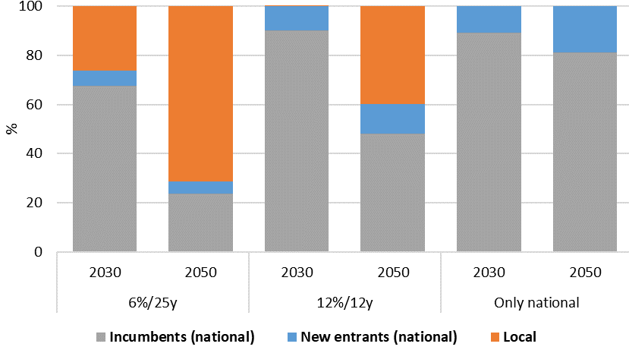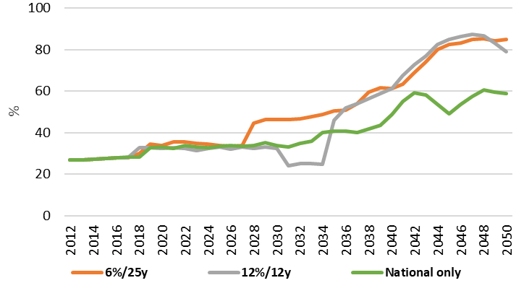
Figure 1: Market shares of national and local investors Figure 2: Share of RE in total electricity production

Conclusions
This work addresses the “Disruptive business models in energy sector” topic of the IAEE 2021 International Conference, and shows how investors’ investment strategies and the market structure can impact the scale-up of SLES. Moreover, preliminary results demonstrate how SLES and a more decentralised electricity sector lead to a faster scale-up of the RE share, thus contributing to a faster and deeper decarbonisation of the UK electricity sector. Adding new business model to BRAIN-Energy will allow to further study which enabling condition can help new business models grow and accelerate the scale-up of SLES for a successful net-zero transition of the UK electricity sector. Results can support policy-makers in producing policies which are targeted to the heterogeneous motivations of local and national investors to effectively mobilise private investments towards RE.

References
Barazza and Strachan (2020a) “The impact of heterogeneous market players with bounded-rationality on the electricity sector low-carbon transition”. Energy Policy, 138, doi:10.1016/j.enpol.2020.111274
Barazza and Strachan (2020b) “The co-evolution of climate policy and investments in electricity markets: Simulating agent dynamics in UK, German and Italian electricity sectors”. Energy Research and Social Science, 65.
Busch et al. (2017) “Scaling up local energy infrastructure; An agent-based model of the emergence of district heating networks”, Energy Policy, https://doi.org/10.1016/j.enpol.2016.10.011
European Union (2018), “Models of Local Energy Ownership and the Role of Local Energy Communities in Energy Transition in Europe”, European Committee of the Regions
Foxon et al. (2015) “Low carbon infrastructure investment: extending business models for sustainability”. Infrastruct. Complex 2, https://doi.org/10.1186/s40551-015-0009-4
IRENA (2019), “Business models: innovation landscape”, https://www.irena.org/-/media/Files/IRENA/Agency/Publication/2020/Jul/IRENA_Business_Models_Collection_2020.pdf
Iychettira et al. (2017) “Towards a comprehensive policy for electricity from renewable energy: Designing for social welfare”. Applied Energy, 187: 228–42. doi: 10.1016/j.apenergy.2016.11.035
Kattirtzi et al. (2021) “Incumbents in transition? The role of the ‘Big Six’ energy companies in the UK”, Energy Policy, 148. https://doi.org/10.1016/j.enpol.2020.111927

