***How are business strategies and activities for mitigating climate change, influenced by social pressure?: A survey of Japanese enterprises***

Shiro HORI, Central Research Institute, Fukuoka University,+81-92-877-6631 horishiro@fukuoka-u.ac.jp

Kayoko KONDO, Faculty of Design, Kyushu University,+81-92-553-4449. kondo@design.kyushu-u.ac.jp

Daisuke NOGATA, Faculty of Economics, Saga University, +81-952-28-8429, nogata@cc.saga-u.ac.jp

Yuriko HAYABUCHI, Global innovation center, Kyushu University, +81-92-553-4585, hayabuchi@gic.kyushu-u.ac.jp

## Overview

Recently, companies feel pressure to make further long term commitments toward the 2050 climate change goal,as a carbon neutral. When companies pursue these tasks, how they were influenced by social pressure for their actions.

According to institutional theory (DiMaggio and Powell, 1983; Scott, 1995), company behavior is affected by three factors, namely, regulative pressure, normative pressure, and cognitive pressure. First, regulative pressure is the pressure from entities that a company depends on, such as government, as regulative entity, as well as suppliers and customers for company, which affect the behavior of actors by altering benefit or cost (Hechter et al., 1990). Second, normative pressure is the pressure to impose constraints on social behavior, as society and community. Third, cognitive pressure includes a variety of elements (D’Andrade, 1984), such as imitation, a mimetic process (DiMaggio and Powell, 1983), goal creation, and solidarity (Aronowits, 1992; Calhoum, 1991). These correlate to elements within a company, like internal pressure.

Daddi et al. (2020) examined institutional pressure and showed normatic and mimetic pressures are effective. A survey of 394 companies that were part of the Global Compact also indicated that the normative and mimetic mechanisms of institutionalization (peer pressure) influenced corporate decision-making (Perez-Batres et al., 2011).

Cognitive pressure is based on reputation, which could lend importance to a company’s climate actions (Gasbarro et al., 2017). For example, a company might join the GRI simply for the purpose of reputation management (Brown et al., 2009). Reputation management is one of the key elements inside cognitive pressure.

Thus, we examine the role of social pressure in this survey, assuming that the behavior of a company is influenced by three elements: regulative, normative, and cognitive pressure.

The previous survey showed the role of social pressure on company’s motivation toward climate change actions. In this survey, we try to demonstrate the different motivation between general CO2 reduction activities and long term commitment toward 2050 goal. Because long term commitment toward 2050 goal requests companies to implement revoltional business change. Thus, we survey companies’ climate change attitudes, in terms of the General CO2 reduction and long term commitments.

This study surveys over 200 Japanese companies to examines these questions. The survey showed that there are different motivations for different types of climate actions.

## Methods

To identify companies’ response against climate change, a questionnaire survey was conducted of major Japanese companies. An earlier study verified that company carbon strategies differ according to company size, and leading companies are more actively addressing climate change. Previous company surveys on carbon management have suggested that larger companies are better at carbon management (Lee, 2011; [Böttcher](https://onlinelibrary.wiley.com/action/doSearch?ContribAuthorStored=B%C3%B6ttcher%2C+Christian+Felix) and [Müller](https://onlinelibrary.wiley.com/action/doSearch?ContribAuthorStored=M%C3%BCller%2C+Martin), 2013). We created a list of companies whose sales volumes were greater than 100 billion yen in 2018. This list was based on COSMOS business data from Teikoku Databank LTD (Teikoku Databank, 2019), a comprehensive database of Japanese companies, excluding the public sector, public associations, and small and local banks. A total of 1,714 companies made our list and were sent questionnaires by mail in May, 2019. Subsequently, 241 companies returned questionnaires by mid-July, 2019. Survey questions social pressure:government; internal; clients and society.

Analysis of the factors that inspire companies’ strategies and actions, was conducted by using an ordered logic model. To examine the factors promoting general CO2 reduction activities and long-term commitments as dependent variables, and social pressures are set as independent variables.

## Results

The majority of companies responded that addressing climate change is part of the mission of their company. In fact, 77% of companies slightly to strongly agreed that part of the company’s mission is dealing with climate change. This suggests that climate change related action has actually become a business value. Business priorities, the environment, social issues, customer relationships, and the efficient use of materials and resources were perceived as having close relationships with climate change related actions.

Table Effect of social pressure

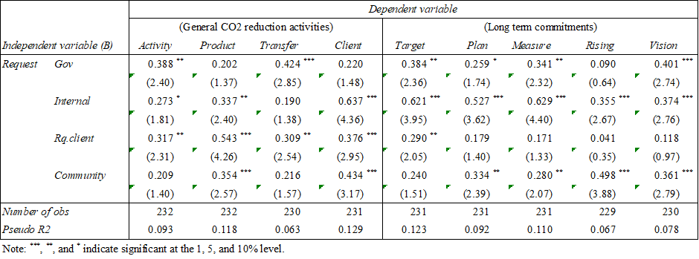

The result shows that government pressure affects activity and long-term commitment (Table). Internal pressure affects all activities and commitment. Request from clients seem to mainly affect general activities. Community pressure affects product, supply chain management, and long-term commitment. This indicates that CO2 reduction in business activities can be motivated by clients. This is in line with arguments in previous studies (Jeswan et al., 2007; Böttcher and Müller, 2013; Damert et al., 2017) who found that stakeholder pressure is the driver of climate strategy. However, government also affected activities, which does not coincide with previous studies. This may be a unique feature in Japan; government guidance is very influential on company attitudes (Arimura et al., 2019). Clients do not affect vision setting, but internal pressure strongly affects it, which may indicate that vision setting is an internal task of the company, not an issue for clients. This supports that the behavior of a company is influenced by three elements: regulative, normative, and cognitive pressure.

Regarding pressure, what is a company’s motivation? The result shows that all pressures have strong influences. However, they do not equally influence dependent variable. According institutional theory (DiMaggio and Powell, 1983; Scott, 1995), company behavior is affected by three factors, namely, regulative pressure, normative pressure, and cognitive pressure. Regulative pressure is the pressure from entities that a company depends on, that is, the government, suppliers, and customers. The result shows that requests from the government affect long-term action, including vision setting. Requests from clients affect general activities and target setting. This result does not coincide with previous surveys (Gasbarro et al., 2017; Daddi et al., 2020). However, previous studies only deal with general CO2 reduction activities. Thus, long term commitments are supposed to be affected by regulative pressure because the government is very sensitive to achieving the long-term climate goal. As for normative pressure, social and community pressure affects products, suppliers, and long-term actions. This coincides with previous studies (Daddi et al., 2020).

Cognitive pressure is the pressure to imitate competitors and create goals. Japanese companies are said to follow these pressures in particular. These pressures usually come from internal sources. A strong internal pressure creates implicit mimetic pressure. This result also coincides with previous studies (Daddi et al., 2020). Internal pressure effect all variables, including long-term actions, except transfer.

## Conclusions

These results suggest that long term commitments are affected by government, community, and internal pressures. This implies that all element of institutional theory could be the motivation for all activities and actions. Particularly, to achieve long-term goals, the government and community must continue to provide pressure to promote long-term commitments