How Would Real-time Electricity Pricing Affect the Saudi Power Sector in the Long-run?

Walid Matar, King Abdullah Petroleum Studies and Research Center (KAPSARC), +966(0)53-600-4253, walid.matar@kapsarc.org

Overview

This paper describes how the electric power system is affected if customers are charged real-time electricity prices (RTP). It links a multi-sector energy system model with a residential electricity use model. The energy system model contains an economic electric power dispatch optimization component. The residential framework embeds households, whose decisions are governed by microeconomic principles, in a physical building energy model. The analysis is performed for Saudi Arabia, which currently has government-set prices for fuels and electricity. It entails liberalizing fuel prices and setting the price of electricity equal the long-run marginal costs of power generation and transmission. The real-time electricity prices are solely offered to households, while those charged to other consumer segments are not changed.

Methods

This analysis links two models:

• The KAPSARC Energy Model (KEM). KEM is a multi-sector energy system equilibrium model developed for Saudi Arabia. It consists of six energy or energy-intensive sectors. They are: electricity, cement production, petrochemical and fertilizers, water desalination for municipal water use, oil and natural gas extraction and transport, and oil refining. The model characterizes the operational and investment decisions of each of those sectors. Each sector aims to either minimize its own cost or maximize its own profit. The electric power sector in particular is formulated to minimize costs to meet power load demand in eight daily load segments.

• A custom residential electricity use model in which a household is embedded in a physical building energy model. The residential electricity use model is described by Matar (2018, 2019, 2021). It merges the physical laws that govern energy flows in a dwelling with the microeconomic fundamentals by which household decision-making is studied. Households’ decisions are guided by a utility function that measures its welfare or satisfaction. The electricity consumption variables in the utility function are defined by the building energy model. Price elasticities are implicitly determined for each pricing scheme applied while adhering to physical laws.

An iterative process ensues between the two models to converge upon the – equilibrium – long-run marginal power generation costs, which are passed as RTP to households, and the power loads. The results compare RTP to the 2017 electricity tariffs that were offered in Saudi Arabia.

Results

As a consequence of fuel price liberalization, the electric power sector utilizes more natural gas and invests in renewable power capacity. The current use of oil in Saudi Arabia becomes excessively costly. Furthermore, the higher natural gas allocation to the power generation sector is achieved through equipping water desalination with reverse osmosis plants and improving the energy efficiency across all sectors. In this fuel pricing environment with or without RTP, around 1,700 trillion British Thermal Units of natural gas are used by power generations. The use of natural gas is slightly lower when RTP is applied.

Although the natural gas use in both fuel price liberalization scenarios is similar, the investment story begins to contrast the effects of RTP on the power generation sector. Without RTP, the sector would build 33 GW of solar photovoltaic (PV) plants and 31 GW of natural gas-fired combined cycle plants. With RTP charged to households, PV capacity additions fall to 17 GW. That is around a half of the additions of a scenario that does not charge RTP. Combined-cycle capacity falls to 24 GW. In all, around $24 billion in capital expenditure would be unneeded. The resulting demand response can help the power utility recoup the $2.4 billion it has spent to overhaul the electricity metering system.

The effect of RTP on the power sector’s marginal costs are shown in Figures 1 and 2. With RTP in place, the reduction in deployed PV capacity would result in a flatter duck curve throughout the year. This means the power system experiences lower ramping of thermal power plants and a higher trough during the day. Once deployed, PV is typically first in the merit order as it has a zero marginal generation cost. Thus without RTP, in the cooler winter months when power loads are lower than in the summer, the marginal costs during the late morning and early afternoon periods can fall to zero. This is due to the high levels of PV deployed to meet summertime demand. Pricing electricity at RTP would lessen the likelihood to exhibit electricity prices of or near zero. Relative to just fuel price liberalization, the consumer in this instance would benefit from a more stable electricity price throughout the year.

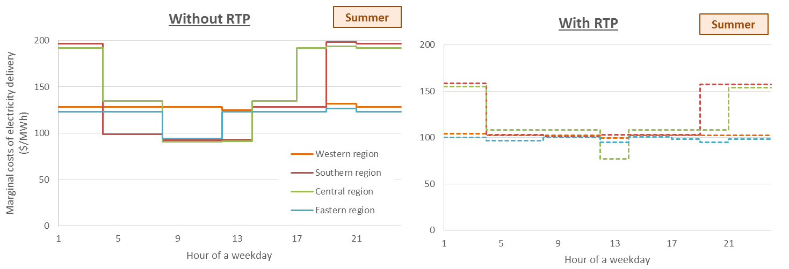
Figure 1 – The long-run marginal costs of electricity delivery on a summer weekday after liberalizing fuel prices, without and with RTP (source: model results)
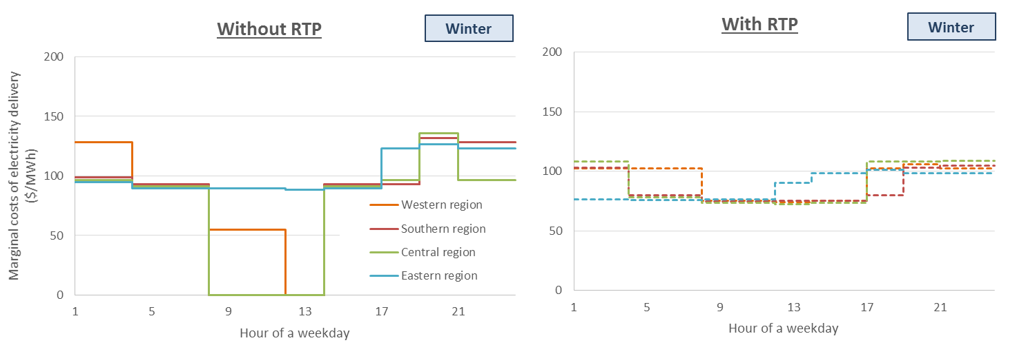
Figure 2 – The long-run marginal costs of electricity delivery on a winter weekday after liberalizing fuel prices, without and with RTP (source: model results)

Conclusions

RTP, a form of dynamic electricity pricing, reduces the variability of the marginal costs to Saudi power utilities throughout the day. Moreove, lowered capital spending results from RTP and consequently lower power loads. The curtailed investment in power plants would more than cover the costs of residential smart meter replacements.

References
Matar, Walid. 2018. Households’ response to changes in electricity pricing schemes: bridging microeconomic and engineering principles. Energy Economics 75: 300-308.
Matar, Walid. 2019. A household’s power load response to a change in the electricity pricing scheme: An expanded microeconomic-physical approach. The Electricity Journal 32: article number 106644.
Matar, Walid. 2021. Residential energy efficiency investment and behavioral response under different electricity pricing schemes: A physical-microeconomic approach. International Journal of Sustainable Energy.

