FUZZY PORTFOLIO OPTIMIZATION OF ONSHORE WIND POWER PLANTS

Barbara Glensk, Institute for Future Energy Consumer Needs and Behavior (FCN),
School of Business and Economics / E.ON Energy Research Center, RWTH Aachen University, Aachen, Germany,
+49 241 8049833, bglensk@eonerc.rwth-aachen.de
Reinhard Madlener, Institute for Future Energy Consumer Needs and Behavior (FCN),
School of Business and Economics / E.ON Energy Research Center, RWTH Aachen University, Aachen, Germany,
+49 241 8049820, RMadlener@eonerc.rwth-aachen.de

[Other Author’s Name, Affiliation, Phone, email]
[Format: single space, 10 point font, Times New Roman]

Overview
A number of studies have demonstrated the applicability of portfolio theory to power generation assets (for a useful review of the literature see Madlener, 2012). One of the first studies in this field is Bar-Lev und Katz (1976), focusing on the regulated US energy market. Awerbuch and Berger (2003) investigate the power generation portfolios of the EU-15 member states, finding significant portfolio diversification effects from using different power generation technologies. Krey and Zweifel (2006) deal with power generation portfolios in the US and Switzerland, using the seemingly unrelated regression (SUR) estimation method for the modeling of correlated shocks among power generation costs. Borchert and Schemm (2007), also using the Markowitz’ mean-variance portfolio optimization method, model a portfolio of onshore wind power plants at fictitious, spatially non-diversified locations, but extend the approach by using the conditional value at risk (CVaR) as a risk measure. Roques et al. (2009), by applying mean-variance portfolio theory, focus on the diversification of wind power locations at the European level. When optimizing spatially diversified wind parks, the differing remuneration schemes in the countries studied have to be taken into account as well. Rombauts et al. (2011) investigate the diversification effects for wind power, taking into account cross-border transmission capacity constraints. They consider three models for addressing the case of zero, infinite, and some positive limited value transmission constraints.
Portfolio optimization by means of fuzzy sets theory is a relatively young subfield of portfolio analysis. The focus of the literature so far has been on applications in financial markets, for instance by Ramaswamy (1998) or Tanaka and Guo (1999), who aimed at finding an improved modeling approach for tackling the uncertainties and risk attitudes of investors, relative to what can be achieved by means of the classical optimization approach of Markowitz. Decision-makers are often subject to societal and economic influences that can bias the results from an optimization approach. Therefore, the approach followed in portfolio analysis by means of fuzzy sets theory is to find a satisficing rather than an optimal solution, i.e. one that is sufficient to meet a decision-maker’s aspiration levels and preferences (Watada, 1997: p.220). Glensk and Madlener (2014) provide a useful review of the literature on how to transfer fuzzy portfolio selection procedures from financial to energy markets and its application.
In this paper, we apply fuzzy sets theory to the portfolio optimization of power generation assets, using a fuzzy semi-mean absolute deviation (FSMAD) model. The model is applied to five onshore wind power plants in Germany considered for the portfolio analysis. The results show that the combinations of favorable assets (portfolio shares) for efficient portfolios are very similar but differ regarding the efficient portfolio characteristics according to changes in support schemes. The return and risk spans when applying the FSMAD model under the framework conditions set by the German Renewable Energies Act (Erneuerbare-Energien-Gesetz, EEG) 2009 and 2012 are very similar to each other, but differ a lot when considering the EEG 2014 and 2017 amendments, and especially the market premium model.

Methods
Modern portfolio theory, introduced by Harry M. Markowitz in 1952, is based on probability theory and widely used for both financial as well as real assets. However, to capture the complex reality of decision-making processes we propose the use of fuzzy sets theory as an alternative to the probabilistic approach. In contrast to probability theory, the possibility distribution function, which corresponds to the probability distribution function, is defined by a so-called membership function describing the degree of affiliation of fuzzy variables. In our model, the investor's aspiration levels of a portfolio's return and risk are regarded and expressed by logistic membership functions. Moreover, we applied a semi-mean absolute deviation (SMAD) as a single-sided risk measure particularly useful in situations where only negative deviations are to be considered.
The model introduced by Konno and Koshizuka (2005) serves as the basis for the fuzzy optimization model for the presened empirical analysis, where the two goals of the SMAD model are, on the one hand, the minimization of risk and, on the other hand, the maximization of the returns under certain restrictions.
This bi-objective portfolio selection model can be solved either through the minimization of the portfolio risk for a given required return level or, alternatively, through the maximization of the return for a given predetermined risk level. In both cases, the determination of the required return and predetermined risk level is difficult a priori. The decision-maker would have to state precise and justifiable numbers for both values. Fuzzy sets theory offers the possibility to approximate these values. It means, if an expectation level can be satisfied within a certain span, this level is expressed as a fuzzy number with just this span (Watada, 1997: p.225). From these considerations we obtain the membership functions for return and risk. Their form is in this case sigmoid (or S-shaped), i.e. non-linear and logistic).

Results
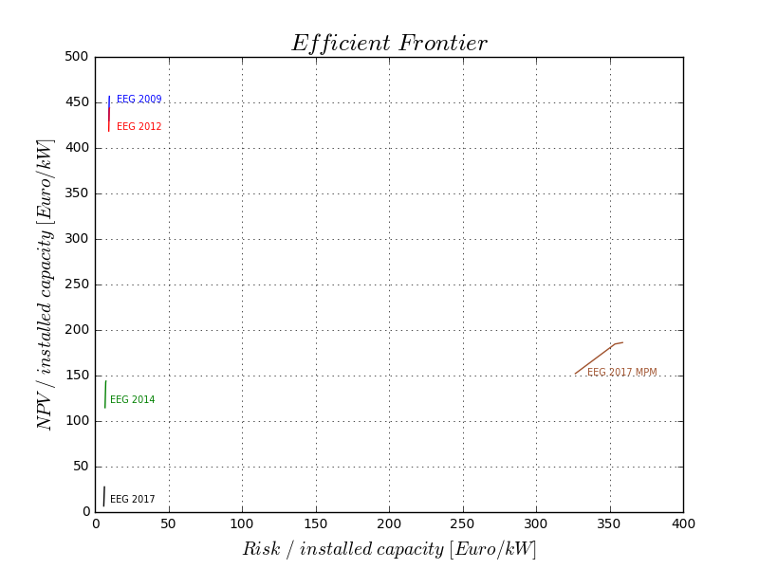
In the results, we compare the efficient frontiers obtained according to FSMAD model for four EEG regimes and the market premium model. A comparison of the efficient frontiers obtained for EEG 2009 – EEG 2017 (feed-in tariff scheme only) suggests that the decrease in EEG remuneration causes a decrease in the efficient portfolio’s returns and risks. Efficient portfolios obtained for EEG 2009 and EEG 2012 show relatively minor differences in the portfolio’s characteristics but major differences for EEG 2014 (in comparison to EEG 2009 and 2012) and even more so for EEG 2017.
Significant changes can also be observed when investigating the impact of the market premium model. The efficient portfolios are characterized by: (1) a higher risk in comparison to all efficient portfolios obtained under the feed-in tariff scheme; (2) a smaller return in comparison to the efficient portfolios obtained with the feed-in tariff scheme used in EEG 2009 and 2012; and (3) a higher return in comparison to the efficient portfolios obtained using the feed-in tariff scheme according EEG 2014 and 2017.

Figure 1: FSMAD efficient frontiers obtained for EEG 2009 – EEG 2017 (feed-in tariff scheme and market premium model)

Conclusions
In this paper, we introduce a fuzzy semi-mean absolute deviation (FSMAD) portfolio selection model, and investigate its usefulness for the selection of wind power generation assets. Using a semi-mean absolute deviation (SMAD) model as a benchmark, and a fuzzy semi-mean absolute deviation model for comparison, we analyze five onshore wind parks in Germany in the portfolio analysis as an illustration.
Regarding the changing EEG regulatary frameworks the results show that the combinations of the assets favored in the efficient portfolios are very similar, although the portfolio shares are markedly different. In addition, the return and risk span of the SMAD model are much broader in comparison to that of the FSMAD model. The highest returns are generated by portfolios based on the latter model. Offering less portfolio choices, the FSMAD model thus facilitates decision-making. This is in compliance with the notion that portfolio optimization by fuzzy sets theory is able to better account for the decision-maker’s preferences under real-world conditions.

References
Awerbuch S., Berger M. (2003), Applying portfolio theory to EU electricity planning and policy-making, IEA/EET Working Paper EET/2003/03.
Bar-Lev D., Katz S. (1976), A portfolio approach to fossil fuel procurement in the electric utility industry, Journal of Finance, 31(3), 933-947.
Borchert J., Schemm R. (2007), Einsatz der Portfoliotheorie im Asset Allokations-Prozess am Beispiel eines fiktiven Anlageraumes von Windkraftstandorten, Zeitschrift für Energiewirtschaft, 31, 311-322.
Glensk B., Madlener R. (2014), On the Use of Fuzzy Set Theory for Optimizing Portfolios, in: M. Lübbecke, A. Weiler, B. Werners (eds.), Zukunftsperspektiven des Operations Research – Erfolgreicher Einsatz und Potenziale, Springer Gabler, pp. 263-274 (ISBN: 978-3-658-05706-0).
Konno H., Koshizuka T. (2005), Mean-absolute deviation model, IIE Transactions, 37, 893-900.
Krey B., Zweifel P. (2006), Efficient electricity portfolios for Switzerland and the United States, Working Paper No. 0602, University of Zurich, Socioeconomic Institute, February.
Madlener R. (2012), Portfolio Optimization of Power Generation Assets, in: Q. P. Zheng, S. Rebennack, P. M. Pardalos, M. V. F. Pereira and N. A. Iliadis, Handbook of CO₂ in Power Systems: Springer-Verlag, Berlin/Heidelberg/New York, pp.275-296.
Ramaswamy S. (1998), Portfolio Selection using Fuzzy Decision Theory, BIS Working Paper No.59, Bank of International Settlements, Monetary and Economic Department, Basle, Switzerland, November.
Rombauts Y., Delarue E., D’haeseleer W. (2011). Optimal portfolio-theory-based allocation of wind power: Taking into account cross-border transmission-capacity constraints, Renewable Energy, 36: 2374-2387.

Roques F., Hiroux C., Saguan M. (2009), Optimal wind power deployment in Europe – A portfolio approach, Energy Policy, 38(7), 3245-3256.
Tanaka H., Guo P. (1999), Possibilistic Data Analysis for Operations Research, Physica-Verlag, Heidelberg, Germany.
Watada J. (1997), Fuzzy Portfolio Selection and its Applications to Decision Making, Tatra Mountains, Mathematical Publications, 13, 219-248.

