SOURCES OF COST OVERRUN IN NUCLEAR POWER PLANT CONSTRUCTION CALL FOR A NEW APPROACH TO ENGINEERING DESIGN

Philip Eash-Gates^, Massachusetts Institute of Technology, +1 617 661 3248 philipeg@mit.edu
Magdalena M. Klemun^, The Hong Kong University of Science and Technology and Massachusetts Institute of Technology, +852 3469 2558, magdalena@ust.hk
Goksin Kavlak, Massachusetts Institute of Technology, +1 203 500 6534, goksin@mit.edu
James McNerney, Massachusetts Institute of Technology, +1 401 243 3696, james.mcnerney@gmail.com
Jacopo Buongiorno, Massachusetts Institute of Technology, +1 617 253 7316, jacopo@mit.edu
Jessika E. Trancik, Massachusetts Institute of Technology and Santa Fe Institute, +1 617 715 4552, trancik@mit.edu
^contributed equally

Overview
Nuclear plant costs in the US have repeatedly exceeded projections (e.g., [1-3]). Here, we use data covering 5 decades and bottom-up cost modeling to identify the mechanisms behind this divergence (Figure 1). We observe that nth-of-a-kind plants have been more, not less, expensive than first- of-a-kind plants. ‘‘Soft’’ factors external to standardized reactor hardware, such as labor supervision, contributed over half of the cost rise from 1976 to 1987. Relatedly, containment building costs more than doubled from 1976 to 2017, due only in part to safety regulations. Labor productivity in recent plants is up to 13 times lower than industry expectations. Our results point to a gap between expected and realized costs stemming from low resilience to time- and site-dependent construction conditions. Prospective models suggest reducing commodity usage and automating construction to increase resilience. More generally, rethinking engineering design to relate design variables to cost change mechanisms could help deliver real-world cost reductions for technologies with demanding construction requirements.
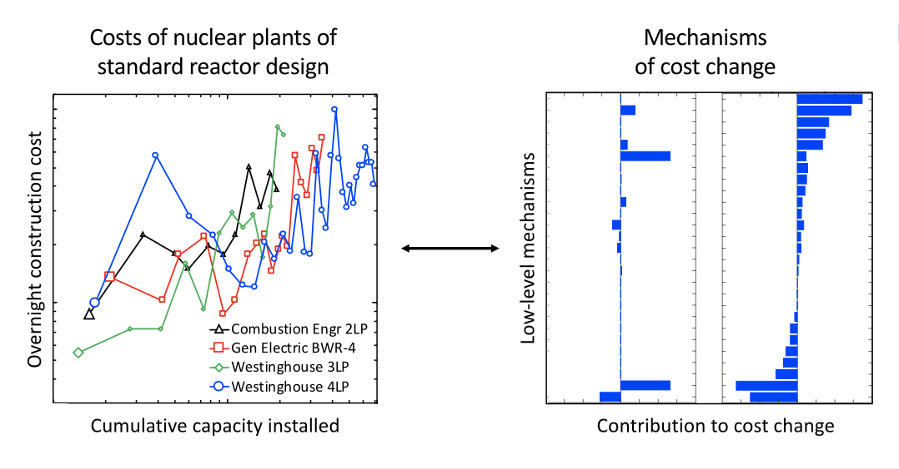

Figure 1: Graphical abstract as published in: Eash-Gates^, P., Klemun^, M.M., Kavlak, G., McNerney, J., Buongiorno, J., and Trancik, J.E., 2020. Sources of Cost Overrun in Nuclear Power Plant Construction Call for a New Approach to Engineering Design, Joule, 4(11), pp.2348-2373

Methods
We first examine the overnight cost of construction of 107 nuclear plants from across the U.S. nuclear experience, and split out the cost trajectories of several reactor designs to examine cost trends in nominally standard designs. We also examine the contributions of 61 different cost accounts from the Department of Energy’s Energy Economic Database (e.g., [3, 4]) to overnight construction cost increase over the 1976-1987 period. We then use a case study of the reactor containment building to decompose cost increases observed over the 1976-2017 period into technical, economic, and regulatory drivers, advancing a recently developed method to attribute cost change in a technology to engineering-level and higher-order mechanisms [5, 6]. Finally, we apply this method prospectively to estimate the effect of specific innovations such as advanced manufacturing and advanced construction materials.

Results
First, by separating the cost trajectories of four standard U.S. reactor designs deployed since the 1960s, we observe that nth-of-a-kind (NOAK) plants have been more, not less expensive than first-of-a-kind (FOAK) plants. In fact, the FOAK plant was the least expensive for three of the four designs we study. Breakdowns of cost indicate that ‘soft’ factors external to standardized reactor hardware, such as rising expenses for engineering services and on-site labor supervision, and construction support infrastructure, contributed over half of the cost rise in the period 1976-1987.
Decomposing overnight cost changes in the reactor containment building, a major safety-grade structure, we find that real costs more than doubled from 1976 to 2017, due to a combination of declining on-site labor productivity and rising commodity usage. Notably, actual productivity in recent U.S. plants is up to thirteen times lower than industry expectations. Overall, direct interference to address safety, often viewed as a major driver of cost escalation, contributed significantly but was not the only driver of cost escalation. Scenarios for future cost reduction show that automated construction systems and advanced materials could reduce construction costs by approximately 30-40%, though additional efforts may be needed to ensure these innovations can be adapted for nuclear applications.

Conclusions
Our retrospective and prospective analyses together provide insights on the past shortcomings of engineering cost models and possible solutions for the future. Nuclear reactor costs exceeded estimates in engineering models because cost variables related to labor productivity and safety regulations were underestimated. These discrepancies between estimated and realized costs increased with time, with changing regulations and variable construction site-specific characteristics. Our analyses demonstrate the importance of rethinking engineering cost models and design approaches to anticipate these effects and choose designs that are robust to them. Mechanistic models of cost change of the kind presented in this paper could be used to explore potential solutions. In the case of nuclear fission plants, reducing commodity usage and automating some aspects of construction could be particularly important though automation should be evaluated in the context of the effects on jobs and workers. While this study focuses on nuclear fission reactors, other technologies with similarly demanding on-site requirements may also benefit from this approach.

References
[1] Koomey, J. and Hultman, N.E., 2007. A reactor-level analysis of busbar costs for US nuclear plants, 1970–2005. Energy Policy, 35(11), pp.5630-5642.
[2] Bade, G., 2017. Vogtle nuke cost could top $25 B as decision time looms. Utility Dive.
[3] Buongiorno, J., Corradini, M., Parsons, J., and Petti, D., 2018. The future of nuclear energy in a carbon-constrained world. MIT Energy Initiative.
[4] United Engineers & Constructors, 1979. Energy economic data base (EEDB) program: phase I. United States Department of Energy.
[4] United Engineers & Constructors, 1988. Energy economic data base (EEDB) program: phase IX. United States Department of Energy.
[5] Kavlak, G., McNerney, J. and Trancik, J.E., 2018. Evaluating the causes of cost reduction in photovoltaic modules. Energy Policy, 123, pp.700-710.
[6] Klemun, M. M., Kavlak, G., McNerney, J., Trancik, J. E., 2021. Solar energy cost trends reveal mechanisms of hardware and soft technology evolution. Under Review.

