Market Participance of retail Customer flexibility by pooling

[Regina Hemm, Johanna Spreitzhofer , Christian Fuchs, Stefan Hauer, Tara Esterl,
AIT Austrian Institute of Technology GmbH, regina.hemm@ait.ac.at]
[Paul Sumerauer, Christoph Bacher, iDM- Energiesysteme GmbH, christoph.bacher@idm-energie.at ]

Overview
The expansion of renewable energies is driven forward in Europe, in order to reach the 2030 climate goals. Due to the high volatility caused by environmental influences, technologies like wind or solar power are causing fluctuations in the grid. Therefore storages are needed, to save the production surplus and reject it back into the grid when needed. Capacities to provide such storage are already existing in households of many retail electricity customers, in the form of heat pumps, which will be described in this work, as well as boilers, electric vehicles and batterie storages, which are also investigated in the scope of the project Flex+ ¹. If the components are aggregated in a pool, the emerging flexibility can be used to participate at frequency restoration reserve (frr) markets as well as spot markets. The aim of the project Flex+ is to evaluate the potential of these component pools to maximize revenues and to reduce costs at the day-ahead, frr and intraday markets. The comprehensive usage of heat pump flexibility, combined with the storage capacity of building masses, as well as domestic hot water storages, can contribute to decabonisation and a stable grid. The project Flex+ is funded by “Klima-und Energiefonds” in the scope of the program “Energieforschung”.

Methods
The trading of energy products at the day-ahead and frr markets takes place one day before the delivery of the products. To determine the most beneficial schedule for every component, mathematical models, optimization tools and suitable simulation environments are used. Physical characteristics of the different components and the buildings are considered, as well as the market design of day-ahead and frr markets and forecasts of prices, weather and load. In Figure 1 the correlation of all these components is displayed.
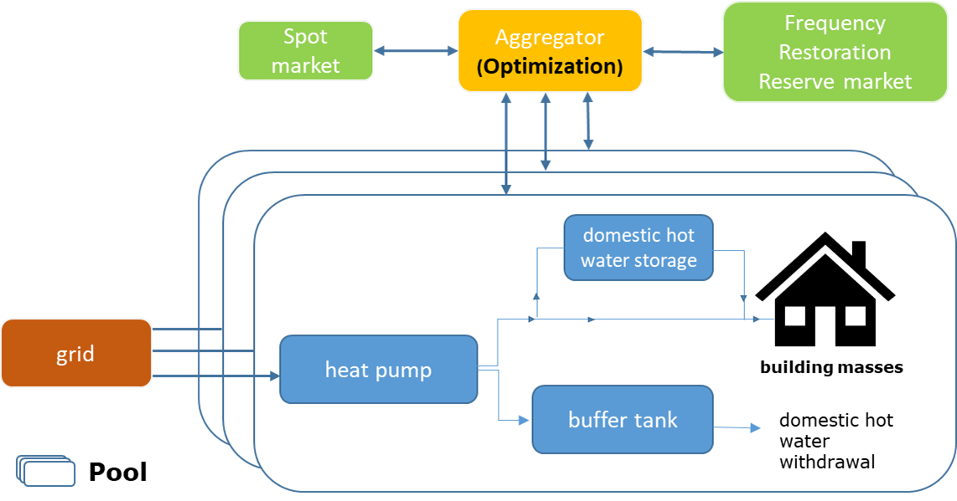
Figure 1Interaction of the different components
The optimization problem is solved by minimizing the total costs, using a mixed-integer-linear-programming algorithm. The savings will be transferred to the retail customers by discounted tariffs. The total costs are consisting of energy costs, grid costs and revenues of the frr-markets. If forecasts are deviating from the real behaviour, energy can be rebought hourly at the intraday market. Costs, which are arising from this circumstance, are also contributing to the final costs, but are not part of the optimization problem. The heat pump pool is able to offer positive as well as negative frr energy as 4h-products at the market. Positive frr is provided by cutting the heat pump load, negative frr is provided by increasing the power. To picture the trading strategies realistically, the optimizer can choose between a low-price-strategy at the beginning and a high-price-strategy at the end of the merit-order-list.
The optimization of the heat-pump-pool takes place in two stages. First, a calibration of the building model based on building monitoring data is done, followed by the creation of a schedule for the next day:
The building model is calibrated with measured data about solar irradiaton, outside temperature and heat supply of the building of the last two days. It’s based on a mathematical resistance-capacity model (RC), which is being displayed as state-space-model. Considering the temperatures of rooms and buildings, as well as their thermal capacities, the model is calibrated with the aim to fit the modelled thermal behaviour to the measured dataset of room temperatures. The resulting state space matrices serve as an input for the optimization model. Every building can additionally have a domestic hot water storage and another buffer tank for heating. The heat pump model is based on measured electrical and thermal power values, dependent of the pumps number of rounds per second, heat source temperatures and outside temperatures. The optimization of pools with a high amount of thermal components is nontrivial, as a result of the occuring nonlinearities. Solving the problem by partial linearization and binary variables can still lead to challenging calculation times. Therefore a linear coefficient of performance is proposed for the pool optimization, which is dependent on the different heat source and outside temperatures. Under the constraints, that certain comfort criteria mustn’t be violated, the optimizer finds a combined schedule of day-ahead and frr amounts under the goal of minimizing the costs. For intraday-rebuying there has to be reserved a certain power amount, so that all frr can actually be provided if needed.

Results
Goal of the optimization problem is to decrease the costs, compared to a conventional reference scenario, by participating in different markets. The reference scenario is modelled with a flat tarif, so that the building is just heated when the minimum temperature would be undercut. The final reference costs are determined by reevaluation of this schedule with fluctuating spot market prices. Figure 2 shows the savings for the different scenarios. Participation of the heat pump pool at the secondary reserve market allows up to 13% cost reduction, compared to the reference scenario. Tertiary reserve only enables low revenues, compared to the day-ahead market. The produced CO₂ amount can be reduced by 183 kg per component per year by even slightly lower costs, compared to the reference scenario. The comparison between the optimization of CO2 production and the cost minimization at the day-ahead market is shown in Figure 3. The height of revenues correlates strongly with the forecast quality. If the real values are differing a lot from the ones forecasted, more energy has to be rebought at the intraday market. In this work, perfect forecasts are used, except for the frr call probabilities. In the field operation, possible forecast errors of user behaviour have to be considered, as well as errors for weather and production forecasts. Moreover different coefficients of performance at different power levels can occur, which might increase the total load. Higher losses at higher storage temperatures could lead to the same effect. Therefore the end load for the consumer could be higher, although still at cheaper total costs. The right incentives have to be found for customers, in order for them to provide their flexibilities.
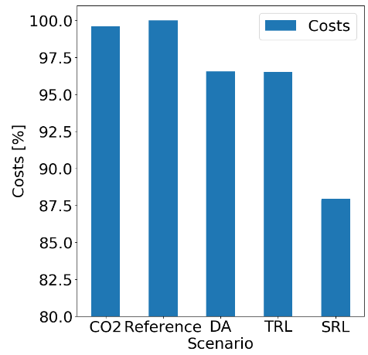  Figure 2 Costs of the different simulated scenarios in [%] | 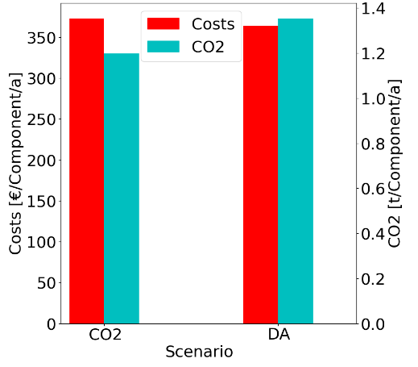  Figure 3 Comparison of CO₂ and costs, each for optimization of costs and opimization of CO₂-production

Conclusions
The algorithms which are used for the simulation, are planned to be implemented in the scope of the research project Flex+ within a real heat pump pool. The implementation will be done in a cloud solution and tested with a real pool. The heat pumps, provided by the company iDM², are already individually controllable. Besides a possible specification of a daily new schedule, they are able to react shortly to requests of the frr market. In a real test with a pool of 20 heat pumps, the real flexiblility potential of the heat pumps can be evaluated even better.

References
¹ www.Flexplus.at
² www.idm-energie.at

