A Comparison of Storage Modelling Methods

Kamaria Kuling, Simon Fraser University, 604-789-2946, kamaria_kuling@sfu.ca
Taco Niet, Simon Fraser University, 778-782-7183, taco_niet@sfu.ca

Overview
Recent works by Welsch et al. [1] and Niet [2] present two different approaches for incorporating storage into capacity expansion models. Recent studies have began to investigate the effect different storage formulations have on model results [3] [4] [5]. This paper will expand on that body of work by comparing storage equations formulated by Welsh et al. and Niet and examining their effect on model outputs and performance. This paper gives insight into when to use a particular method to model storage in an energy system as well as contributes a more rigorous examination of an energy system model’s sensitivity to different storage equations. Welsch et al. have formulated a storage equation that utilizes a pseudo-intra-day structure to increase temporal resolution but also makes this equation computationally more complex. An updated storage equation by Niet simplifies modelling storage by removing the pseudo-intra-day structure. We find that, when modelling long term storage such as a hydro dam, the version provided by Niet has no significant variation on the results from that of Welsch et al. while decreasing computation time. The savings in computation increases as more time slices are used to create a higher temporal resolution. Due to this, the equation by Niet is more well suited to energy systems with little intra-day variation. In contrast, the storage equation by Welsch et al. can accommodate long term models where intra-day variation may impact the results. As always, the method used should be carefully considered as to which equation’s strengths and weaknesess best fit a specific endeavour.

Methods
This work compares two equations for modelling storage within the OSeMOSYS Energy Modelling System [6] [7]. OSeMOSYS is an open-source modelling system widely used for energy planning and in academia. Welsch et al. implement storage for the OSeMOSYS system using a pseudo-intra-day structure, and using season types to define timeslices. This pseudo-intra-day structure allows a long term model to include considerations of the short-term dynamics of storage, with less complexity and computation time compared to increasing the number of time slices used to create a higher resolution model. The other storage equation, by Niet, uses sequential time slices to represent storage and does not create this pseudo-intra-day structure. The version by Niet also includes the option of implementing a storage refilling constraint rather than define a starting storage level. By comparing the operation, results, and computational efficiency of the two storage equations we can evaluate their relative strengths and weaknesses.

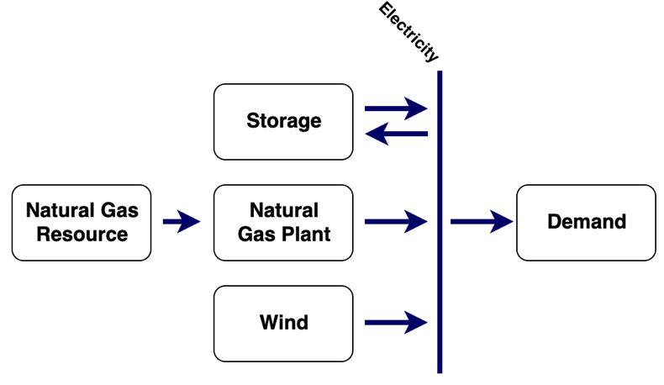
Two test energy systems are used to compare the operation of the two storage equations. First, we use a simple existing test case which includes storage as a hydro power plant fed with riverwater. This scenario allows for a comparison of how the two storage equations by Welsch et al. and Niet model a long term storage facility with little short term variation. As a further comparison, another case study was created to model an energy system that uses battery storage in which daily variation is more influential in the system and a higher temporal resolution is required (Figure 1).
Figure 1 - Diagram of energy system including battery storage used to compare effects of daily variation in storage modelling.

Choice of temporal resolution, or the number of timeslices used in one’s model, also has an impact on modelled storage operation. We examine the results for both storage equations for an increasing number of timeslices from 6 (two time slices per season with three seasons) to 8760 (hourly). Computation time is measured for each of these time slice variations to see how the time increases with the complexity of the model for both of the storage equations.

Results
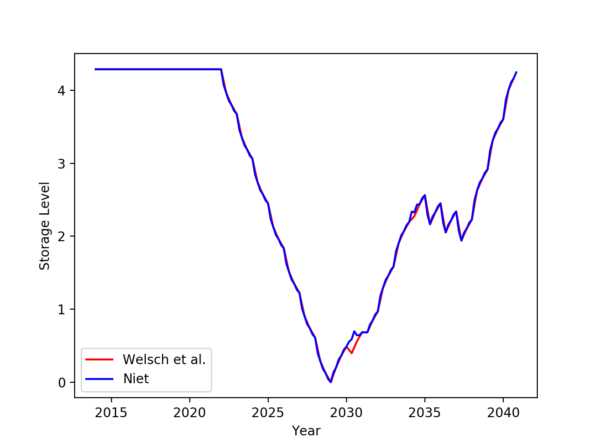
Figure 2 shows the storage level over a twenty-seven year time period, with storage being measured at each of the six time slices per year. When modelling for long term energy storage with no daily variation, both equations give very similar results for storage. There are two points in Figure 2 where the storage level differs for the two equations. This is due to technologies being swapped in at different times, but causes no net change in energy generation within a year, therefore these variations do not impact the operation of the model. The overall results, including cost and emissions for the system, are independent of which equation for storage is used.
Figure 2 - Comparison of storage level for different storage equations

The storage equation by Niet is computationally more efficient, perfmorning 4% more quickly than that of Welsh et al. when six timeslices are used, with the percentage increasing with the number of timeslices.

When modelling a system such as that shown in Figure 1, though the equation formulated by Niet remains computationally more efficient, the structure by Welsh et al. is able to more accurately model the daily variation in storage. By including the pseudo-intra-day structure, Welsh et al.’s equations can better capture the dynamics of the storage system.

Conclusions
This paper demonstrates that while the Welsch et al. storage equation can better model storage that requires consideration of daily variation, for a long-term storage system without intra-day variation this added resolution does not improve the operational aspect of storage. Niet simplifies the storage equation and increases computational efficiency. In choosing what storage equation is required for one’s model considerations will include the time scale and resolution required, as well as what type of storage is being modelled. While long term storage, such as hydro, might not require the pseudo-intra-day formulation, shorter term models that include battery technology are enhanced by the more detailed approach of Welsch et al.

References
[1] M. Welsch, M. Howells, M. Bazilian, J. DeCarolis, S. Hermann, and H. Rogner, “Modelling elements of Smart Grids - Enhancing the OSeMOSYS (Open Source Energy Modelling System) code,” Energy, vol. 46, Oct. 2012, doi: 10.1016/j.energy.2012.08.017.
[2] T. A. Niet, “Mitigating risk of emissions in energy planning and the operational implications,” Thesis, 2018.
[3] T. Niet, “Storage end effects: An evaluation of common storage modelling assumptions,” Journal of Energy Storage, vol. 27, p. 101050, Feb. 2020, doi: 10.1016/j.est.2019.101050.
[4] L. Kotzur, P. Markewitz, M. Robinius, and D. Stolten, “Time series aggregation for energy system design: Modeling seasonal storage,” Applied Energy, vol. 213, pp. 123–135, Mar. 2018, doi: 10.1016/j.apenergy.2018.01.023.
[5] J. English et al., “Flexibility requirements and electricity system planning: Assessing inter-regional coordination with large penetrations of variable renewable supplies,” Renewable Energy, vol. 145, pp. 2770–2782, Jan. 2020, doi: 10.1016/j.renene.2019.07.097.
[6] M. Howells et al., “OSeMOSYS: The Open Source Energy Modeling System: An introduction to its ethos, structure and development,” Energy Policy, vol. 39, no. 10, pp. 5850–5870, Oct. 2011, doi: 10.1016/j.enpol.2011.06.033.
[7] F. Gardumi, M. Welsch, M. Howells, and E. Colombo, “Representation of Balancing Options for Variable Renewables in Long-Term Energy System Models: An Application to OSeMOSYS,” Energies, vol. 12, no. 12, p. 2366, Jan. 2019, doi: 10.3390/en12122366.

