INFLUENCE OF HOUSEHOLD PROSUMAGE GROWTH ON UTILITY GENERATION AND STORAGE PORTOFLIOS IN WESTERN AUSTRALIA

Kelvin Say, University of Melbourne, +61 4-21996880, kelvin.say@unimelb.edu.au
Wolf-Peter Schill, DIW Berlin, +49 30 89789-675, wschill@diw.de
Michele John, Curtin University, +61 8-92661286, m.rosano@curtin.edu.au

Overview
Utilities are not the only benefactors from the falling costs of solar PV and battery energy storage system technologies. These falling costs also have the potential to encourage household investment in PV-battery prosumage, which are being driven by a different set of economic assumptions (i.e., electricity bill minimisation vs cost of dispatch). With household PV penetration already exceeding 27% (and growing) of all households in Western Australia’s South West Interconnected System (SWIS) island network, a greater understanding of the investment dynamics, at both the household- and utility-scales, is required to determine the extent that installed utility generation and storage portfolios are vulnerable to a growth of household PV-battery prosumage.
In this paper, we examine how changing retail Feed-in Tariffs (FiTs) and renewable energy shares influence household investments in PV battery capacity and its consequences on the cost-minimal utility generation and storage capacity in the year 2030. Comparing against the counterfactual, we determine the installed capacity and generation changes across various utility technologies and under different household prosumage growth scenarios.

Methods
We soft-coupled two open-source models to evaluate scenarios in the year 2030 within the SWIS island network. A techno-economic simulation model of household PV battery investment, Electroscape (Say et al. 2019), is used in which a set of heterogeneous households invest in additional PV and battery capacity to minimise electricity bills across a range of FiT values while retail market conditions change between 2019 and 2030. By using this set of households as representatives for the segment of customers investing in prosumage, we quantify the grid utilisation changes in 2030. These serve as inputs for the dispatch and investment optimisation model, DIETER (Zerrahn and Schill 2017), which determines cost-minimal utility generation and storage capacity while meeting different exogenous renewable energy targets. By comparing the results against a counterfactual scenario (i.e., without household prosumage), the effects of household prosumage on the overall system are separated. We analyse scenarios in 2030 with renewable energy shares constrained to 39%, 49% and 59% and with feed-in tariffs valued at 0%, 25% and 50% of the volumetric retail tariff. This modelling approach allows us to examine the system implications that arise from competing capacity investment objectives between prosumagers and utilities.
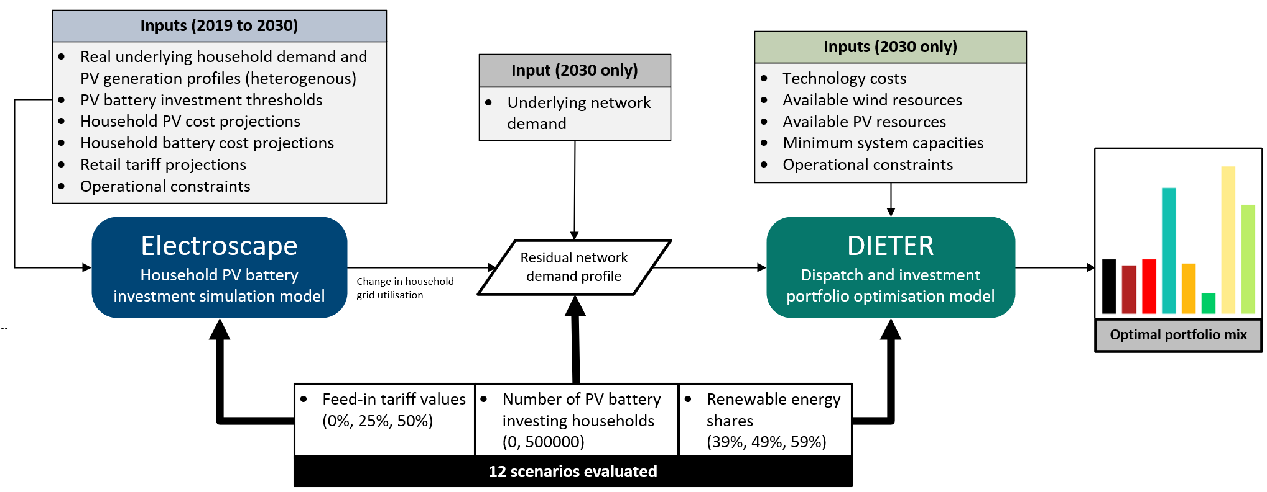
Figure 1: Model integration and overview

For transparency and reproducibility, the model code and data from both models are openly available under a permissive license.

Results
Figure 2 shows the changes in both installed capacity (nominal and energy) and generation across each of the FiT and renewable energy shares in 2030. Investments in household prosumage are strongly influenced by the FiT, where lowering the FIT increases the average battery capacity (0-8.7 kWh per household), while average household PV capacity remains consistent (4.7-5.3 kW_{P} per household) due to a 5 kW_{P} FiT eligibility limit. The widespread installation of household batteries changes the residual network demand by lowering the midday demand and evening peak, while still exporting surplus PV generation that cannot be stored. Utility PV is the most vulnerable to prosumage substitution, since its temporal dispatch competes directly against surplus household PV generation, leading to significant reductions in installed capacity across all scenarios. Wind capacity is also substituted but is less affected overall. Moreover, increasing the renewable energy share generally leads to additional wind capacity at the further expense of utility PV capacity. As household battery systems are designed to increase self-consumption rather than provide system benefits, the prosumage impact on utility battery storage results in an imperfect substitution. This is evident in the ‘PV-only FiT₅₀’ scenario that incentivises additional utility battery capacity. In the ‘PVB FiT₂₅’ and ‘PVB+ FiT₀’ scenarios that include a significant increase in household battery capacity, utility battery capacity is not significantly affected. There is also a minor coal enhancing effect from prosumage due to its substitution of wind capacity reducing the diurnal variation and granting additional full load hours to coal. A range of sensitivities are evaluated to determine the effects of our parameter assumptions. We find that reducing the cost of batteries raises average household battery capacities, resulting in further substitution of utility PV capacity. We find that increasing the number of prosumagers on the network strengthen the already observed effects.
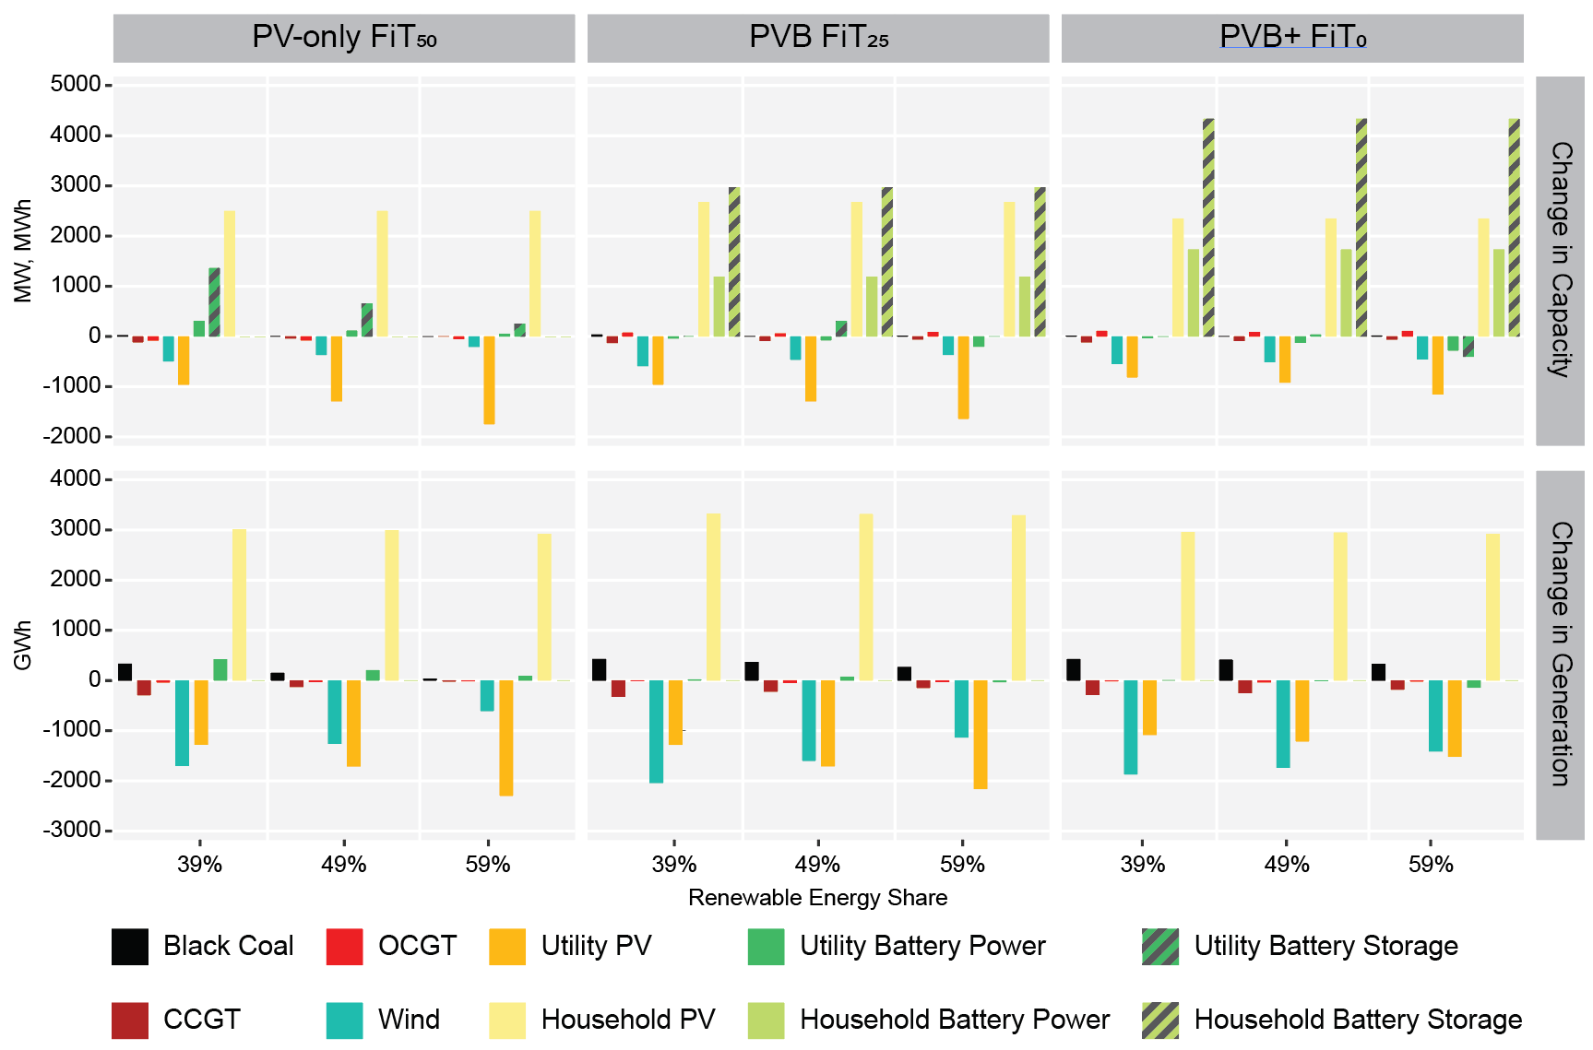
Figure 2: Changes in installed capacity and generation compared to counterfactual

Conclusions
Many utility portfolio studies do not consider the influence of prosumage, yet todays power systems are already having to manage their growing impact. As utility dispatch depends on customer load, grid utilisation changes from prosumage can have significant implications for future utility portfolios. Our analysis contributes to the research by quantifying the dynamics of household PV battery investment and their influence on the optimal utility portfolio. Our results indicate that utility PV is much more vulnerable to prosumage growth than wind, and that utility batteries are less affected by rising household battery adoption. Future research directions could examine new market mechanisms that alleviate these tensions that arise from the differing economic objectives between prosumagers and utilities, such that the benefits, costs and risks are more evenly shared.

References
Say, K., John, M. and Dargaville, R. (2019): Power to the people: Evolutionary market pressures from residential PV and battery investments in Australia. Energy Policy 134, 110977. https://doi.org/10.1016/j.enpol.2019.110977
Zerrahn, A. and W.-P. Schill (2017): Long-run power storage requirements for high shares of renewables: review and a new model. Renewable and Sustainable Energy Reviews 79, 1518-1534. https://doi.org/10.1016/j.rser.2016.11.098

