Battery-electric vehicles: customized bottom-up time series and their application in power system models

Carlos Gaete, German Institute for Economic Research (DIW Berlin), +49 30 89789-574, cgaete@diw.de
Wolf-Peter Schill, German Institute for Economic Research (DIW Berlin), +49 30 89789-675, wschill@diw.de
Alexander Zerrahn, German Institute for Economic Research (DIW Berlin), +49 30 89789-453, azerrahn@diw.de
Overview
In the coming years, the fleets of battery-electric vehicles (BEV) are expected to increase substantially around the globe. This will have multiple effects on the power system in terms of greater electricity demand, its temporal pattern as well a new potential flexibility resource. A growing literature aims to identify such effects of battery electric vehicles in future power systems from an economic and technical perspective, using simulation and optimization models. As a central input, research requires sound time series that represent electric vehicles, mostly in an hourly resolution. Specifically, these comprise (i) a BEV’s electricity consumption from the battery, (ii) a BEV’s grid availability and, optionally, (iii) a BEV’s grid electricity demand. Yet such data is scarce and, if it is available, specific to small regions and subject to data protection and privacy provisions.
The purpose of our paper is twofold. First, we develop the tool emobpy that creates battery-electric vehicle profiles from publicly available mobility statistics. Each profile consists of the three hourly time series – electricity consumption from the battery, grid availability, and grid electricity demand – for one year. Emobpy can be flexibly adjusted to accommodate data availability for different countries and researchers’ assumptions on mobility behavior. Code and input data are provided open source. Second, we generate BEV profiles for Germany to assess the effects of different charging rules on the electricity system. Specifically, we compare the effect of user-driven charging versus system-optimized charging on the total costs of the power system and integration of renewables in a mid-term future scenario with a large BEV uptake and ambitious renewables targets.
Methods
Central input data for emobpy are relative frequencies of the (i) shares of different driver types, for instance commuters or pensioners, (ii) number of trips per day, (iii) purpose of trips, and (iv) length of trips as well as (v) the their starting hours. Number, purpose, length, and starting hours are additionally often differentiated for driver types and weekdays. Ideally, the mobility data at hand feature joint frequencies for some combinations of the trip number, purpose, length, and starting hour. For instance, commuting trips are regularly shorter than free-time trips but longer than shopping trips. These data are regularly provided in mobility statistics for many countries. Additionally, the model requires data or assumptions on the power rating of charging stations at different generic locations. In general, own assumptions can replace missing input data or enable to design custom scenarios.
The model uses the fed-in frequencies as probabilities and generates a number of BEV profiles. Constraints make sure that trips are feasible with respect to battery size, charging availability, and the location of the vehicle. The central model output are the BEV profiles. In general, each profile of a BEV consist of three time series, usually in hourly step length over one year: (i) electricity consumption from the battery; (ii) grid availability rendering whether the vehicle is connected to the electricity grid; and (iii) grid electricity demand rendering the electricity demanded from the grid to charge the battery. Some models require such exogenous charging information while others determine the timing of charging endogenously.
For our application to Germany, we generate two hundred profiles as inputs for the open-source power system model DIETER. Three different charging options are evaluated. One system-optimized charging option that schedules the timing of charging endogenously according to minimize total power system costs and two user-centered charging options, immediate charging at full capacity at any charging point and at-home only charging. For each option, we exogenously vary the number BEVs in the system and enable or disable whether a vehicle can feed back electricity to the grid. All scenarios are applied to a mid-term projection of the German power system with 65% renewables in electricity demand.
Results
First results for system-optimized charging without flexibility provision through V2G show that increasing fleets of electric vehicles lead to a higher electricity demand and system costs. This increase is not linear when it comes to determine the additional system costs per vehicle (next page right figure), which are around 45 Euros in case of 5 million BEVs and 60 Euros in case of 10 million BEVs. This reflects the impact of an increasing demand that does not act as an additional source of flexibility.
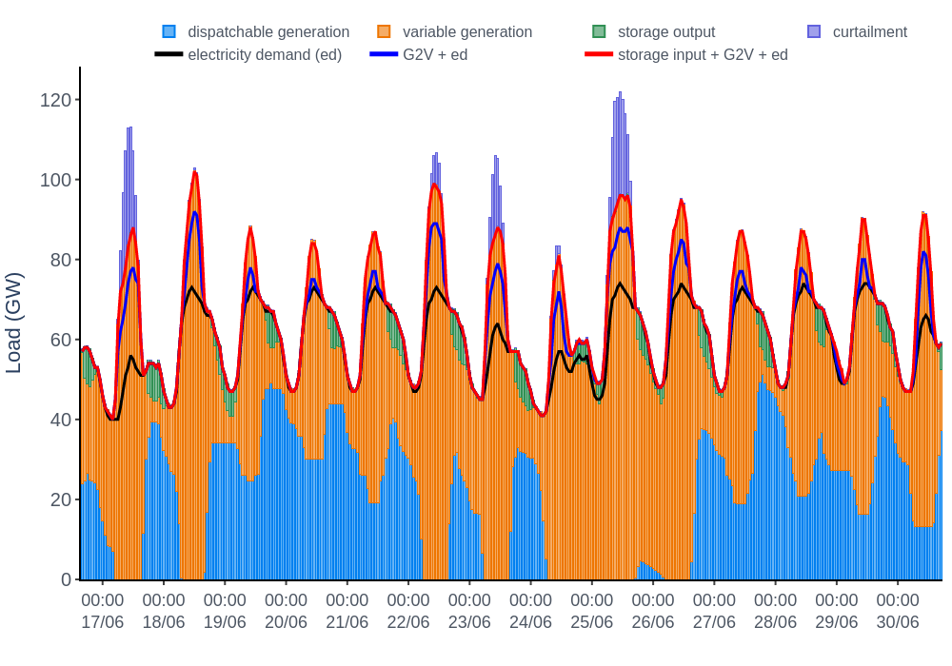
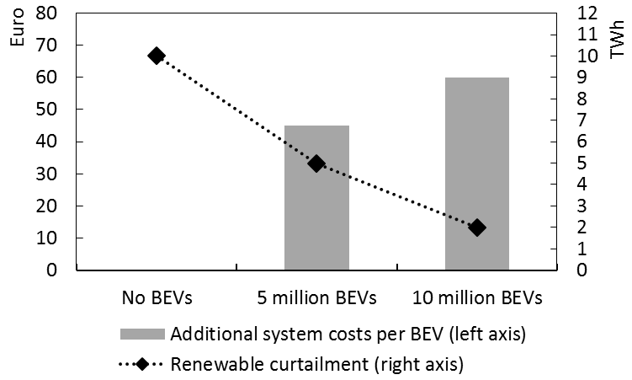
The charging decisions are driven by variable generation of renewables, mostly solar in summer and wind in winter. The right figure shows an exemplary dispatch plot for two weeks in summer for the case with 10 million BEVs. Thus, the system-optimized charging allows making use of low-variable-cost renewables when they are available. Accordingly, it also allows to reduce curtailment (below figure) leading to a slight increase of the effective capacity factor for renewables. The CO2 emissions per vehicle-km represent about 40% of fossil fuel combustion engine car [1] due to still high contribution of fossil fuel option for electricity generation.

Further results will systematically compare system-optimized versus user-centered charging according to different rules implemented in emobpy as well as the impact of system-optimized vehicle-to-grid. We aim to isolate the tradeoff between an increased electricity demand from BEVs and their potential flexibility benefit.
Conclusions
We present the open-source, python-based tool emobpy that flexibly generates battery-electric vehicle profiles comprising electricity consumption from the battery, grid availability, and, optionally, grid electricity demand. Emopby is based on mobility statistics and can be customized to different countries and researcher assumptions on future mobility. Our tool is provided to the research community open-source and may serve as a valuable input for future research.
In an application to Germany, we evaluate the impact of different charging options for 200 profiles generating using emobpy. First results show over-proportionately increasing costs to the electricity system of BEV penetration yet a better use of available renewable resources for mobility purposes. Further results finalized by the time of the conference will derive more insights on the role of system-optimized versus user-centered charging as well as vehicle-to-grid as a further flexibility options. Thus, we address the fundamental tradeoff between increased electricity demand from BEVs and their potential role as a flexibility option.
References
1. G Harrison, J Krause, C Thiel (2016). Transitions and Impacts of Passenger Car Powertrain Technologies in European Member States. Transportation Research Procedia. 14. p. 2620-2629. doi.org/10.1016/j.trpro.2016.05.418.

