***Planning electric vehicle charging infrastructure in a transitioning community***

Eric Hittinger, L2EP, Université de Lille, [eric.hittinger@univ-lille.fr](mailto:eric.hittinger@univ-lille.fr)

Alain Bouscayrol, L2EP, Université de Lille, [Alain.Bouscayrol@univ-lille.fr](mailto:Alain.Bouscayrol@univ-lille.fr)

Elodie Castex, TVES, Université de Lille, [elodie.castex@univ-lille.fr](mailto:elodie.castex@univ-lille.fr)

Anatole Desreveaux, L2EP, Université de Lille, [anatole.desreveaux@univ-lille.fr](mailto:anatole.desreveaux@univ-lille.fr)

## Overview

The transportation sector is the largest contributor to global greenhouse gases (GHG), exceeding even electricity system emissions in most developed countries [1]. The 2016 IEA report on Mobility indicates that rapid adoption of electrified vehicles (EVs) is essential to limit global warming to 2°C [2]. Political interest in EVs is also growing in specific communities: for example, the mayor of Paris has announced a plan to banish thermal vehicles by 2030 [3]. This transition requires more than just vehicles: a shift towards EVs involves new infrastructure in the form of charging points, new electricity generation, and transmission/storage to help manage the new demand patterns.

In this work, we consider the lowest-NPV charging infrastructure plan for a university campus that expects an ongoing shift towards EVs and wants to supply zero-carbon charging for EVs as a way to manage the University’s Scope III emissions. We study what infrastructure the university would want to build and when, given factors like project economy of scale (suggesting larger projects), cost declines in most technologies (suggesting delaying deployment), and uncertainty in EV adoption (suggesting minimization of committed project costs). Results suggest that the economic balance between these factors calls for large expansion projects every 5-15 years, with each new expansion of a larger scale than the previous one, and a tendency to delay projects to improve NPV. While this analysis was focused on a university campus, the same challenges apply to cities or nations converting to EV fleets and suggests that “lumpy” infrastructure additions may be a logical response in the transition to EVs.

## Methods

The techno-economic model used in this research is divided into three levels. Conceptually, this design is similar to capacity expansion models of electricity grids that attempt to minimize discounted costs of an electricity system over some time horizon, given expected demand patterns. A lower-level operational dispatch model tracks the hourly demand and supply of energy between electric vehicles and stationary charging infrastructure. It uses technical characteristics of EVs, solar, storage, and charging points to determine the ultimate energy sources for EVs. An economic model makes up a central layer, calculating Net Present Cost (NPC) of building and operating a proposed charging system. As inputs, it uses infrastructure plans (from the high-level investment model) and runs the dispatch model many times. At the highest-level is an investment model, which searches for charging infrastructure plans that minimize Net Present Cost (NPC) to the system operator while meeting user demands. It runs the economic model many different times with different plans for infrastructure in an attempt to find plans that have lower long-term costs.

Charging of EVs is tracked through an hourly dispatch-style model (Figure 1), which includes arrival and departure times of vehicles, state-of-charge of each EV battery, local solar production, grid purchases of zero-carbon energy, and allows local solar energy to be routed separately to different categories of vehicles (high-priority versus low-priority vehicles). Net Present Cost of building and operating a system is calculated using projections of future prices (for solar, stationary batteries, and charging points), economies of scale for all three technologies, and a fixed-cost alternative for zero-carbon electricity from the grid. An iterative optimization routine is used to identify the “buildout plan” with lowest NPC of the charging system over a 20-year window.

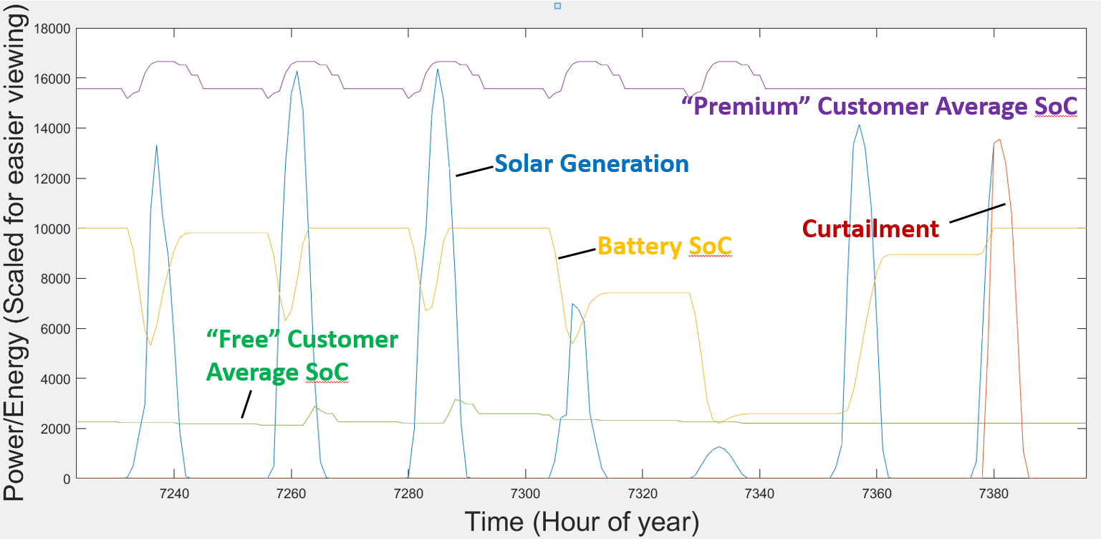

Figure 1: Example week of operation of the energy dispatch model. Solar generation varies each day, but can supported by stationary storage (Battery SoC (state of charge)). The state of charge (SoC) of vehicles are divided into two groups with different priority for charging (Premium and Free). During the weekend (right side), solar is first used to charge the stationary storage and is then curtailed. This dispatch model is used by a higher-level economic model to study the cost and performance of different system designs.

## Results

The NPC-minimizing buildout plans identified in the model have several important properties that are consistent across scenarios. First, while adoption of EVs is generally continuous, cost-minimizing buildout of infrastructure is “lumpy”, occurring in larger blocks that appear every 5-15 years (depending on cost and growth scenarios). This is because of the project economy of scale – it is cheaper, even after discounting, to build 100 kW of solar today than to build 20 kW/yr for 5 years. Second, delaying construction allows you to build a bigger (because of increased demand in the future) and cheaper (because of cost declines and economy of scale) project. This drives the model to delay building when possible, preferring to buy relatively expensive zero-carbon energy from the grid for several years in order to improve the NPV of a specific project by delaying and expanding it.



Figure 2: Installed chargers, solar, and battery over the 20 year planning horizon, in a scenario with annual 12% growth in EVs. No battery is built and chargers/solar are built at infrequent intervals.

## Conclusions

While this work fills a research gap on optimal design of local charging systems when demand is expected to grow over time, it also has some general lessons for larger-scale transitions towards electric vehicle infrastructure. This work suggests that big infrastructure projects that overbuild today and allow demand to catch up over years may be economically efficient. However, when it is possible to delay construction (because of some alternative), “strategic delay” makes sense because building the project today may pre-empt an even larger (and more cost effective) project in the future. This is a type of options value and represents a logical reason not to build positive-NPV projects today, and is relevant to the observed rate of investment in emerging clean technologies.

## References

|  |
| --- |
| [1] World Bank, “CO2 emissions from transport (% of total fuel combustion),” 2014. [Online]. Available: https://data.worldbank.org/indicator/EN.CO2.TRAN.ZS?locations=FR. [Accessed October 2017]. |
| [2] International Energy Agency, “Global EV outlook 2016: beyond one million electric cars,” 2016. [Accessed October 2017] [Online]. Available: https://www.iea.org/publications/freepublications/publication/Global_EV_Outlook_2016.pdf.. |
| [3] B. Love, “Paris plans to banish all but electric cars by 2030,” 12 October 2017. [Online]. Available: https://www.reuters.com/article/us-france-paris-autos/paris-plans-to-banish-all-but-electric-cars-by-2030-idUSKBN1CH0SI. [Accessed October 2017]. |