The relevance of national markets for the development of new industries in the energy sector
Marlene O’Sullivan, Department of Energy Systems Analysis, Institute of Networked Energy Systems, German Aerospace Center (DLR), Curiestr. 4, 70563 Stuttgart, Germany, phone: +49-711-6862-667, marlene.osullivan@dlr.de

Overview
In order to meet the goals of the Paris Climate agreement, the energy system in each country has to undergo a rapid transition process. Among many other challenges, this transition to low-carbon technologies poses a threat to existing industries providing energy technologies. Sales of established energy technologies will decline, while the market for new energy technologies is not yet mature. This represents both a challenge for the market position of countries in the global energy system and an opportunity to achieve a stronger and more sustainable market position for the future. Overall, this situation provides a strong motivation for political decisions regarding the energy system in each country.
This article takes a look at the development of the photovoltaic (PV) and onshore wind industries to gain a better understanding of the role of national markets in the development of new industries in the energy sector. These two industries are particularly interesting as their development is already relatively advanced. Therefore, empirical data could be used to investigate the influence of global as well as national market developments on companies.

Methods
The analysis presented here is mainly based on the industry life cycle theory (ILC) [1]. It describes the development of certain indicators over time, such as the creation of technological innovation, market trends and the number of companies active in a market. It outlines the dynamics in the various phases of industry developments. Overall, it shows that a large number of companies typically emerge both during an exploratory phase and in the early growth phase of an ILC. The market shakeout takes place in the second part of the growth phase, once the dominant design has been established. Company consolidation continues in the phase of maturity when market demand slows down and finally stabilizes.
Market demand in the ILC theory is usually driven by innovation that creates demand for a new good or service. However, this is not the case for most technologies relevant for the energy transition. As these new technologies often do not provide any new or advanced service to the customer, they do not create any new demand but aim to replace established technologies. This poses the challenge that new technologies are in direct competition with the price level of mature technologies. In most cases, they are not capable of doing so as they have not yet reached their optimum technological and economic performance. It is, therefore, necessary to support the market diffusion of new energy technologies with policy instruments until they have reached competitiveness [2]. Overall, it can be assumed that political instruments influence the market development of new energy technologies.
The empirical data used in this analysis focuses on a data collection of wind turbine manufacturers and solar cell manufacturers over time as well as the market development of photovoltaic systems and onshore wind turbines. The data has a global scope, but can also be used to study individual countries. Whenever possible, it goes back to the 1970s, when the oil crises triggered the development of renewable energy technologies. The data is analyzed using descriptive statistical methods.
With regard to the creation of technological innovations, this study builds on the findings of a global patent analysis [3].

Results
The analysis of the evolution of the photovoltaic and onshore wind industry shows many differences in the development of these two industries. Both have in common that the creation of a national demand has been a driver for the creation of companies in a country. However, national markets have had a much more significant influence on the overall development of the wind energy sector.
Figure 1 indicates that company shakeout phases have occurred at several points in time in the development of the global wind onshore industry. These shakeout phases could only partly be explained by the global market development. Therefore, the national developments were examined in greater detail. The results of this analysis show that the global evolution of the global wind industry is characterized by a number of national industry developments. The development of national wind industries followed the path described by the original ILC theory when stable framework conditions resulted in relatively stable market developments. Other national markets, which did not have the same reliability in the political framework conditions, experienced a very changeable demand for wind turbines. A sharp decline in these markets had the direct consequence that national wind turbine manufacturers experienced a market shakeout. Although most of these markets experienced another substantial increase in demand for wind turbines at a later point in time, no further significant development of new national companies could be observed. Another result of the analysis of the wind industry is the dominant role of a few companies in countries with a national industry. A more competitive market was found in countries without a national industry.
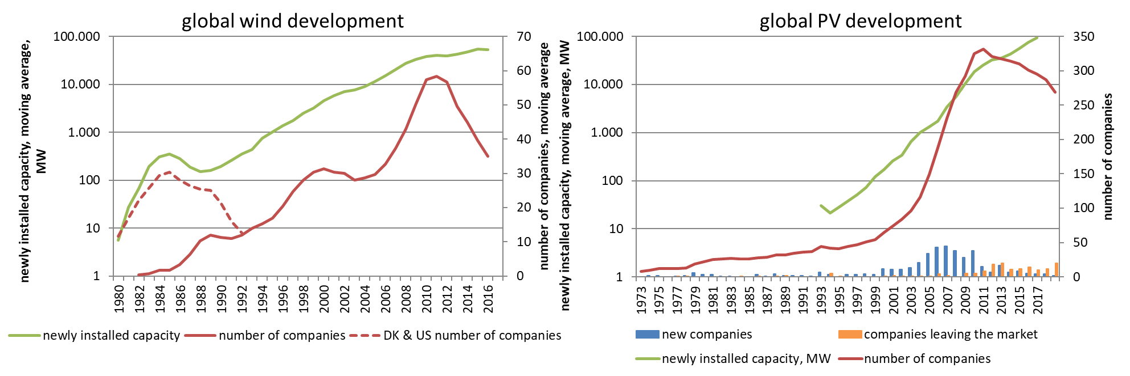
Figure 1: Global development in onshore wind and PV cells
Regarding the evolution of the PV cell industry, the statistical analysis of the global market development shows excelent explanatory values. Overall, the global development of the companies that produce solar cells follows the original ILC theory. Since 2011 the number of companies active on the global market has been decreasing as global market growth slows down (see Figure 1). The statistical analysis of the national market dynamics does not show the same explanatory value for the development of the national market participants as the global market evolution. The only country where national market developments show slightly better results in explaining the growth phase of its industry is Germany. However, it should be noted here that the German market dominated the global market development in this phase with shares of up to 66%. Another country that has developed a comparable significance as a single market in the global PV market is China. Here the statistical explanatory value of the national market is almost equal to the global market development. The overall development of PV cell manufacturers is still not done. Even today, there are still new companies founded that pick up on the latest developments in cell technology.

Conclusions
Political decisions regarding the support of new technologies in the energy sector have a direct influence on the initial creation of companies. However, the development of industries providing energy technologies is not clearly dependent on a particular market. In the case of wind turbine manufacturers, the domestic market seems to play a decisive role in the survival of the companies. For PV cell manufacturers, however, the development of the global market is of greater relevance.
The research carried out in the context of this paper does not provide insights into why the role of national markets for these two technological sectors is so different. However, there are most likely a number of reasons that play a role. One reason could be the different investor structures; another might be trade structures and transport. Further research is needed to gain a better understanding of this issue.

References (Optional)
[1] Klepper, S. (1997): Industry Life Cycles. In: Industrial and Corporate Change, 6 (1), pp. 145–182.
[2] Menanteau, P., Finon, D. and Lamy, M.-L. (2003): Prices versus quantities: choosing policies for promoting the development of renewable energy. Energy Policy 31 (2003), 799-812.
[3] Huenteler, J., Schmidt, T. S., Ossenbrink, J. and Hoffmann, V. H. (2016): Technology life-cycles in the energy sector — Technological characteristics and the role of deployment for innovation. In: Technological Forecasting and Social Change, Volume 104, 2016.

