Overview

COGNITION, ENERGY LITERACY AND THE CLASS VALUATION EFFECT FOR ENERGY LABELS
Shutong He, Vrije Universiteit Amsterdam, +31-20-59 88690, shutong.he@vu.nl
Julia Blasch, Vrije Universiteit Amsterdam, +31-20-59 89546, julia.blasch@vu.nl
Pieter van Beukering, Vrije Universiteit Amsterdam, +31-20-59 89524, pieter.van.beukering@vu.nl
Junfeng Wang, Nankai University, +86 138-0200-8065, jfwangnk@126.com

Categorical energy labels with grade-like efficiency ratings are widely used. However, representing energy efficiency information with limited categories has been found to induce heuristic decision-making, i.e., consumers value the efficiency class per se while ignoring the more precise difference in energy use, which is also known as the “class valuation effect” (Schubert and Stadelmann, 2015; Andor et al., 2019; Andor et al., 2020). This effect has been found to be especially pronounced among those with a low level of cognitive reflection (Andor et al., 2019). Alternatively, energy labels with continuous rating-scales include more detailed information and are more suggestive for comparison, thus could stimulate more conscious and rational energy-related decisions (Schuber and Stadelmann, 2015; Egan, 2000). However, the effectiveness of the continuous-scale label has not been formally examined yet.

For an energy label to be effective, it is essential that consumers understand and process the information well. The continuous and categorical visualisation of the energy-efficiency rating on energy labels is intrinsically related to the concepts of holistic versus analytic cognitive style. This study therefore accounts for interpersonal and cross-country differences in holistic cognitive tendency (Chiu 1972; Choi et al., 2003; Ji et al., 2000; Masuda and Nisbett; 2001; Norenzayan and Smith, 2002) when studying the processing of information on energy labels, which adds to the understanding of the role of cognition in energy-related choices (Andor et al., 2019; Blasch et al., 2019). Besides, the effectiveness of an energy label also depends on whether individuals have the knowledge to understand and utilise information and if they hold values and norms towards energy-saving (Thøgersen, 2000). Therefore, this study systematically measures and examines the influence of energy literacy on decision-making by following the multifaceted energy literacy concept (DeWaters and Powers, 2011; van den Broek, 2019).

Overall, this study addresses the following issues (1) whether the continuous-scale label, as opposed to the categorical label, can support rational decision-making and decrease the use of heuristics, (2) the role of cognitive styles and energy literacy for the processing of information on energy labels, and (3) the differences in the effectiveness of the labels across countries.

Methods
Our analysis is based on a household survey including a decision task with randomized information treatments (between subjects-design). In the decision task, participants were randomly assigned to either a categorical label treatment or a continuous-scale label treatment (Figure 1). Respondents were asked to identify the refrigerator that minimises lifetime cost, among two otherwise identical models, based on the energy-related information communicated on the energy label and the cost information. Each participant was asked to make decisions in three different situations. In situation B, where energy efficiency levels of the two models were close but belonged into different classes, we expected the categorical label to trigger decision-making heuristics, whereas the continuous-scale label could support a more rational decision. The decision task was embedded in a survey questionnaire eliciting individual-level characteristics such as socio-demographic information, energy literacy (including knowledge, attitude, behaviour), holistic cognitive tendency, and reasons of making the decision.
Data are collected in the Netherlands and China, two countries representing the analytical-focal Western and the holistic-contextual Asian cognitive style. The survey questionnaires were administered via Qualtrics with the sampling being done by two professional survey companies. 994 and 1041 valid questionnaires were collected from the Dutch and Chinese respondents, respectively. Both samples are representative for the general urban population in terms of gender and age, yet less representative with respect to education and income, where we observe a slight tendency towards higher education and higher income groups.

Results
Random effects probit models are used to analyse the data. Below we present the average partial effects of the independent variables separately for the Chinese and Dutch samples. Overall, indicating energy efficiency with a continuous scale does not significantly increase the likelihood of correct identification in either the Chinese or the Dutch sample, with p-values of 0.209 and 0.188, respectively. We include an interaction between continuous-scale label treatment and situation B to test whether the effectiveness of the continuous scale is dependent on the type of decision situation ﻿(Figure 2). We do not observe a significant interaction effect in the Chinese sample. However, for the Dutch sample, a continuous-scale label significantly increases the probability to identify the cost-minimising refrigerator by 11.6 percentage points (p < 0.001) - in situation B, while not showing a significant impact in situations A and C.

Based on the theory about analytic vs. holistic cognitive style, we expected that people with a holistic rather than analytical cognitive style process the information provided on a continuous-scale label more effectively. Results for the Dutch sample suggest that, as an individual’s holistic cognitive tendency increases from 0.65 to 1, the continuous-scale label increases the probability of correct identification by 2.9 to 9.1 percentage points. However, no significant interaction effect was found in the Chinese sample ﻿(Figure 3). Additionally, possessing energy-related knowledge related to daily life increases the probability of rational decisions in both countries. However, especially for the Chinese sample, having positive attitudes toward energy-saving and having installed energy-saving devices at home decrease the correct identification.

Conclusions
This study critically evaluated the use of categorical rating-scales on energy labels in the EU and China. Our findings suggest that energy labels indicating the efficiency level of an appliance in efficiency categories, on average, tend to undermine rational decision-making of consumers. In certain situations, a continuous-scale label can correct for the “class valuation effect” (Andor et al., 2019; Andor et al., 2020). Further, our study demonstrates that a holistic cognitive style can influence the effectiveness of visual information, which is a valuable insight to consider for the design of energy labels across countries dominated by different cognitive styles.

References
﻿﻿Andor, M. A., Frondel, M., Gerster, A., and Sommer, S. (2019). Cognitive reflection and the valuation of energy efficiency. Energy Economics, 84:104527.
Andor, M. A., Gerster, A., and Sommer, S. (2020). Consumer inattention, heuristic thinking and the role of energy labels. The Energy Journal, 41(1).
﻿Blasch, J., Filippini, M., and Kumar, N. (2019). Boundedly rational consumers, energy and investment literacy, and the display of information on household appliances. Resource and Energy Economics, 56:39–58.
﻿Chiu, L.-H. (1972). A cross-cultural comparison of cognitive styles in chinese and american children. International Journal of Psychology, 7(4):235–242.
﻿Choi, I., Dalal, R., Kim-Prieto, C., and Park, H. (2003). Culture and judgement of causal relevance. Journal of Personality and Social Psychology, 84(1):46–59.
﻿DeWaters, J. E. and Powers, S. E. (2011). Energy literacy of secondary students in new york state (USA): A measure of knowledge, affect, and behavior. Energy Policy, 39(3):1699–1710.
﻿Egan, C. (2000). An evaluation of the Federal Trade Commission’s EnergyGuide appliance label: An interim summary of findings. Available at https://www.aceee.org/research-report/a003.
﻿Ji, L.-J., Peng, K., and Nisbett, R. E. (2000). Culture, control, and perception of relationships in the environment. Journal of Personality and Social Psychology, 78(5):943–955.
﻿Masuda, T. and Nisbett, R. E. (2001). Attending holistically versus analytically: Comparing the context sensitivity of japanese and americans. Journal of Personality and Social Psychology, 81(5):922–934.
﻿Norenzayan, A., Smith, E. E., Kim, B. J., and Nisbett, R. E. (2002). Cultural preferences for formal versus intuitive reasoning. Cognitive Science, 26(5):653–684.
Schubert, R. and Stadelmann, M. (2015). Energy-using durables - why consumers refrain from economically optimal choices. Frontiers in Energy Research, 3.
﻿Thøgersen, J. (2000). Psychological determinants of paying attention to eco-labels in purchase decisions: Model development and multinational validation. Journal of Consumer Policy, 23(3):285–313.
﻿van den Broek, K. L. (2019). Household energy literacy: A critical review and a conceptual typology. Energy Research & Social Science, 57:101256.

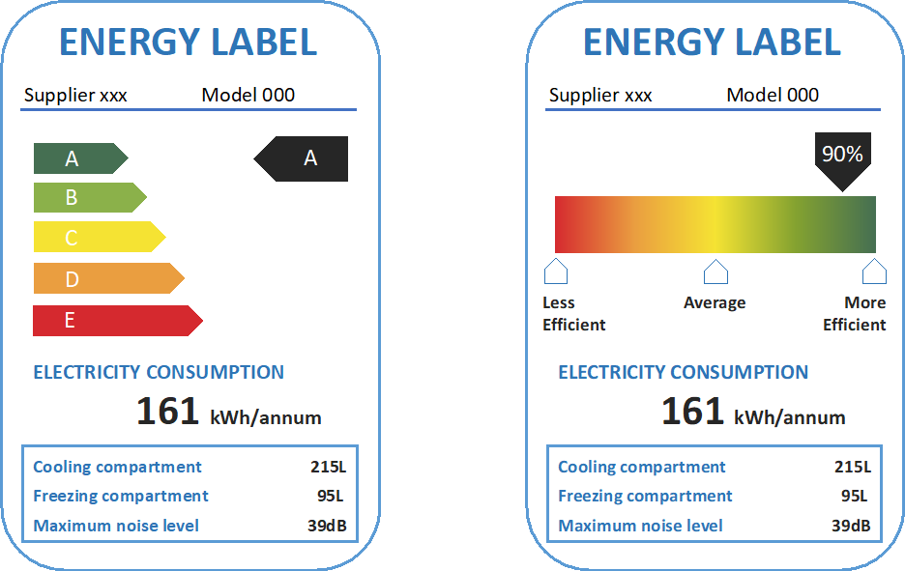
Figure 1. Examples of categorical and continuous-scale label

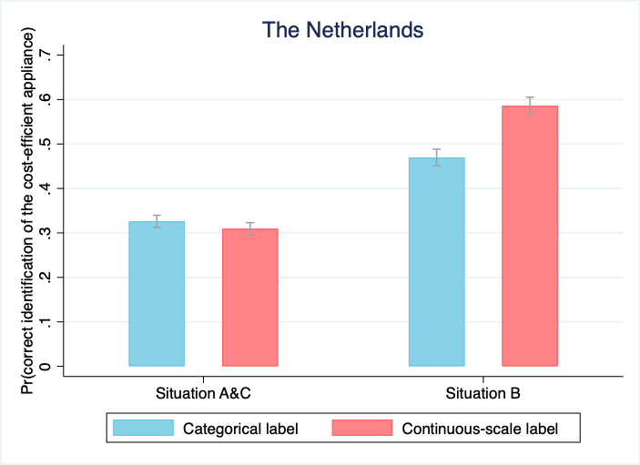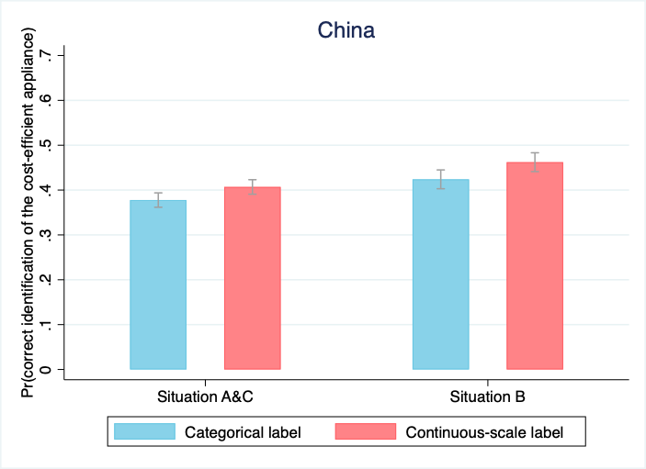
Figure 2. Interaction effect between label treatment and situations

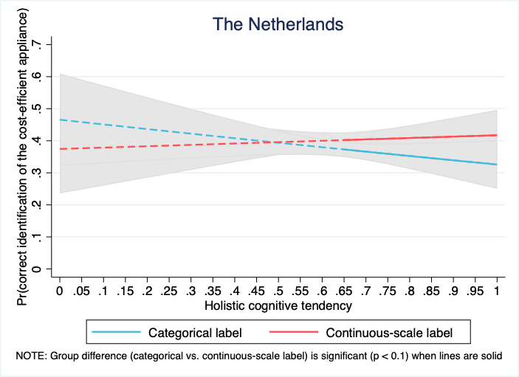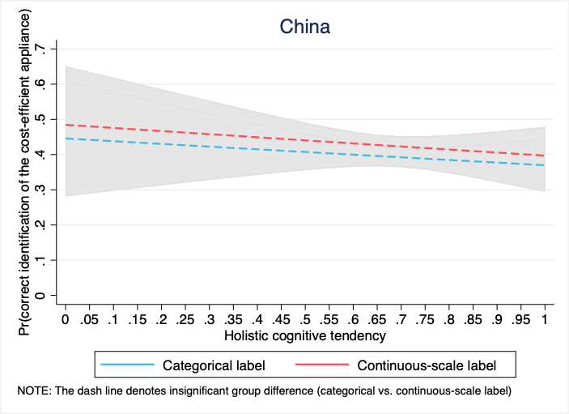
Figure 3. Interaction effect between label treatment and holistic cognitive tendency

