Carbon Fuel Sources and Electricity Prices in Europe: Why U.S. Energy MARKET POLICIES Matter

Atle Oglend, University of Stavanger, Department of Industrial Economics and Risk Management, NO-4036,Stavanger, Norway, +47 51832247, atle.oglend@uis.no

Petter Osmundsen, University of Stavanger, Department of Industrial Economics and Risk Management, NO-4036, Stavanger, Norway, +47 51831568, petter.osmundsens@uis.no

Overview

The largely unexpected boom in U.S. unconventional oil and natural gas production is arguably one of the most important energy market events in recent decades. It has led to a large glut in domestic U.S. natural gas availability, and U.S. natural gas price decoupling from crude oil (Erdős, 2012, Oglend et al, 2015). However, because of regulatory and export capacity constraints, the effects of the shock have up to recently been largely localized to the U.S. market. It is difficult to identify much impact on European natural gas prices, which maintained a stable high level during the earlier period of the shale gas boom (2009-2014).

In this paper, we document another important and policy relevant channel by which the recent U.S. energy market conditions indirectly have affected European energy markets. We argue that cheaper U.S. natural gas led to cheaper electricity in Europe because of cheaper imported coal. Natural gas and coal are substitutes in electricity generation. Cheaper U.S. natural gas led to lower demand for coal in domestic U.S. electricity production. This kept down the price of U.S. coal. Since Europe is one of the main export market for U.S. coal (second behind India in 2018, https://www.eia.gov/tools/faqs/faq.php?id=66&t=2), it led to cheaper coal in Europe. With coal remaining a marginal supplier of electricity in Europe, this led to lower electricity prices.

We make this case empirically. First, by using conventional time-series analysis we show that the Nord-Pool electricity price trend from 2008 to 2019 was influenced by the trend in the North-West Europe (NWE) coal price, consistent with previous studies in Europe (Frydenberg et al, 2014) and the U.S. (Mohammadi, 2009). The analysis controls for the expansion in renewables generation in the period and the impact of other carbon fuel sources (U.K. natural gas and Brent crude oil). As in Lion (2018), expansion in renewables capacity is also shown to have been important for low Nord-Pool electricity prices in the period. We document that the trend in the NWE coal price was strongly influenced by the unique U.S. natural gas price trend from the domestic impact of the shale gas revolution. We instrument the NWE coal price trend by the (weakly exogenous) U.S. natural gas price and show that the glut in the U.S. natural gas market has significantly reduced Nord-Pool electricity prices in the period.

Our findings are important to better understand the implications of U.S. energy market conditions and policies on European energy markets. Clearly, the economic profitability of continued renewables expansion in Europe depends on electricity prices, which we show depends on U.S. energy market policies with regards to coal and unconventional oil and natural gas, at least as long as coal remains a marginal supplier of electricity in Europe.

Methods

The analysis relies on conventional methods of analysing non-stationary time series. To investigate Granger non-causality between electricity prices and carbon fuel sources (coal, crude oil and natural gas) we apply the Toda and Yamamoto method that is robust to the order of integration of the price. We also test long and short run Granger non-causality using cointegrated vector error correction models when relevant.

To investigate the dynamics of the electricity and coal price we estimate conditional models using Autoregressive Distributed Lag Models (ARDL) that adjust for instantaneous endogeneity and allow testing for significant level relationships when the order of integration of the regressors are unknown (Pesaran and Shin,1998). The estimated ARDL models are used to evaluate the impacts of shock to carbon fuels source prices and renewable generation.

Results

We investigate weekly prices of electricity (day-ahead price system price of electricity in the Nord-Pool integrated electricity market for Northern Europe), Crude Oil (Brent spot), Coal (North-West Europe Front Month Forward), Natural Gas (NBP ICE day ahead price), from January 2008 to May 2019. All prices are expressed in USD/MWh, where we apply average power generation efficiency rates to convert crude oil, coal and natural gas prices to MWh. From 2013 we also use data on Nord-Pool wind power generation and hydropower reserves to control for impacts of renewables expansion on electricity prices.

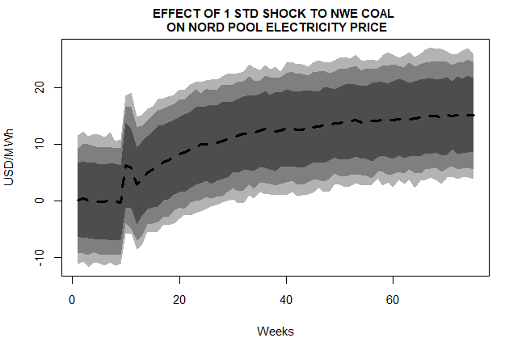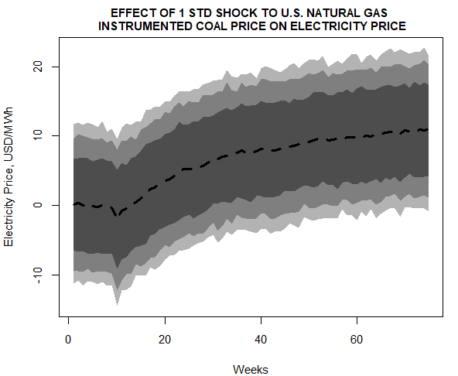
FIGURE 1. Left diagram shows the impact of a positive one standard-deviation shock to the North-West Coal price on the Nord-Pool electricity price. Right shows the impact of a one standard deviation shock to the U.S. natural gas price instrumented coal price on the Nord-Pool electricity price.
Nord Pool Wind Power generation (in 10 000 MWh) on the electricity price.

Figure 1, left diagram shows the effect of a one standard deviation shock to the NWE coal price on the Nord-Pool electricity price as estimated by the ARDL model. Results suggest that cheaper coal in combination with higher wind power production has contributed approximately equally to the low electricity price in the sample period. The right panel shows the same impact but with the NWE coal price instrumented by the U.S. natural gas price. The U.S. natural gas price decoupled from the crude oil price in around 2009. The low natural gas price determines the trend in the NWE coal price, contributing to lower Nord-Pool electricity prices.

Conclusions

We have document a channel by which U.S. unconventional natural gas production affects European energy markets. Cheaper U.S. natural gas has led to lower demand for coal in electricity production, leading to cheaper U.S. coal. North-West Europe is one of the main export markets for U.S. coal. Consequently, coal has been cheaper in Europe due to the shale gas boom. Since coal is a marginal supplier of electricity in Europe, this has contributed to cheaper electricity in Europe. This has strong implications for renewables policies in Europe and its relationship to U.S. energy market policies.

References
Erdős, P., 2012. Have oil and gas prices got separated?. Energy Policy, 49, pp.707-718.
Frydenberg, Stein, Joseph I. Onochie, Sjur Westgaard, Nora Midtsund, and Hanna Ueland. 2014. "Long‐term relationships between electricity and oil, gas and coal future prices—evidence from Nordic countries, Continental Europe and the United Kingdom." OPEC Energy Review 38, no. 2: 216-242.
Hirth, Lion. 2018. "What Caused the Drop in European Electricity Prices? A Factor Decomposition Analysis." Energy Journal 39, no. 1.
Mohammadi, Hassan. 2009. "Electricity prices and fuel costs: Long-run relations and short-run dynamics." Energy Economics 31, no. 3: 503-509.
Oglend, Atle, Morten E. Lindbäck, and Petter Osmundsen. 2015. "Shale gas boom affecting the relationship between LPG and oil prices." The Energy Journal : 265-286.
Pesaran, M. Hashem, and Yongcheol Shin. 1998. "An autoregressive distributed-lag modelling approach to cointegration analysis." Econometric Society Monographs 31: 371-413.

