Prosumage of solar electricity: tariFF design, capacity investments, and power system eﬀects

[Claudia Günther, Auroa Energy Research, claudia.guenther@posteo.de]
[Wolf-Peter Schill, DIW Berlin, +49 30 89789 675, wschill@diw.de]
[Alexander Zerrahn, DIW Berlin, +49 30 89789 453, azerrahn@diw.de]

Overview
The global energy transition towards decarbonization enhances the role of distributed renewable electricity generation. As small-scale renewable energy sources become more economical, battery-enhanced self-generation of photovoltaic electricity becomes more attractive – in the context of the residential sector referred to as prosumage. Whether households engage in prosumage and in which way, crucially depends on the regulatory framework.
We investigate how the design of retail and feed-in tariﬀs (FIT) aﬀects household decisions to invest in PV and battery storage systems. We also explore impacts on the power sector in terms of renewable energy capacities, peak PV feed-in, and the contribution of households to non-energy power system costs, that is, costs for renewable support schemes or the electricity grid infrastructure.

Methods
To put some structure on a household’s incentives for self-generation, we first devise a qualitative discussion of drivers for or against prosumage, based on the current German regulatory framework. To this end, we provide the intuition how household incentives are shaped by retail tariﬀs, feed-in tariﬀs, and respective investment cost for PV and batteries. This discussion also inspires the scenarios for our quantitative analysis.

For the quantitative analysis, we explore household incentives and their eﬀects in a computational equilibrium model applied to a German 2030 setting. We devise a numerical mixed complementarity problem (MCP), derived from the established numerical electricity sector model DIETER. The model has two agents: an aggregated household agent and a market agent. In equilibrium, either agent has an optimal consumption, generation, and investment schedule, taking the actions of the other agent into account.

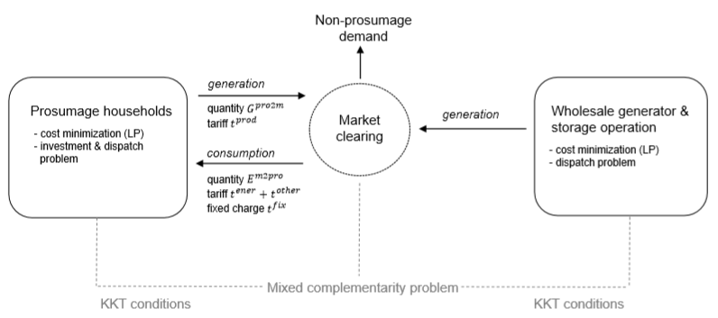

Figure 1: Setup of the equilibrium model

The household agent minimizes her total annual electricity costs by trading off market electricity consumption, self-consumption, and selling electricity to the market. She decides on investments into rooftop PV and battery storage capacity as well as their hourly use. Market electricity consumption comes at a retail rate that consists of an energy charge and regulated components such as taxes and surcharges. PV generation is either self-consumed, directly or facilitated by the battery, or sold to the market, at the wholesale price or a fixed feed-in tariff. The market agent minimizes total dispatch costs of the non-prosumage electricity system. With given generation and storage capacities, she decides on their optimal hourly use to satisfy electricity demand. Figure 1 illustrates the setup.

A range of scenarios explores the impact of regulatory policies on prosumage household and market behavior. The scenarios vary (i) the retail energy price, either fixed or real-time; (ii) the height of the regulatory retail price component and whether it is energy- or capacity-based; (iii) the height of the feed-in tariff; and (iv) prosumer grid feed-in restrictions. We parameterize all scenarios to a German 2030 setting, assuming one million prosumage households with an annual electricity consumption of 5 MWh each. Their hourly demand pattern follows a standard load profile.

Results
The qualitative discussion shows that prosumage incentives depend on the tradeoff between the feed-in tariff and retail price that households face (Figure 2). If feed-in tariffs and retail prices are below the levelized costs of PV electricity (LCOE), the household will not adopt PV (area A). With low retail prices but a feed-in tariff above the LCOE, the household will consume from the grid and produce for the grid (B). This was the historical situation in Germany. If retail prices exceed the LCOE, then self-consumption is optimal (C, D). If retail prices exceed the LCOE by an amount that compensates for battery investments, then households find it optimal to install a battery to enhance self-consumption (E, F).

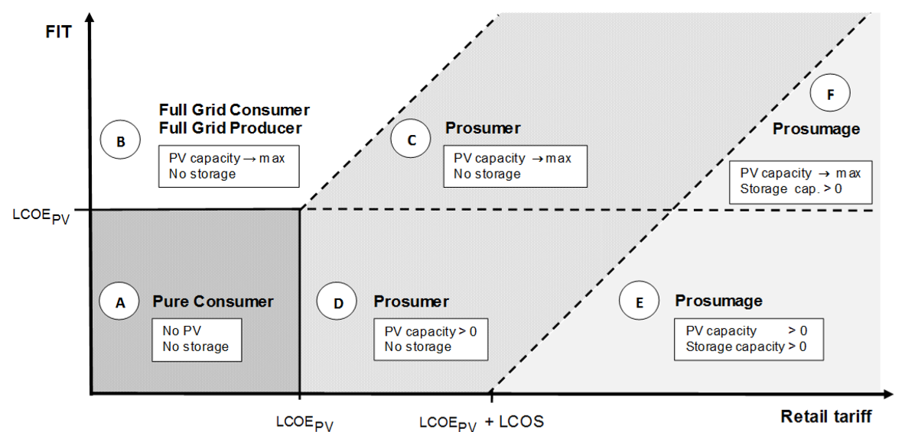

Figure 2: Household prosumage incentives, depending on the feed-in tariff, LCOE, and the retail rate

Quantitative model results for households reflect the qualitative findings. In most scenarios, households achieve a high rate of self-generation (autarky rate), mostly above 70%, facilitated by storage. Only if parts of the regulated retail price component is capacity-based, autarky rates are low. In this case, the retail price per energy unit is low and households do not invest in storage. If households face real-time prices instead of a feed-in tariff, their PV electricity earns less revenues on the market and, accordingly, PV installations are lower.

Regarding system effects, none of the considered tariﬀ options is superior regarding all of the investigated dimensions (renewable energy capacities, peak PV feed-in, contribution non-energy power system costs). Instead, we identify tradeoffs between these dimensions. A greater contribution to non-energy power sector costs can generally be achieved with higher ﬁxed non-energy charges. This can be combined with a FIT, and potentially also with a feed-in cap, which would incentivize high investments into PV capacity, while avoiding high stress on grid.

Conclusions
We conclude that the design of regulated retail price components has a decisive influence of the decisions of households to engage in prosumage. If the retail price contains high energy-based surcharges and taxes, as it is the case in Germany by 2019, then the incentive for PV self-consumption, also facilitated by a battery, is high. If the retail price is time-varying and follows wholesale prices in real-time, prosumage incentives are low. Likewise, a higher feed-in tariff, ceteris paribus, lowers incentives for self-consumption because the alternative of selling electricity to the grid is more attractive. From an energy (transition) policy perspective, prosumage is not desirable or detrimental as such. Instead, its system effects crucially depends on the regulatory framework.

