“WILD” TARIFF SCHEMES: EVIDENCE FROM GEORGIA

Levan Bezhanishvili, Charles University Prague, levan_bezhanishvili@yahoo.com
Anna Alberini, University of Maryland, 001 202 236-4774, aalberin@umd.edu
Milan Scasny, Charles University Prague, milan.scasny@czp.cuni.cz

Overview
Increasing block tariffs (IBRs) are common at many locales. The simplest variant consists of a lower price per unit of energy input (e.g., electricity) up to a certain level, and a higher price per unit for each of consumption that exceeds that level. The rationale behind IBRs is that they should encourage conservation due to the heavy penalty they place on excessive consumption.

Borenstein (2009) shows that consumption should “bunch” at the cutoff between blocks in the presence of block pricing. Ito (2014) shows that IBRs do not truly help curtail consumption if consumers respond to the average price per unit, instead of the marginal price per unit of energy input, and brings empirical evidence that residential customers in California respond to average prices rather than marginal prices. This may happen because consumers find it difficult to keep a track of their consumption on a daily basis and/or because they do not perceive the penalty from excessive consumption as especially burdensome.

In this paper we examine a very unusual block pricing scheme for electricity—one where the higher price is applied to the entire quantity consumed, not just the units that exceed the block cutoff. A penalty this strong should make it easier for consumer to try to curtail consumption. This pricing scheme is in force in Georgia, a former Soviet Republic, where it has been in place for at least 10 years, with periodic revisions to the price per unit.

We ask two key research questions: First, are consumers fully aware of the pricing scheme? Are they responding to it in the way described by Borenstein (2009). Second, can we infer their sensitivity to price—summarized into a price elasticity of demand—in the presence of this unusual IBR variant?

Methods
We use data from two sources. The first are billing records from a random sample of residential customers in Tbilisi (the capital) and the area around the Tbilisi city boundary. Households that reside inside and outside the Tbilisi city limits are served by two different companies—Telasi and EnergoPro, respectively, which enforce the same blocks (less than 101 kWh/month, 101-301 kWh/month, and 301 and more kWh/month) but apply slightly different tariffs. We use these records to form a longitudinal dataset that follows consumers for several months, and to look for evidence of bunching around the block cutoffs.

Our second source of data is the Georgia Household Budget Survey from 20. Every year a new sample from the population is drawn, but data from participating households are collected on a quarterly basis and in such a way that we can form a panel dataset, with the expenditure on electricity (and gas, and other fuels) for each month, and hence kWh consumed. We take advantage of the revisions in the tariffs over time and across regions to econometrically estimate a demand function and obtain the price elasticity of demand. Our identification strategy relies on increases/decreases in tariffs and on the fact that in one region the tariffs remained unchanged while they were changing elsewhere. As shown in figure 2, for example, the local utility in the Kakheti region—unlike Telasi and EnergoPro, which serve Tbilisi City and the rest of Georgia—did not reduce the tariffs in 2013-2015 and did not raise them in late 2015-2017 (see Figure 2).

This allows to fit a demand function where log consumption is regressed on household-specific fixed effects, log marginal price, weather controls, log income, and log subsidies. Log marginal price is instrumented for using the published tariffs. Log subsidies are treated as a separate entity than income because they are applied to the bills, but are not cash transfer to the households.

Alternatively, one can interpret the subsidies are an implicit reduction in the price paid per kWh, or even potentially use them as instrument for price paid (subsidies are much more automatically issues in former Soviet Republics than in, for example, the US, where they entail selection bias).

Results

We are currently cleaning the data abnd getting them in shape for the analysis and econometric estimation. Figures and 2 present summaries of the data from our two sources.
Figure 1. Average monthly consumption in the EnergoPro customer sample.
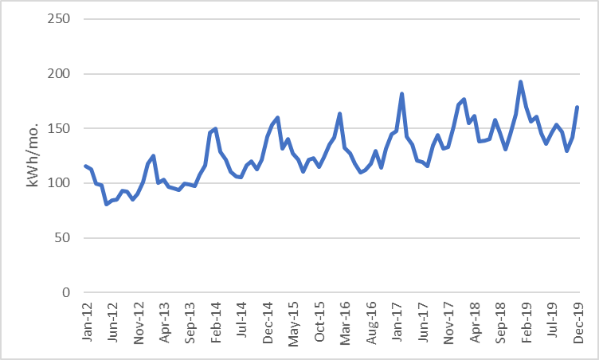

Figure 2. Tariffs in the first block of consumption, 2012-2019.
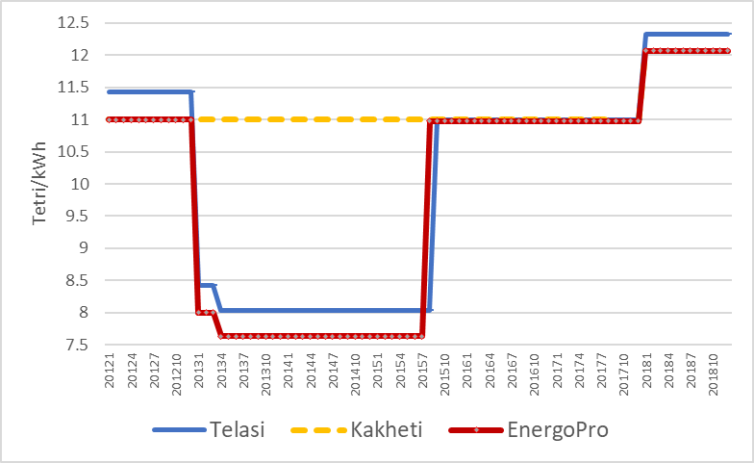

Conclusions

We are currently working on data cleaning. We hope to be able to establish whether this unusual block pricing scheme has helped conservation, or whether this goal has been defeated by salience and other issues affecting the correct perception of the prices.

References
Borenstein, Severin (2012), “To What Electricity Prices do Consumers Respond? Residential Demand Elasticity under Increasing-block Pricing,” available at http://faculty.haas.berkeley.edu/borenste/download/nber_si_2009.pdf

Ito, Koichiro (2014), “Do Consumers Respond to Marginal or Average Price? Evidence from Nonlinear Electricity Pricing,” American Economic Review, 104(2), 537-563

