Ensuring flexibility delivery: the role of penalties on long-term distribution flexibility tenders.
Felipe Gonzalez Venegas, CentraleSupélec - Stellantis, felipe.gonzalezvenegas@centralesupelec.fr
Yannick Perez, CentraleSupélec, yannick.perez@centralesupelec.fr
Marc Petit, CentraleSupélec, marc.petit@centralesupelec.fr

Overview
Distribution System Operators (DSOs) might face significant investments in grid reinforcement to cope with cross-sector electrification and the integration of renewable energy resources. However, connected and controllable resources, such as electric vehicles (EVs), offer the opportunity to provide flexibility improving operation and planning of distribution grids. Flexibility can help manage grid congestion, provide voltage support, and support the grid under fault conditions, and if considered in their planning processes, they can avoid or defer costly reinforcements.
The scientific literature has proposed many local flexibility frameworks where DSOs can procure flexibility for short-term congestion management (local flexibility markets). However, to procure flexibility for investment deferral or for fault-restoration events, DSOs require a medium- to long-term vision of the availability and costs of flexibility resources. Indeed, DSOs can face high risks if they rely only on short-term local markets, since they have limited options if the market fails. A solution to mitigate the availability and price risks is to procure flexibility through long-term contracts, in reserve-like markets [1]. In this case, DSOs can contract flexibility through bilateral agreements or implement competitive tenders. Flexibility providers receive an availaibiltiy payment to ensure flexibility availability, and activation would be made in real-time according to system’s conditions, similar to reserve markets. Long-term contracts can provide certainty on flexibility availability to DSOs as well as revenue certainty to flexibility operators.
Within this context, medium- to long-term tenders for investment deferral have started to be implemented in some countries. In the UK, UK Power Networks (UKPN) has implemented local flexibility tenders since 2018 to contract flexibility for zones of their grid where they expect congestions, allowing them to reduce their investment costs [2]. The April 2020 tender awarded flexibility contracts for over 50 zones for up to 7 years durations. Other DSOs in the UK have implemented similar processes, as well as French DSO Enedis, who launched their flexibility platform with 6 zones to tender during 2020 [3].

Long-term distribution flexibility tenders implement penalties to ensure that aggregators will deliver the contracted flexibility. The penalty regimes differ, with UKPN tender having low penalties to foster competition, while Enedis aligns its penalties with the national balancing mechanism. However, aggregators responding to distribution tenders may face significant uncertainty on the availability of their flexibility assets, such as electric vehicles which may not be connected when needed. Strict penalties policies might prove to be entry barriers for aggregators with variable resources.

In this work we analyze the role of penalties on the participation of EV aggregators in long-term flexibility tenders. In particular, we analyze how different penalties policies affect the amount of flexibility that EV aggregators offer to the tender, and their expected revenues and incurred risks.

Methods
We follow a two-stage methodology that emulates the flexibility tender process, proposed in [4]. In the first stage EV simulations are performed to characterize the availability of the EV fleet, and then to determine the amount of flexibility to bid in the tender (in kW/EV). In the second stage, flexibility activations are simulated to evaluate the delivery of flexibility, and revenues and penalties are computed.
By varying the amount of flexibility bid by the aggregator, we identify the Paretto-optimal levels of flexibility to be bid by a risk-averse aggregator.
We analyse the case of a DSO requiring downwards flexibility (load reduction or generation increase) for their evening peak, between 5pm-8pm. Flexibility is required to be available on weekdays during winter months, but activated only 10 times per year. We evaluate the participation of two kinds of EV fleets doing overnight charging: a company fleet with consistent travel schedules and which is always plugged-in after work, and a commuter fleet with highly variable travel patterns and where users do not plug in their vehicle every day. Both fleets are equipped with a 7 kW bidirectional (V2G) charger.

Results
We evaluate the expected remuneration and the conditional value-at-risk (C-VaR) at 95% confidence for the two EV fleets in study, and for three levels of penalties, shown in Figure. 1. The company fleet has regular travel patterns and is always connected after daily trips, allowing to offer over 7 kW/EV of V2G flexibility with high reliability. Therefore, the company fleet is able to attain high remuneration levels (over 350€/EV/y) with no risk, and the different penalties policies do not affect the bidding of the aggregator.
On the other hand, the commuter fleet has irregular travel and plug-in patterns, allowing to offer lower amounts of flexibility to the DSO and obtaining lower remunerations. The penalty scheme will affect the amount of flexibility bid by the aggregator for this kind of fleet. Under a low penalty scenario (consistent with UKPN penalty policy), the aggregator will offer 3 kW/EV which he can deliver only with a 40% confidence, as this penalty scenario creates low risk for the aggregator. However, if the DSO implements stricter penalty policies, he can force the aggregator to bid only the amount of flexibility he can provide with high certainty. Under the high penalty scenario, the aggregator will bid only 1.6 kW/EV, which can be delivered with 95% confidence.
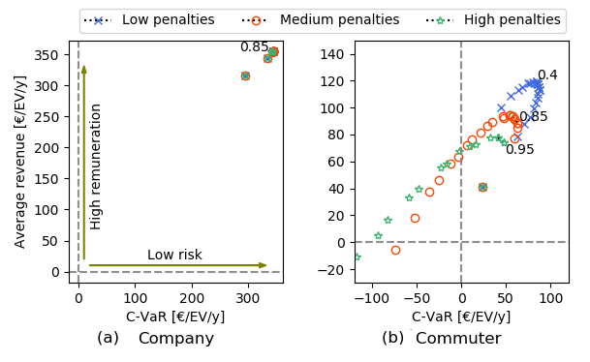
Figure 1: Expected revenue vs. risk (C-VaR) for the two studied EV fleets and three penalty levels. Each point corresponds to a different amount of bid flexibility. The optimal confidence level of the aggregator for each fleet-penalty configuration is shown in the plot.

Conclusions
DSOs are implementing tenders to procure flexibility for their long-term needs. To ensure flexibility delivery, contracts consider penalties, which differ from each implementation. We evaluated the impact of penalties on the participation of EV aggregators, which can face high uncertainty on the availability of their assets.
Low penalty policies can allow greater participation of flexibility aggregators, which can foster competition in emerging markets such as distribution-level flexibility tenders. However, they may put DSOs at risk if they do not provide sufficient risk coverage. A trade-off appear between lowering barriers to entry for aggregators and ensuring flexibility delivery.

References
[1] Ramos, A., De Jonghe, C., Gomez, V., Belmans, R., Realizing the smart grid's potential: Defining local markets for flexibility. Utilities policy, 2016, Vol. 40, pp. 26-35.
[2] UK Power Networks, Post tender report 2020, [online] https://smartgrid.ukpowernetworks.co.uk/flexibility-hub/
[3] Enedis, Flexibilités [online] https://flexibilites-enedis.fr/
[4] Gonzalez Venegas, F., Petit, M., Perez, Y., Participation of electric vehicle fleets in local flexibility tenders: Analyzing barriers to entry and workable solutions. EUI Working papers, 2021

