The potential IMPACT of sufficiency measures on energy demand and supply patterns – a model-based scenario analysis for Germany

Gro Lill Økland, NTNU, Norway and TU Berlin, Germany, okland@campus.tu-berlin.de
Elmar Zozmann, TU Berlin (WIP), ez@wip.tu-berlin.de

with a research study team including Alfredo Zamora Blaumann, Michel Kevin Caibigan,
Mirjam Helena Eerma, Dylan Manning, Citlali Rodriguez del Angel,
Seyedsaeed Hosseinioun, Carl-Christian Klötzsch, Morteza Lavaiyan,
Eric Rockstädt, Paul Seifert, Nithish Kini Ullal and Johanna Winkler

Keywords
Energy system modelling, sufficiency, demand-side solutions, energy transformation

Overview
This paper explores the potential impacts of sufficiency measures on both energy demand and supply. The current scientific and public debate on climate change mitigation is mostly focused on technological solutions, whereas human lifestyle changes receive far less attention. Recent studies indicate that demand reductions through behavioral changes, also referred to as sufficiency measures, may not only help to meet climate targets, but even be indispensable to achieve them (Grubler et al. 2018; Creutzig et al. 2018; Mundaca, Ürge-Vorsatz, and Wilson 2019). Against this background, this paper analyzes and models the impact of sufficiency-based demand reductions on a 100% renewable energy supply for Germany.

Methods
Possible sufficiency measures are identified through research in scientific literature, quantified, and translated into reductions of energy demand for the sectors heat, mobility and conventional electricity. The reductions are used to modify the exogeneous demand assumptions of a greenfield energy system model for Germany to quantify their effects on system costs and design. The model is a linear, cost-optimizing capacity expansion model implemented in the AnyMOD-Framework. Including the energy carriers electricity, hydrogen and synthetic gas, the model covers explicitly the power and gas sector; but heat and transport are implicitly included by adding the demand for synthetic fuels and electricity that decarbonization of these sectors requires, both for private and industrial demand On the supply side the model includes renewable generatory, namely photovoltaic, wind onshore and wind offshore (see Figure 1). In a scenario-based approach, demand reductions are analyzed for each sector individually and for all sectors combined, distinguished in low and high ambition scenarios. A sensitivity analysis on peak load shedding assesses the temporal importance of demand reductions.
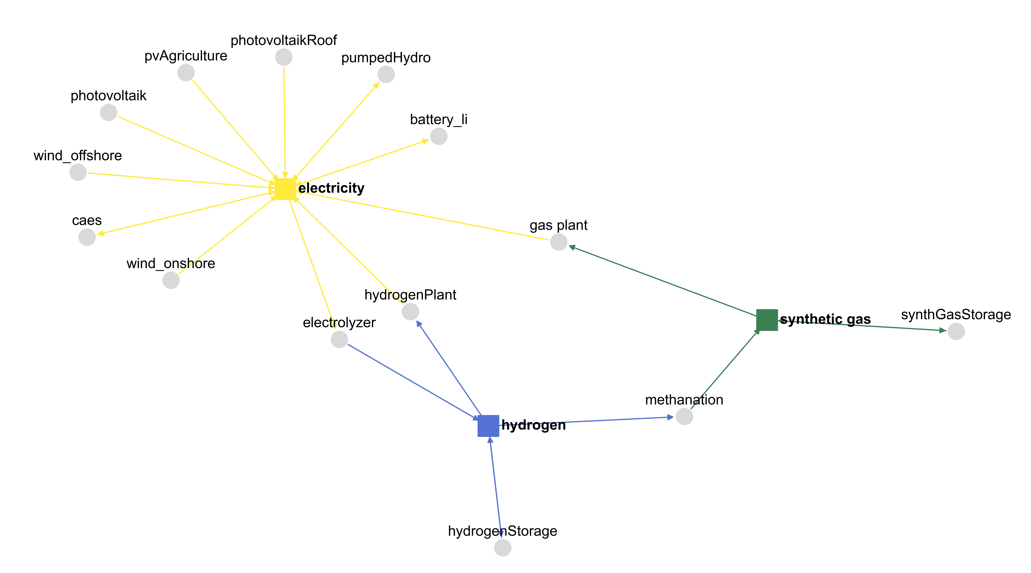
Figure 1: Energy flow diagram of the model implemented in the AnyMOD-Framework. Source: Own illustration.

(Preliminary) Results
Based on the assessment of existing literature, the potential reduction of demand from sufficiency measures ranges from 9.4% to 20.5%, which translates to 138 to 300 TWh of energy demand. A sector-by-sector analysis reveals a similar potential for suffiency measures in the mobilty and heat sector, followed by the conventional electricity sector with approximately half that potential. Sufficiency measures result in cost reductions of 11.3% to 25.6% in comparison to no lifestyle changes (reference scenario). Generation and storage capacity can hence be reduced by 30.6% and 44.5%, respectively. Due to high peak loads, demand reductions in the heat sector can achieve the biggest reduction in system costs (see Figure 2). A sensitivity on demand side management, that assumes electricity demand for heating is balanced in four hour steps instead of hourly, reveals 8% cost reductions and more than 50% short-term storage reductions without any demand reductions. Further sensitivity analysis finds that cutting demand peaks only decrease overall demand by less than 1% but decreases installed generation capacities by 2% and storage capacities by 5%.
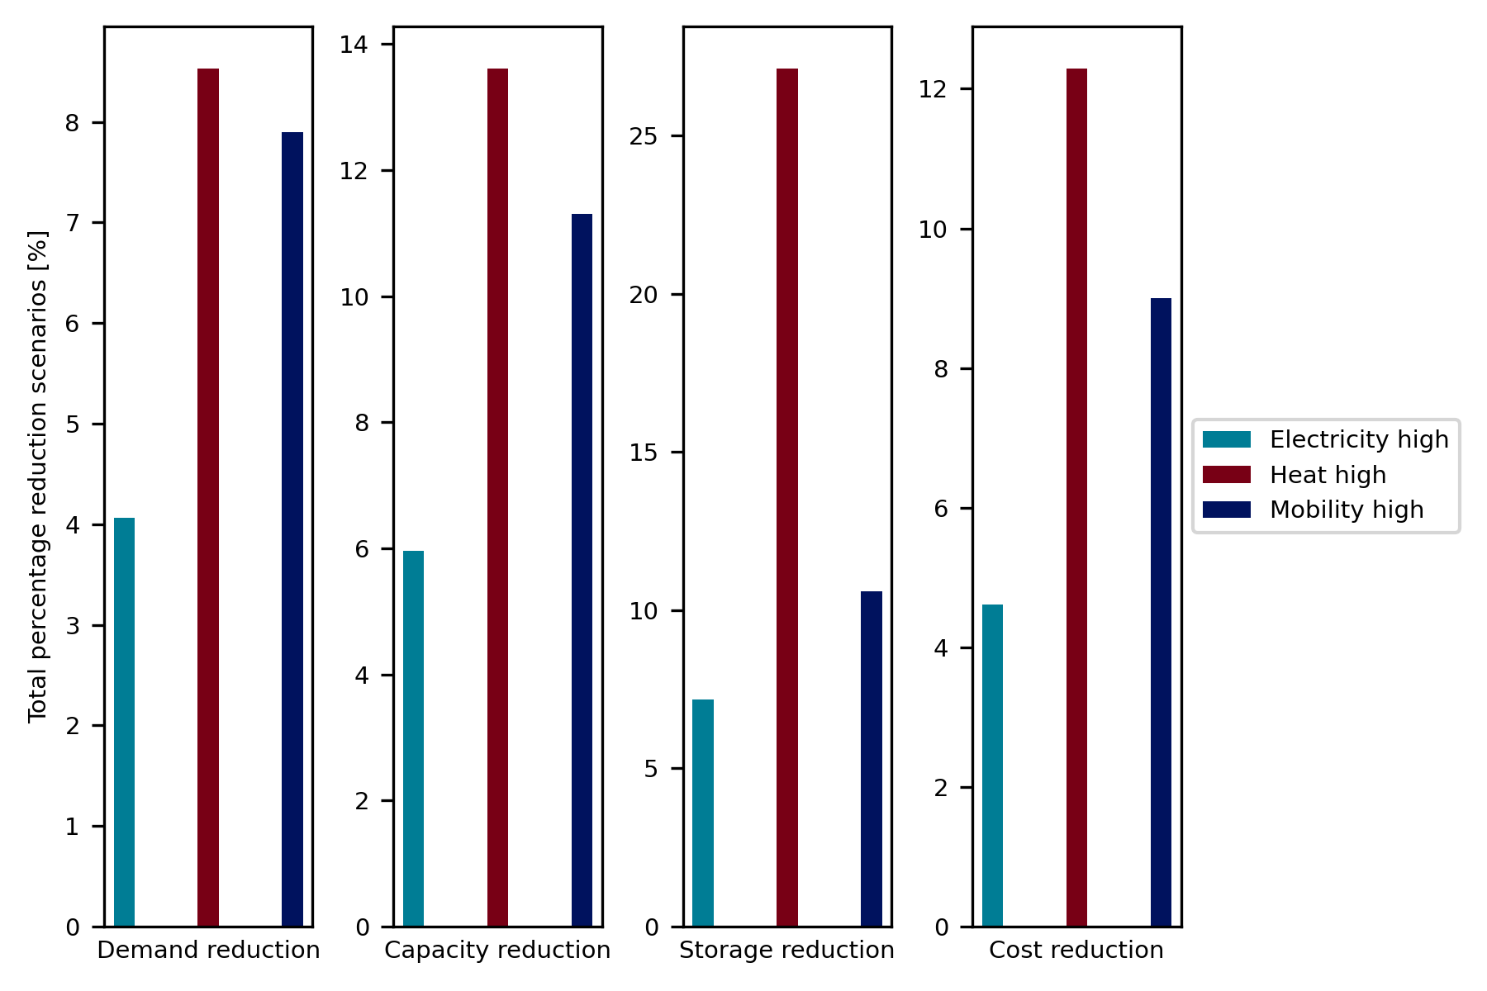
Figure 2: Comparison of the sectoral impact of high-ambition scenarios on the energy system. Source: Own illustration

Conclusions
The paper provides insights into the impact of lifestyle changes on decarbonization of the energy system. Main conclusions include that sufficiency measures have the potential to reduce energy consumption, their effect on the supply side is significant and should therefore be included in energy modeling and policy advice.

References
Creutzig, Felix, Joyashree Roy, William F. Lamb, Inês M. L. Azevedo, Wändi Bruine de Bruin, Holger Dalkmann, Oreane Y. Edelenbosch, et al. 2018. “Towards Demand-Side Solutions for Mitigating Climate Change.” Nature Climate Change 8 (4): 260.
Goeke, Leonard. forthcoming. “AnyMOD – A Graph-Based Framework for Energy System Modelling with High Levels of Renewables and Sector Integration.” DIW Discussion Paper.
Göke, Leonhard. 2020. “AnyMOD – A Graph-Based Framework for Energy System Modelling with High Levels of Renewables and Sector Integration.” Archive.
Grubler, Arnulf, Charlie Wilson, Nuno Bento, Benigna Boza-Kiss, Volker Krey, David L. McCollum, Narasimha D. Rao, et al. 2018. “A Low Energy Demand Scenario for Meeting the 1.5 °C Target and Sustainable Development Goals without Negative Emission Technologies.” Nature Energy 3 (6): 515.
Mundaca, Luis, Diana Ürge-Vorsatz, and Charlie Wilson. 2019. “Demand-Side Approaches for Limiting Global Warming to 1.5 °C.” Energy Efficiency 12 (2): 343–362.

