How effective is energy efficiency? Assessing industrial rebound effects in Switzerland
Michel Zimmermann, École Polytechnique Fédérale Lausanne, +41 21 693 93 99, michel.zimmermann@epfl.ch
Frank Vöhringer, École Polytechnique Fédérale Lausanne, +41 21 693 32 97, frank.voehringer@epfl.ch
Philippe Thalmann, École Polytechnique Fédérale Lausanne, +41 21 693 73 21, philippe.thalmann@epfl.ch
Vincent Moreau, École Polytechnique Fédérale Lausanne, +41 21 693 93 98, vincent.moreau@epfl.ch

Overview
At its core, an energy efficiency improvement reduces the costs for a given energy service when constant energy prices are assumed (e.g. reduced fuel expenses per kilometres travelled in case of a more fuel-efficient vehicle). This leads to direct rebound effects through increased demand for said energy service (e.g. more trips with the new vehicle) and indirect rebound effects via an increase in demand for other goods, which further stimulates energy use. Together, these effects are part of the reasons, why the premise that energy efficiency leads to absolute reductions of energy use and emissions has been frequently called into question.

Rebound effects have been frequently studied and discussed ever since the 1980s and are now commonly recognized to be a direct consequence from energy efficiency improvements (Madlener and Turner, 2016). This is particularly true when analysing higher levels of aggregation, as the uncertainties and difficulties in determining the rebound effect grow with the increasing number of interdependencies. This translates into further possible meso- and macroeconomic rebound effects. These encompass effects, such as the composition effects (e.g. change in production factor use), market price effects, growth effects and output effects (Santarius, 2016). For these economy-wide rebound effects, the magnitude of these effects are similarly uncertain. In an extensive literature review, Stern (2020, p.5.) asks the question how large rebound effects at the economy-wide level are and comes to the conclusion that “despite much research on this topic, we do not have a definitive answer”.

To the author’s knowledge, rebound effects received no discernible attention in devising Swiss climate policy, in which energy efficiency plays a crucial role. Furthermore, no study appears to exist that explicitly measures sector-specific or economy-wide rebound effects as a result of energy efficiency improvements in Switzerland. This paper intends to fill this research gap. Moreover, we aim to contribute to the debate on the complementarity / substitutability between capital and energy, which has been frequently pointed out as an important determinant of rebound effects (Broadstock et al., 2007). Specifically, the author analyses the rebound effects that occur as a result of annual industrial energy efficiency improvements, at the sector-specific, industry-wide and the economy-wide level. The analysis is undertaken via a newly developed recursive-dynamic computable general equilibrium (CGE) model for the Swiss economy, which constitutes the predominantly chosen method for assessments of economy-wide rebound effects. By providing a complete picture of the different interactions between the actors as a result of energy efficiency improvements, it will thus shed a valuable light on the effectiveness of energy efficiency in Switzerland and show whether continued efforts in energy efficiency policy are worth pursuing.

Method
The Swiss Energy Efficiency Model (SEEM) is a newly developed multi-sectoral recursive-dynamic CGE model with a time horizon from 2020 until 2050. For the analysis presented here, the Swiss economy is summarised into seven representative sectors with four non-energy good sectors and three sectors that represent the energy supply, based on the Swiss energy input-output table. The non-energy good sectors comprise two energy-intensive sectors (high energy-intensive manufacturing industries and the transport sector) and two less energy-intensive sectors (Rest of industry and the service sector). Energy supply consists of a refined oil sector, a natural gas (distribution) sector and electricity sector. Households are assumed to be utility-maximising, while firms are profit-maximising with all markets being perfectly competitive without economies of scale. The production function employed are nested CES functions with capital, labor, energy and materials as the production factors. Outputs can either be sold domestically, exported or combined with imported intermediate goods, as the model is governed by a small open economy assumption. The chosen elasticity parameters were taken from established literature and adapted to the Swiss context.
In SEEM, capital is modelled with a putty-clay formulation. Total capital is invested in the two capital types (putty) and once it is installed, it cannot be changed and used elsewhere (clay). We differentiate two types of capital: energy system capital (ESC) and non-energy capital (NEC). ESC represents the part of the capital that turns energy into usable energy (e.g. the internal combustion engine of a truck or the kiln in a cement factory). NEC refers to the remaining capital (e.g. the truck itself or the factory the kiln is located in). This accounts for the ongoing and inconclusive debate on whether capital and energy are supposed to be complements or substitutes (Broadstock et al., 2007). By differentiating the two types of capital, the model represents the fact that some capital can effectively be substituted for energy (i.e. the ESC) in case of energy efficiency improvements. Meanwhile, certain capital can only be used in a complementary fashion (i.e. NEC) and actually increases with the higher demand for energy services as a result of the efficiency stimulus.
In order to measure the industrial rebound effect at the industry- and economy-wide level, a costless energy efficiency improvement of 2.2% p.a. is implemented for all industries at the end of each period through energy-augmenting technological change at the energy composite. Consequently, absent any rebound effect, the use of all energy (refined oil, natural gas and electricity) in production would decrease by 2.2% p.a. This counterfactual scenario is compared with a steady-state scenario, which provides the actual energy savings that were accrued as a result of the energy efficiency stimuli. The rebound effects are measured by comparing these actual energy savings to the potential energy savings (e.g. 2.2% for year t=1) via the following formula: ${Rebound Effect}_{t}=\left[1-\frac{A{ctual energy savings}_{t}}{{Potential energy savings}_{t}}\right]x 100$. In order to gauge the importance of different assumptions and parameters chosen in SEEM, these results are then validated by a sensitivity analysis of key elasticities of substitution.

Results
The sectoral, industry-wide and economy-wide rebound effects from annual industrial energy efficiency improvements are illustrated in Figure 1 for the short- and the long-term. For all non-energy sectors, rebound effects significantly reduces the efficacy of energy efficiency measures. This is most pronounced in the energy-intensive manufacturing sector and the services sector. These two highest sectoral rebound effects of almost 60% and 40% in the short-run, respectively, which gradually decreases over time. This hints at decreasing substitution as energy is becoming more and more efficient. Super-conservation was found for the fossil fuel sectors, as their production strongly contracts due to a strong decrease in demand. The weighted sum of these sectoral rebound effects equals 38% overall rebound effect in the first period after the first energy efficiency improvement, which gradually decreases over time to 30% in 2050. The industry-wide rebound effects in a given year thus decrease with each additional energy efficiency improvement. The total rebound effects, which includes the change in final energy use, are larger and amounts to roughly 35% in 2050. Households benefit from the price adjustments that occur due to the increased efficiency that stimulates consumption, which is further amplified via an income effect. In Switzerland, rebound effects thus significantly erode absolute energy savings from increased energy efficiency.

Figure 1: Industry-specific, industry-wide and economy-wide rebound effect (in %) in the short- and long-term, following annual energy efficiency improvements of 2.2% p.a.
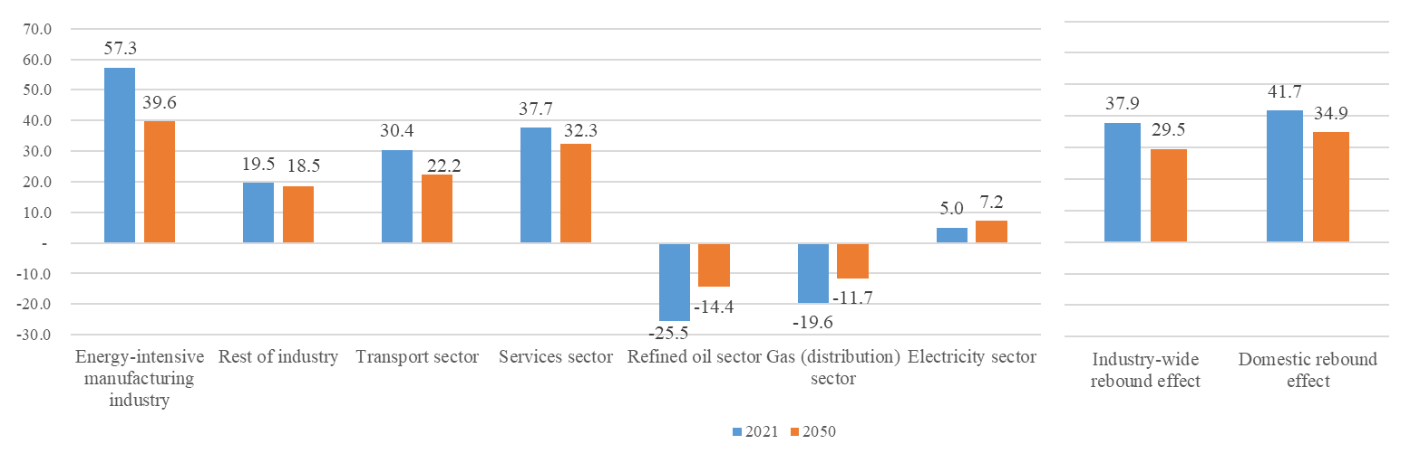

These measured rebound effects are a direct consequence of economic and behavioural adjustments to the energy efficiency improvements. By reducing the effective price of energy and thus the marginal costs of production, the stimulus in energy efficiency induces economic growth, amounting to an increase in GDP of almost 2% in 2050, relative to the steady-state scenario. Moreover, the energy efficiency has a positive impact on wages, income and thus private consumption. Sensitivity analyses show that both these sectoral differences and the aggregate results crucially depend on the elasticity of substitution between capital and energy. Moreover, the disaggregation of capital in two capital types with differing substitutability with energy lowers rebound effects overall.

Conclusions
Our simulations show that energy efficiency measures are only partially successful in reducing energy use. Industry-wide and economy-wide rebound effects erode more than a third of annual energy savings. The more productive use of energy increases GDP and income. Additional investment further enhances these growth effects. Industrial energy efficiency measures in Switzerland thus have positive economic effects. From an energy policy perspective however, it is clear that a solid understanding of the resulting rebound effects in Switzerland is paramount, as otherwise the established national energy reduction targets are likely going to be missed.

References
Broadstock, D., Hunt, L and Sorrell, S., 2007. UKERC Review of evidence for the rebound effect: Technical report 3: Elasticity of substitution studies. http://sro.sussex.ac.uk/id/eprint/53999 [Accessed on 27.05.21]

Madlener, R. and Turner, K., 2016. After 35 Years of Rebound Research in Economics: Where Do We Stand?, in: Santarius, T., Walnum, H.J., Aall, C. (Eds.), Rethinking Climate and Energy Policies: New Perspectives on the Rebound Phenomenon. Springer International Publishing, Cham, pp. 17–36. https://doi.org/10.1007/978-3-319-38807-6_2

Santarius, T., 2016. Investigating meso-economic rebound effects: production-side effects and feedback loops between the micro and macro level. Journal of Cleaner Production 134, 406–413. https://doi.org/10.1016/j.jclepro.2015.09.055

Stern, D. I., 2020. How large is the economy-wide rebound effect?. Energy Policy, 147, 111870. https://doi.org/10.1016/j.enpol.2020.111870.

