investment in smart homes under different tariFf structures: consumer and distributor perspectives

Seyyedreza Madani, HEC Montreal, 514 340-6922, seyyedreza.madani@hec.ca
Pierre-Olivier Pineau, HEC Montreal, 514 340-6922, pierre-olivier.pineau@hec.ca

Overview
Smart homes should play a key role in smart grids and in how Electricity Generation and Storage Devices (EGSD) are used. These homes (with solar PV, electric vehicle, storage, and energy management systems) can significantly influence total market demand and prices [1]. As the number of devices to control is growing, the number of decisions consumers must take expands, and automation will likely be more common [2]. However, for smart homes to become dominant, the right incentives and regulations have to be developed. Who should invest? Who should control EGSD? The distributor, the consumer or possibly other parties? To explore these questions, this study investigates different aspects of the smart home investment and management problems. While investment in solar PV and stand-alone batteries has attracted great attention in the literature [3], this study adds investment in Vehicle to Grid (V2G) devices to the current options and, investigates the profitability of connecting the storage capacity of Electrical Vehicle (EV) to smart homes. Five scenarios are designed, combining different EGSD devices - see Table 1. Their profitability, use and impact on peak load are studied in this paper. Moreover, when EGSD are controlled by the consumers, they can change the load shape and impose significant infrastructure expansion costs on the grid. However, under a proper tariff structure, consumers can be incentivized to reduce their demand or even sell back some stored energy during the peak-hours. Hence, this paper also studies the effects of the tariff structures on the distributor’s and consumers’ costs and consumption patterns. furthermore, some managerial insights for the distributor are provided and explained.
Table 1 Five investment scenarios along with a basic scenario
Scenario | Capacity of the stationary battery (kWh) | Charge and discharge capacity (kWh) | Capacity of the EV’s battery (kWh) | Solar PV availability | Total cost (purchase and installation, USD)
0 – Base case | 0 | 0 | 0 | No | 0
1 – Stationary Battery | 40.5 | 3.75 | 0 | No | 27,300
2 – Stationary Battery + PV | 27 | 2.5 | 0 | Yes | 35,125
3 – EV with V2G | 0 | 1.9 | 36 | No | 4,000
4 – EV with V2G + PV | 0 | 1.9 | 36 | Yes | 17,145
5 – Battery + V2G + PV | 10 | 1.9 | 36 | Yes | 23,724

Methods
Four different tariff structures are considered in this study, based on a real US context: Flat rate (rate 1), Time-of-Use rate (rate 11), Flat rate + Time-of-Use (rate 74) and Real-time regional locational price ( rate RTLMP).
In order to model the aforementioned problem, under different scenarios, the various decision variables and parameters are defined, one mathematical model and two objective functions are developed. The first one takes the consumer’s costs (from the tariff) into account and tries to minimize his electricity bill. The second model addresses the distributor’s wholesale, capacity and network costs and minimizes the costs while covering the daily loads. The two Mixed-integer linear models are formulated and solved by the gurobi solver in python. Then, within different time horizons ranging from 10 to 30 years, the Net Present Values (NPV) and Internal Rates of Return (IRR) for each scenario are calculated. Furthermore, some sensitivity analyses are done on the important parameters of the problem and their impact on the objective values are shown.

Results
In order to validate the results of the models, the real consumption and generation records from five houses and electricity rates in Vermont during the year 2019 are used in this study which are provided by the main electricity distributor in Vermont (Green Mountain Power company). Also, Ossiaco company (which develops a V2G device named DCBEL) provided the purchase and installation costs of each scenario.
The solved models show the optimal utilization strategy of EGSD and final annual/weekly/hourly flows from all sources to all destinations. Moreover, different investment and rate structures yield different cost-saving values for the consumers and the distributor. Thus, under different circumstances, different strategies are suggested to the agents. According to Figure 1, the results show that scenario 3 is the only profitable case (NPV = 909 USD) when the distributor owns and operates EGSD, and it has the highest IRR (9.53%). However, when the consumer owns and utilizes EGSD, the combination of four tariff structures and trade allowance condition creates 8 situations; where, there is not a global optimal solution for all cases and, one of the scenarios 3, 4, or, 5 is the optimal choice for each case. Figure 2 depicts how changes in EGSD ownership and investment scenarios can affect the monthly peak loads. The blue line on both sides represents the basic scenario (where EGSD are not used) and, it is the upper bound for the distributor’s graph and, lower bound for the consumer’s graph.
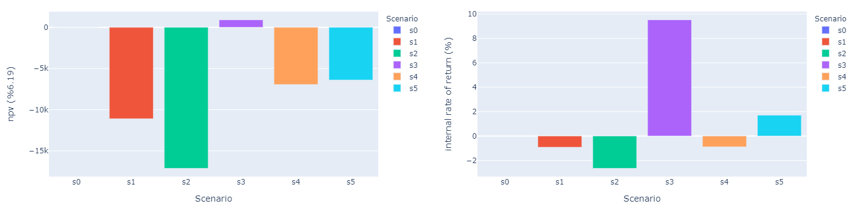
Figure 1 NPV and IRR of scenarios when distributor operates EGSD

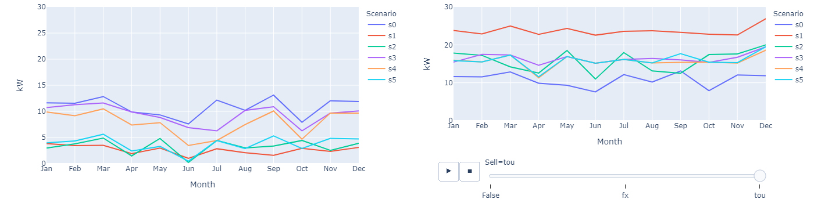
Figure 2 Monthly peak loads when EGSD are owned and operated by distributor (left) and consumer (right)

Conclusions
This study discusses the potential challenges and benefits of investment in smart home technologies from the ownership and EGSD combination aspects. The results show that investment in V2G devices and connecting the EV to the smart home is the only profitable investment scenario for the distributor. Moreover, the optimal investment scenario for the consumer depends on the tariffs that the distributor sets. As well, the results prove that an inappropriate tariff structure can even double the peak loads. Therefore, regulators should pay particular attention to subsidies and rules, to make sure the deployment of EV and V2G helps the system (to lower costs, mostly by lowering peak load), and are not just used to trick the system (by playing a rate game to extract money from tariffs).

References
[1] X. He, L. Chu, R. C. Qiu, Q. Ai, and Z. Ling, “A Novel Data-Driven Situation Awareness Approach for Future Grids-Using Large Random Matrices for Big Data Modeling,” IEEE Access, vol. 6, pp. 13855–13865, Mar. 2018.
[2] N. Halman, G. Nannicini, and J. Orlin, “On the complexity of energy storage problems,” Discret. Optim., vol. 28, pp. 31–53, May 2018.
[3] K. K. Zame, C. A. Brehm, A. T. Nitica, C. L. Richard, and G. D. Schweitzer, “Smart grid and energy storage: Policy recommendations,” Renewable and Sustainable Energy Reviews. 2018.

https://greenmountainpower.com/rates/
https://www.iso-ne.com/isoexpress/web/reports/pricing/-/tree/zone-info

