Unfolding distributed demand-response through future-proof tariff design:
Benefits and consumer reaction to future tariff design

Cabot Clément, MINES ParisTech, PSL University, Centre for industrial economics (CERNA),
i3 UMR CNRS, 60 Bd St Michel 75006 Paris, France , +33669011176, clement.cabot@mines-paristech.fr
Villavicencio Manuel Research associate, Chaire European Electricity Markets, PSL Research University, LEDa [CGEMP], Place du Maréchal de Lattre de Tassigny, 75775 Paris, France. +33666623523, manuel.villavicencio@dauphine.psl.eu

Overview
Following the liberalization of power markets, the competition on retail activities have offered consumers an increasing choice of suppliers. Yet, unbundling of the market hasn’t yet translated into a diversification of billing schemes when it comes to tariffs: majority of consumers are still charged a flat tariff based on their energy consumption. This historical choice was driven by metering capabilities, as the infrastructure deployed only allowed for annual or bi-annual readings. Yet, both the literature and fields experiment have demonstrated tangible welfare gain from switching to dynamic pricing, notably by having a direct cost pass-through from wholesale market prices to end-users. This would enable to send price incentives to end-users that would better reflect the market situation, and notably enable them to manage their load to respond to grid congestion or scarcity in the supply-side. If short-term benefits might be low, literature has demonstrated long-run welfare gains by delaying or avoiding investments in peaking capacity and network expansion that can be important. Those benefits are expected to be even more tangible now that most countries are on the verge of completing a national rollout of smart meters and that system variability starts to be driven by wind and solar generation. Notwithstanding the benefits, concerns exists as dynamic pricing results also in a pass-through of risks linked to price volatility towards end users, that are less able than retailers to hedge against price volatility. Mitigation options consist in second-best pricing schemes such as Time-Of-Use, or Critical Peak Pricing.

This article explore welfare gains of different time-differenciated electricity tariffs in future power markets. With the joint increase of near-zero marginal price capacities linked to renewable power and the rise of short-run marginal cost of remaining thermal units linked to an increasing carbon price, electricity market prices are called to face an increasing volatility in the near-future. We investigate in a first step how renewables and carbon price affect power price volatility in a joint optimization of France, the UK and Germany. Given our interests, we focus on obtaining credible power prices from an unit commitment model, and used novel techniques to reproduce historical price volatility before investigating the impact of increasing renewable capacity and carbon price. Then, based on generated market prices, we estimate long-term benefits of different dynamic pricing schemes, notably Time-of-use (ToU) and Real-time pricing (RTP), for different level of end-user price-elasticity. This allow us to explore to what extent risk-averse end-users, opting out of RTP, are an impediment to welfare gain of dynamic pricing.

Methods
Differrent metholodogies have been used to assess the welfare gain of switching to real-time prices. A first segment of the literature represented by Borenstein and Holland (2003), Joskow and Tirole (2007), Léautier (2012) and Schweppe et al. (1985) analysis flat-tariff inefficiencies using a model of competitive wholesale and retail electricity markets. Results demonstrate that direct pass-through is optimal in most cases, even if expected gain appears marginal compare to the cost of smart meter rollout (Léautier, 2012). Yet, as the rollout is on the verge of being completed and as fields experiments (Allcott, 2011; Faruqui and Sergici, 2010) tends to demonstrate the effectiveness of dynamic pricing, the potential could easily be triggered. De Jonghe et al. (2012) Gambardella and Pahle (2018) and Wolak (2019) developed a model-based methodology to assess welfare gains from RTP implementation, and underlined the reduction of required investment in peaking generation capacity with demand response deployment, with slight change expected in the electricity bills.
This research, and associated methodology falls within this stream of the literature. Ackowledging the lack of attention reguarding temporal price variation, underlined by Ward et al. (2019), we built a modified Unit Commitment model paying particular attention on market fundamentals leading to a more accurate fit of price volatility. We believe this refinement could lead to more accurate results when assessing pricing schemes as it provides a more realistic price signal to end-users, and also allows to represent future price dynamics on markets with increasing shares of renewable energy sources. A large part of the improvement of the Unit commitment model is based on a modified merit order resulting from a optimization model to align short-run marginal cost with historical clearing prices. Clearing price divergences could be explained by simplified technology and/or market representation in models (notably that of combined heat and power plants (CHP), the bidding incentives of renewables under feed-in tarrifs, lack of unit by unit technical details or non-competitive bidding). The methodology applied allows to close to some extent this gap. As a second step, we coupled a system dynamic model to represent price-elastic users under different tariff schemes. As there is uncertainty related to the exact price elasticity of users despite evidence of demand response, we perform several sensativities to consider the intertemporal effects of elasticities on welfare gains and assess to what extent it is an important assumption to assess the future value of demand response under different tariff schemes .

Results
Figure 1 – 2018 Hourly price density in Germany: Historical (left) and modelled (right)

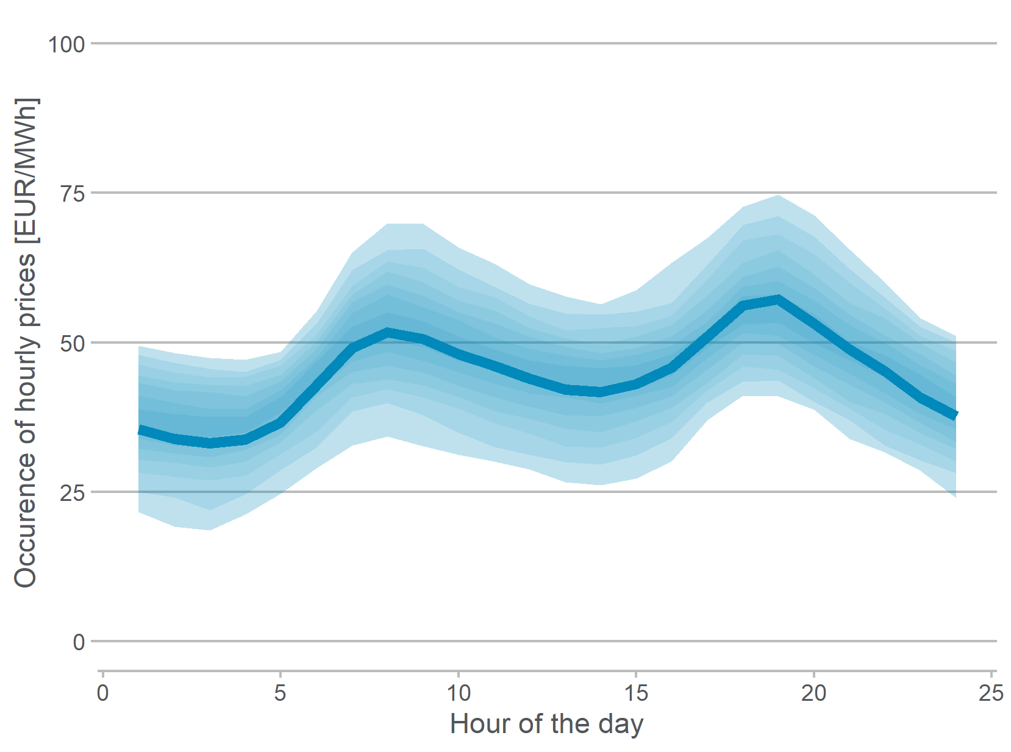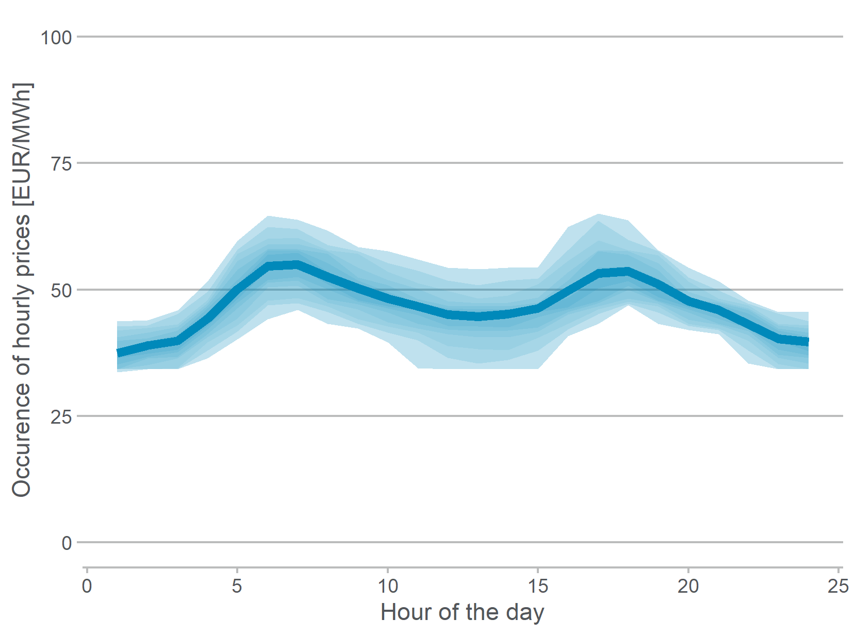

Market prices will be more and more volatile with increasing share of renewables and rising carbon price. Second, price-elastic end-users allow welfare gains, yet this doesn’t necessarily implies a reduced peak demand, it would depend on the wholesale market situation and on the intertemporal demand effects considered. Third, as price become more volatile, price elasticity of end-users become an important hypothesis to capture welfare gains. Fourth, the more static the derived dynamic pricing scheme is, the less it captures the full theoretical value of demand response.

References
Allcott, H., 2011. Rethinking real-time electricity pricing. Resource and Energy Economics, Special section: Sustainable Resource Use and Economic Dynamics 33, 820–842. https://doi.org/10.1016/j.reseneeco.2011.06.003
Borenstein, S., Holland, S.P., 2003. On the Efficiency of Competitive Electricity Markets With Time-Invariant Retail Prices (Working Paper No. 9922), Working Paper Series. National Bureau of Economic Research. https://doi.org/10.3386/w9922
De Jonghe, C., Hobbs, B.F., Belmans, R., 2012. Optimal Generation Mix With Short-Term Demand Response and Wind Penetration. IEEE Trans. Power Syst. 27, 830–839. https://doi.org/10.1109/TPWRS.2011.2174257
Faruqui, A., Sergici, S., 2010. Household response to dynamic pricing of electricity: a survey of 15 experiments. J Regul Econ 38, 193–225. https://doi.org/10.1007/s11149-010-9127-y
Gambardella, C., Pahle, M., 2018. Time-varying electricity pricing and consumer heterogeneity: Welfare and distributional effects with variable renewable supply. Energy Economics 76, 257–273. https://doi.org/10.1016/j.eneco.2018.08.020
Joskow, P., Tirole, J., 2007. Reliability and competitive electricity markets [WWW Document]. The RAND Journal of Economics. https://doi.org/10.1111/j.1756-2171.2007.tb00044.x
Léautier, T.-O., 2012. Is mandating “smart meters” smart? 43.
Schweppe, F.C., Caramanis, M.C., Tabors, R.D., 1985. Evaluation of Spot Price Based Electricity Rates. IEEE Transactions on Power Apparatus and Systems PAS-104, 1644–1655. https://doi.org/10.1109/TPAS.1985.319194
Ward, K.R., Green, R., Staffell, I., 2019. Getting prices right in structural electricity market models. Energy Policy 129, 1190–1206. https://doi.org/10.1016/j.enpol.2019.01.077
Wolak, F.A., 2019. The Role of Efficient Pricing in Enabling a Low-Carbon Electricity Sector. EEEP 8. https://doi.org/10.5547/2160-5890.8.2.fwol

