HOW TO COMMUNICATE THE MULTIPLE BENEFITS OF ELECTRIC VEHICLES: RESULTS FROM A CONTROLLED EXPERIMENT

James Carroll, Trinity College Dublin, +353 1 677 2503, jacarrol@tcd.ie
Eleanor Denny, Trinity College Dublin, +353(0)1 8963709, dennye@tcd.ie

Overview
The life cycle CO₂ impacts of electric vehicles (EVs) have received considerable attention in both the academic literature (Tamayao et al., 2015, Wu et al., 2018, Qiao et al., 2019) and mainstream media. Indeed, the benefits of a mass electrification of transportation depends on the CO₂ intensity of electricity (and, in particular, the planned rollout of renewables) and assumptions regarding battery recycling and repurposing at end of life. Any national cost-benefit analysis must also account for potential synergies with the national grid – the long duration between EV chargers combined with the large storage capacity means that EVs can potentially act as a grid balancing tool.

This paper focuses on the private benefits for the prospective EV adopter, how the framing of energy efficiency and CO₂ information affects EV switch rates, and the importance of such benefits relative to other EV attributes. We use an innovative, two-step (pivoted) discrete choice experiment as a platform to randomise a large number of informational treatments. The results from a nationally representative online survey of 2,000 households demonstrate that framing energy efficiency in terms of long-run CO₂ and monetary benefits increases the switch the EVs.
Figure 1: Screenshots from DCE
Step 1: Baseline Car Choice  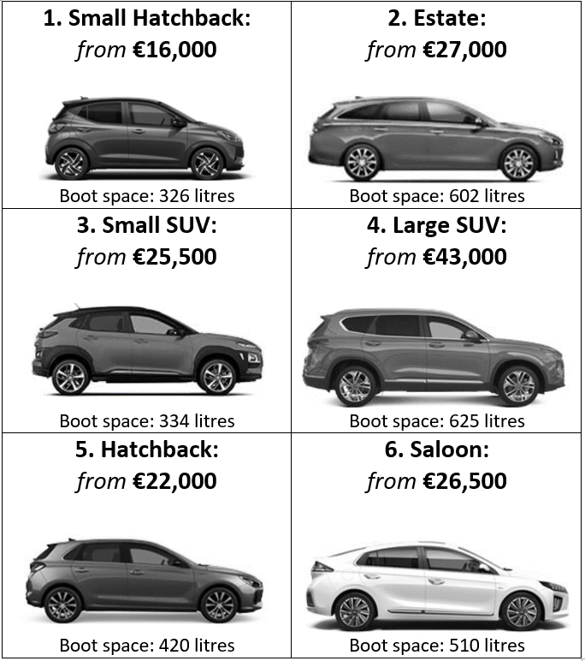 | Step 2: EV Switch Experiment  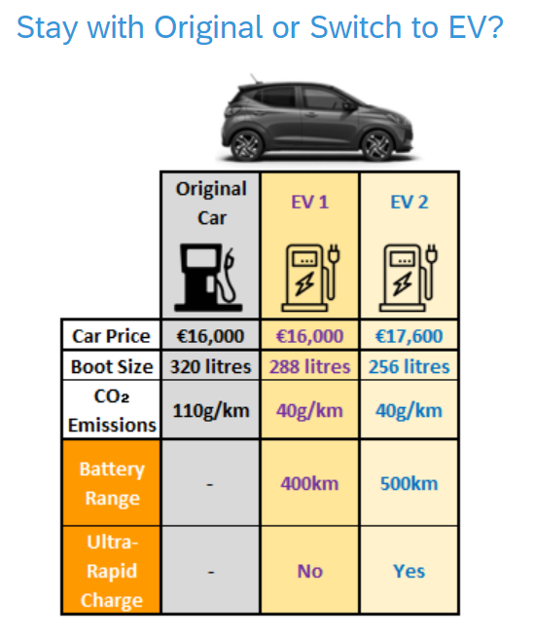
Source: GreenCar DCE

Methods
We use a stated preference methodology – a discrete choice experiment (DCE) – to test the effects of alternative fuel efficiency frames in car choices. To increase task realism and respondent “buy-in” (minimise hypothetical bias), we first asked respondents to choose their preferred car type from six options (left panel of Figure 1), engine type (diesel, petrol or hybrid) and colour (eight available). In the DCE (right panel), this benchmark ICE (internal combustion engine) car was then used to pivot alternative EVs which were identical to a respondent’s initial choice except for four attributes: price (always higher than ICE), range, boot size (always smaller) and “ultra-fast” charge capability.

Eight different energy efficiency frames overlaid this benchmark DCE setup. Respondents were randomly assigned into one of eight experimental groups: control group (carbon per kilometre only) and seven treatment groups which combined various carbon and energy cost frames, the levels of which differed by car type and drivetrain (EV or ICE) only. T1 explored the effect of adding energy cost information per kilometre, while T2 and T3 explored the effects of framing this monetary information over one year and over ten years, respectively (T2 and T3 is compared to T1). In T4, CO₂ is framed over a longer ten-year time frame (T4 is compared to T3). To ensure the effects of T4 are driven by lengthening the respondent’s forecast horizons (and not due to the effects of simply showing larger absolute numbers and differences), T5 and T7 explore alternative but equivalent 10-year frames: CO₂ in kilograms and CO₂ in equivalent washing machine cycles (T5 and T7 is compared to T4). Finally, T6 is considered a special case treatment which explores the effect of framing car price in terms of monthly loan repayments (instead of the full upfront price) and presents energy costs for the same duration (one month).

Results
2,000 respondents (nationally representative) completed the DCE, each choosing from eight choice sets. The overall EV switch rate in the DCE is high at 70%. While this is considerably higher than the share of respondents claiming their next car will be an EV (26%), it is important to note that the DCE displayed hypothetical price and attribute combinations, many of which would be superior to the current market offerings. Figure 2 displays the percentage point (PP) change in the probability of switching from ICE to EV (“switch rate” henceforth) across each treatment group. It appears that monetary fuel efficiency information only increases EV switch rates when framed over time. For example, while T1 (euro per kilometre) has no effect on switch rates, T2 (euro per year) increases EV adoption by 7.2 PPs (relative to T1). However, this duration effect appears to be nonlinear (within our experimental timescale) – T3 (euro per 10-years) is as effective as T2 (no statistically significant difference in effect sizes). Adding long-term CO₂ impacts increases EV switching further. Respondents in T4 received ten-year CO₂ instead of CO₂ per kilometre (but the same monetary information as T3). Compared to T3, respondents in T4 are 5.4 PPs more likely to switch to EV. To ensure the effect of T4 is not simply due to a larger absolute values and differences, T5 and T7 displayed the same ten-year CO₂ information but using smaller units – kilograms of CO₂ (T5) and washing machine cycles (T7) – but both show reduced treatment effects (only significantly lower for T5).

Figure 2: Effect of Treatment (T) on Probability of Switching from ICE to EV Switch in DCE [Mean = 70%]
lower probability higher probability
Source: Own calculations using GreenCar DCE.
Notes: Results describe the percentage point change in the probability of switching from baseline petrol/diesel/hybrid to electric in the DCE. Estimates are based on a logit model (marginal effects) with treatment variables only.

The standard DCE attributes show large and significant effects. Price and range are strong determinants of EV switching. For example, reducing price by ten percent (relative to baseline) increases the EV switch rate by 5.8 PPs. This increases to 12 PPs and 18 PPs for each additional ten PP reduction. In terms of battery range, each 100km increase raises the EV switch rate by 5.4 PPs, 11 PPs and 14 PPs, and, overall, respondents would be willing to pay about €7,000 more for every 100km increase in range. Finally, the presence of “Ultra-Fast” charging capability increases EV switch rates by 5.3 PPs.

Conclusions
Policymakers can support EV adoption through a range of economic supports and informational interventions. Results from this paper show that low awareness of private EV benefits could be slowing EV adoption, and that framing the CO₂ and monetary benefits of EVs in terms of their long-run implications will increase the switch. For example, framing efficiency in terms of ten-year cost and carbon implication increases adoption by about 11 PPs relative to a simple CO₂/km (only) label. However, economic and technological factors will likely be the key determinants of future EV adoption rates. For example, each €10,000 decrease in EV prices is associated with an increase in EV adoption of 5.3 PPs, while each 100km increase in range (holding price fixed) would increase adoption rates by 3.6 PPs. Furthermore, if the typical EV had “ultra-fast” charging and an identically sized boot (to ICE), adoption rates would increase by an additional about 10 PPs.

References
QIAO, Q., ZHAO, F., LIU, Z., HE, X. & HAO, H. 2019. Life cycle greenhouse gas emissions of Electric Vehicles in China: Combining the vehicle cycle and fuel cycle. Energy, 177, 222-233.
TAMAYAO, M.-A. M., MICHALEK, J. J., HENDRICKSON, C. & AZEVEDO, I. M. L. 2015. Regional Variability and Uncertainty of Electric Vehicle Life Cycle CO2 Emissions across the United States. Environmental Science & Technology, 49, 8844-8855.
WU, Z., WANG, M., ZHENG, J., SUN, X., ZHAO, M. & WANG, X. 2018. Life cycle greenhouse gas emission reduction potential of battery electric vehicle. Journal of Cleaner Production, 190, 462-470.

These attributes were randomized using an “efficient” design which created 16 choice unique choice sets spread across two design blocks (eight choices per respondent). The experimental design was implemented in STATA 14 using the “dcreate” command.

