SMR-Concepts (“Small Modular Reactors”)– A System Good Analysis of Producing, Providing, and Financing Nuclear Power with Low Capacities
Jens Leonard Friedrich Kirschner, TU Berlin, +49-(0)30-314-75837, jlk@wip.tu-berlin.de
Ben Wealer, Research Associate, TU Berlin/DIW Berlin, +49-(0)30-314-75837, bw@wip.tu-berlin.de
Christian von Hirschhausen, Professor, TU Berlin/DIW Berlin, +49-(0)30-314-25048, cvh@wip.tu-berlin.de

Overview
In the context of the low-carbon energy transformation, a technology is gaining attention which is currently explored in several countries around the world, called SMR (“Small Modular Reactors”). SMR concepts, i.e. nuclear power with low capacities, date back to developments in the 1940s, in particular the development of naval submarines. However, in the context of discussions about the use of future nuclear reactors, in particular also as a measure against climate change, the concept of SMRs has been receiving renewed attention for some time. For the purpose of this paper, SMRs are reactors in which a single unit has an electrical power output of less than 300 MW_{e} (or a thermal power output of less than 1000 MW_{th}); these can be both based on water-cooled or other (non-water cooled) reactor designs.
In this paper, we provide a system good analysis of SMR concepts, and the similarities and differences with respect to nuclear plants with high electric capacities (often over 1,000 MW_{e}). The paper looks in detail at the complex good (or “system good”) SMR, which often includes a multitude of services and goods that have to be produced in advance or in parallel, which requires coordination among the involved actors. The aim of this paper is to analyze SMRs, both commercial and military, as well as the existing interdependencies in order to design and compare different organizational models for the sector and discuss the role of the state and private companies in the provision of the good. The paper is based on recent research projects by the authors (Wealer, Seidel, and von Hirschhausen 2019; Schneider et al. 2019; Pistner et al. 2021); the systems good approach has been applied to the nuclear power sector by Wealer, et al. (2020).

Methods
We deploy a comparative institutional approach to describe the strategic choices of countries, companies, and national and international governmental bodies with respect to SMR development. We use the methodology for implementing a (system-) good put forward by Beckers, Gizzi, and Jäkel (2012) and Gizzi (2016) as our tool of analysis. It allows us to map all the subtasks involved to make (semi-) public infrastructure available in one framework. The latter consists of three elements and their interaction between these three submodels: the sector model, the decision model (provision), and the organizational model. Key elements of the framework are the technological system (e.g. the nuclear infrastructure), the actors (e.g. individuals, organizations), their asset and roles, as well as institutions (e.g. regulation). In order to compare different organizational models with the aim of creating a ranking, a comparative evaluation of organizational models must be carried out. This includes evaluations (i.e. subjective statements) with respect to certain evaluation criteria based on suitable economic theories (e.g. institutional economics).

Preliminary Results
A compilation made as part of the report underlying this paper (Pistner et al. 2021) includes 136 different historical as well as current reactors or SMR concepts. Of these, 31 concepts were considered in greater detail. A broad introduction of such concepts has not yet taken place. Some of these SMR concepts already have a very long history of development. For example, the development of Argentina's CAREM dates back to the 1970s. Other SMR concepts are more recent and therefore still in an earlier phase of concept development. Further SMR concepts are discussed as current concepts whose development is effectively interrupted (such as the South African PBMR-400).
A variety of motivations intermingle in technology and innovation policy, including industrial and economic development and geopolitical influence. Industrial and geopolitical motivations, as well as military interests, also play a role in SMR development. Most countries pursuing SMR activities maintain nuclear weapons programs and build nuclear submarines and/or already have a large commercial nuclear program. The paper places focus on the financing of SMR-concepts, and the different roles of actors in a highly complex financial architecture. Figure 1 sketches out the financial structure for the NuScale SMR concept.
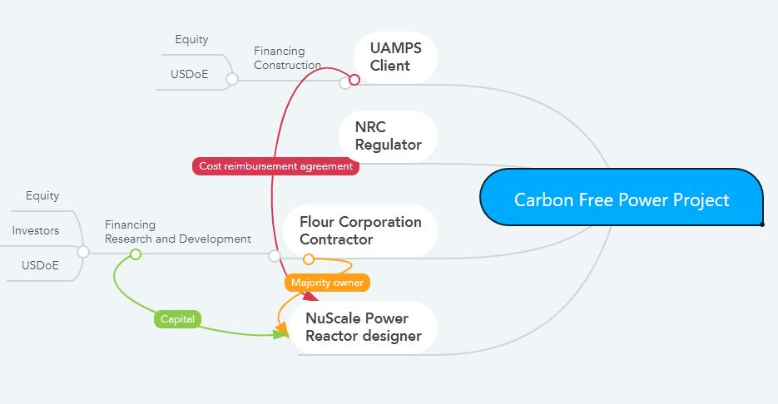
Figure 1: Financial scheme for a SMR concept in the US (Source: Own illustration).

Conclusion
Non-water cooled SMR concepts include fundamental innovations compared with today's nuclear power plants. For example, higher efficiencies are to be achieved through higher operating temperatures. Furthermore, other fields of application, in particular the provision of high-temperature process heat, should become possible. Many of these concepts aim at a so-called closed fuel cycle, with associated high technological risks in the field of fuel development and reprocessing technologies. Significantly less operating experience, mainly from prototype and demonstration reactors, as well as the planned use of novel technological solutions and new materials, lead to the expectation of significantly longer development periods as well as higher technological development risks compared to water-cooled SMR concepts. Achieving a competitive levelized cost of electricity (LCOE) for SMRs compared to renewables seems unlikely.

References
Beckers, Thorsten, Florian Gizzi, and Klaus Jäkel. 2012. “Ein Untersuchungsansatz für Systemgüter: Einordnung, Darstellung, Vorgehen bei der Anwendung.” 2012–01. WIP-Working Paper. Berlin: Technische Universität Berlin.
Gizzi, Florian. 2016. “Implementierung komplexer Systemgüter: Ein methodischer Ansatz für ökonomische Untersuchungen und seine Anwendung auf Verkehrstelematiksysteme für die Straße.” Berlin: Technische Universität Berlin.
Pistner, Christoph, Matthias Englert, Christian Küppers, Ben Wealer, Björn Steigerwald, Christian von Hirschhausen, and Richard Donderer. 2021. “Sicherheitstechnische Analyse Und Risikobewertung Einer Anwendung von SMR-Konzepten (Small Modular Reactors).” Wissenschaftliches Gutachten im Auftrag des Bundesamtes für die Sicherheit der nuklearen Entsorgung (BASE) urn:nbn:de:0221-2021030826028. Darmstadt: Öko-Institut e.V.
Schneider, Mycle, Antony Froggatt, Julie Hazemann, Tadahiro Katsuta, Amory B. Lovins, M. V. Ramana, Christian von Hirschhausen, and Ben Wealer. 2019. “World Nuclear Industry Status Report 2019.” Paris, London: Mycle Schneider Consulting.
Wealer, Ben, and Christian von Hirschhausen. 2020. “Nuclear Power as a System Good. Organizational Models for Production Along the Value- Added Chain.” DIW Discussion Paper 1883. Berlin, Germany: DIW Berlin.
Wealer, Ben, Jan Paul Seidel, and Christian von Hirschhausen. 2019. “Decommissioning of Nuclear Power Plants and Storage of Nuclear Waste: Experiences from Germany, France, and the U.K.” In The Technological and Economic Future of Nuclear Power, edited by Reinhard Haas, Lutz Mez, and Amela Ajanovic, 261–86. Wiesbaden: Springer VS. https://doi.org/10.1007/978-3-658-25987-7_12.

