**[*Research on the resilience of nodes in energy mineral resources supply chain under emergency risk*** ***based on multilayer complex network*]**

[SHEN Xi, China University of Geosciencese(Wuhan), +86 18612116643, senseme@yeah.net]

## Overview

With the severe changing international situation, the energy mineral resources is critical to the development of countries with seldom energy resource endowment, which makes the international trade of energy mineral resources of serious strategic importance. Based on multilayer complex network theory, this paper models the supply chain network of energy mineral resources using a three-layer relational complex network---trade, information and price index layer. In the study of the transmission mechanism of the risk, product supply-demand relationship, Industrial chain input-output relationship as well as the influence of price are comprehensively considerred. The process of the recovery of the system after perturbed by emergency risks is simulation studied and the process and scales of losses of the nodes are quantitatively measured. Using price elasticity of demand for reference, the concept of risk resilience which is calculated with the simulation results of multiple risk situations is introduced to explain the change of the total loss of nodes brought by every 1% of risk degree. The results of the simulation shows that the main factors that affect the loss scale of the coal import of China are risk source, degree of risk, competitive capacity of the nodes and the scale of the import. When facing emergency risks coming from Mongolia and Australia---the two most important coal trade sources of China, China is more fragile while the risks come from Mongolia. As a node of the supply chain network of a energy mineral resource, China has to enhance the capability of risk bearing by improving connectivity with upstream nodes, optimizing the structure of import and improving bargaining power.

## Methods

Based on multilayer complex network theory, this paper models the supply chain network of energy mineral resources using a three-layer relational complex network---trade, information and price index layer. The trade layer network is built according to the real trading relationship between countries which means the countries are treated as nodes and the importation/exportation are treated as weighted edges. The information layer network also sets countries as nodes, but the edges become the competitive relations between countries which would affect the international trading under emergency risks. The last layer is price index layer, which determines the recovery of the total production by attracting or extruding investment.

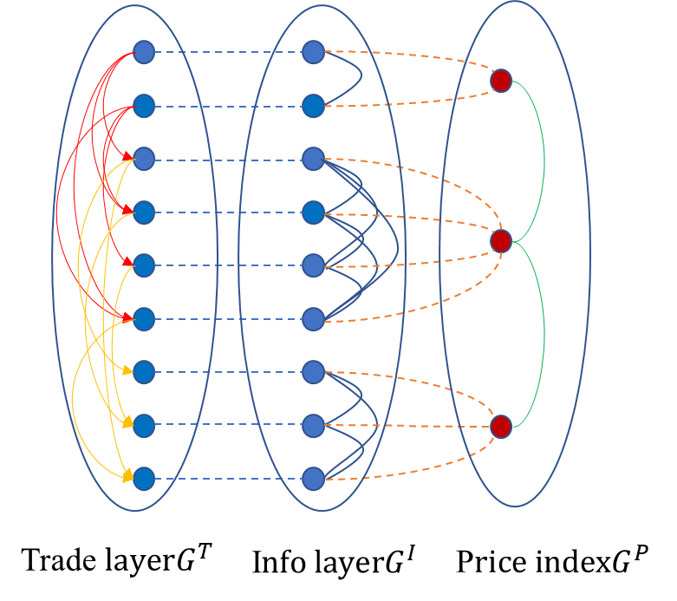The 1st layer---trade layer is set as, Where is the set of nodes(countries), and is the set of edges, and is the weight of edges. The 2nd layer---information layer is represented as , where is the set of the heterogeneity of nodes, which determines the competitive capacity of nodes during the risk, the shortage of mineral resources caused by risk . Here we chose price elasticity of demand as the main factor. The 3rd layer---price layer is represented as , where  is the set of price index in different markets and is the edges between market prices. The 3 layers of network connect and influence each other through nodes, which affecting the transmission of risk.

Based on the PageRank algorithm, we proposed a transmission mechanism of risk, and set a series of risk circumstances to simulate the transfer of risk in the 3-layer network. In the study of the transmission mechanism of the risk, product supply-demand relationship, Industrial chain input-output relationship as well as the influence of price are comprehensively considered. The process of the recovery of the system after perturbed by emergency risks is simulation studied and the process and scales of losses of the nodes are quantitatively measured. Using price elasticity of demand for reference, the concept of risk resilience which is calculated with the simulation results of multiple risk situations is introduced to explain the change of the total loss of nodes brought by every 1% of risk degree:Where is the loss of target node, is the scale of risk(the percentage of exportation reduce of risk source node), is the constant term, is the variation of price index, is the resilience index we are looking for.

## Results

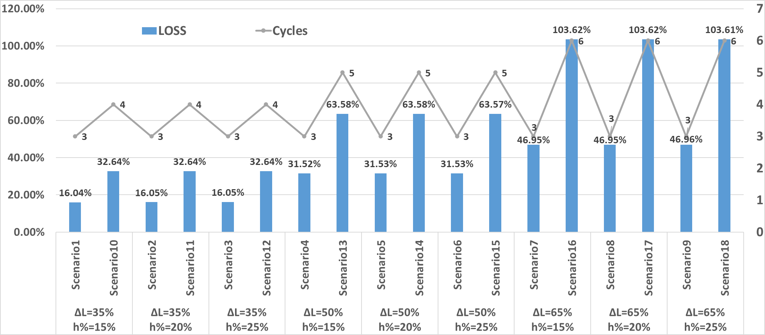The results of the simulation shows that the main factors that affect the loss scale of the energy mineral resources(coal) importation of China are risk source, degree of risk, competitive capacity of the nodes and the scale of the import. The model we proposed based on multilayer complex network is appliable for most of mineral resources such as coal, petroleum and so on. In the experiment section, we chose coal as an example, when facing emergency risks coming from Mongolia and Australia---the two most important coal trade sources of China, China is more fragile while the risks come from Mongolia. When the loss of coal production brought by emergency risks increases by 1%, regardless of the inventory, China would loose about 1.74% coal importation during the whole emergency risk process.

## Conclusions

As a node of the supply chain network of a critical mineral resource, China has to enhance the capability of risk bearing by improving connectivity with upstream nodes to increase the importation sources, optimizing the structure of import to avoid single main importation resource becoming the fatal risk resource and improving bargaining power .