COMMITING TO FLEXIBILITY: A FIELD EXPERIMENT ON HOUSEHOLD DEMAND
Buckley Penelope, UGA, penelope.buckley@univ-grenoble-alpes.fr
Adelaide Fadhuile, UGA, adelaide.fadhuile@univ-grenoble-alpes.fr
Daniel Llerena, UGA, daniel.llerena@univ-grenoble-alpes.fr
Beatrice Roussillon, UGA, beatrice.roussillon@univ-grenoble-alpes.fr

Overview
This article presents the results of a long-term field experiment with the objective of motivating demand response in the household through the use of nudges. We analyse the electricity usage of 173 households with high frequency data (30-min) and we implement a nudge with 96 treatment households during peak hours to encourage them to shift their electricity usage. The nudge takes the form of a commitment from the household to undertake several actions during the peak hours. Preliminary results of the first year experimentation suggest that our nudge is efficient at inducing load shedding or curtailment from the household during peak hours.

Methods
We conducted a field experiment with 173 households beginning in June 2019. The households were distributed into a control group and a treatment group. The control group comprised 79 households and the treatment group comprised 96 households. We nudged the treated group to load shift their electricity usage during peak hours. Our nudges have three features:
- Informing the participants when there is a peak in electricity consumption (alert day).
- Informing the participants of the actions, they can undertake to increase their flexibility, and ask them to commit to several actions.
- Giving a feedback to the participant about their effort on the alert day.
The experiment began with an information session during which we informed participants how grid balancing works, and why demand flexibility is necessary to increase production from renewable energy sources and to reduce that from thermal power plants. The participants then completed a questionnaire on their habits and their electrical appliances. This allowed us to create a personalised list of actions that each household can undertake when demand flexibility is necessary to balance the grid. Each participant then committed themselves to several actions that they would do/or not do during peak hours.
During the 2019-20 winter, we used PP1/PP2 days from RTE website to determine our alert day (Peak Period 1 and 2), these days correspond to high electricity consumption determined by RTE and the use of thermal power plants to produce electricity. This means a high level of tension in the grid and high level of pollution that require action from consumers.
For each alert day, D, participants received an SMS on D-1 to inform them of the period of peak consumption from 6:00pm to 8:00pm the following day. On D, they received an SMS reminding them of the alert and indicating the actions that they committed to. A few days later, participants received an SMS inviting them to connect to their personal page on the study website for feedback on their consumption on the alert day. This feedback takes the form of a reference curve (the consumption the participant should have had without the nudge signal), and measured consumption curve. This feedback allows participants to evaluate the result of their efforts.

Results
Our preliminary results show that, households reduced their consumptions during peak hours on alert days. The effect of the nudge during the alert is approximately a 10% to 15% reduction during consumption peak. This reduction is partly explained by a change in the shape of the electricity curve. The figure below presents the electricity consumption for the day of the 7th alert. We observe a clear difference between the control group (in blue) and the treated group (in green) during the load curtailment period on the D day (grey area). However, we do not find evidence of habit formation, as the nudge effectiveness is not increasing nor decreasing over time. Interestingly, spillovers seem to appear at different time of the day.

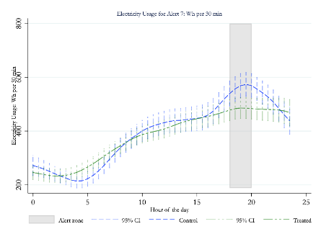

Conclusions
The traditional demand response techniques either ask for direct load control or offers price-based incentives to the residential customer. However, these techniques are intrusive and may be costly and risky for the consumer. Direct load control requires expensive equipment and can lead to a decrease in consumer comfort. Price-based incentives may result in higher bill if the consumers fail to adapt their consumption accordingly. An alternative mechanism is proposed in this article, in which nudge signals are sent to the households of treated group with indirect feedback and no price incentive. This mechanism is used to test energy flexibility for downward flexibility (load curtailment).
In the experiment, we test if predictions of intermittent energy generation and network congestion, and consumer commitments on flexible action can motivate the residential consumers to implement indirect flexibility. A control group is established with same energy consumption behaviour of treated group. The comparison of energy consumption of both groups reveals that the nudge signal has an impact on the households for 7 alerts out of 9 (during winter 2019-20), in which the average energy consumption of treated group on alert day ‘D’ is less than that of the control group.

