Cointegration analysis of Austrian wood and bioenergy markets

Marilene Fuhrmann, BEST – Bioenergy and Sustainable Technologies GmbH, +43502378-9453,
marilene.fuhrmann@best-research.eu
Christa Dißauer, BEST – Bioenergy and Sustainable Technologies GmbH, +43502378-9455, christa.dissauer@best-research.eu
Christoph Strasser, BEST – Bioenergy and Sustainable Technologies GmbH, +43502378-9427, christoph.strasser@best-research.eu
Erwin Schmid, Institute for Sustainable Economic Development, +43 1 47654-73002, erwin.schmid@boku.ac.at

Overview
Wood and woody biomass are essential energy sources in Austria. In 2019, about 32% of the gross domestic energy consumption (1,450 PJ) have been produced from renewables, thereof 55.7% from biomass (258 PJ). The Austrian “Erneuerbaren-Ausbau-Gesetz” (EAG) aims to increase the power consumption from biomass by 3.6 PJ until 2030. Consequently, the competition for woody raw materials is increasing and stimulates the utilization of industrial by-products. Such developments have consequences on product, energy and raw material markets and price developments. Hence, the relationships between roundwood, sawmill by-product and wood product markets are empirically investigated in this study. The consideration of wood pellets and particle board as wood products allows to analyse material and energy utilization pathways. In particular, the analysis of historic price cointegration allows to quantifiy market effects of the EAG as well as price shocks from economic crises and forest calamities.

Methods
Econometric methods are employed to analyse price cointegration of wood product markets in Austria. Monthly price data were used for sawlogs, pulpwood, wood chips, sawdust, pellets and particle board in the period January 2005 to November 2020. The software package R is used for the following analyses:
The Johansen Cointegration Test was applied to all combinations of prices. If cointegration is present, there is a co-movement of prices and a long-term balance, whereby deviations are only short-term. The Granger Causality Test, applied to cointegrated time series, allows to identify price leading and price following markets. Based on identified cointegration and Granger causality, Vector Error Correction Models (VECM) were estimated to analyse the long-term balance of cointegrated time series as well as the adaptation behaviour of a price after short-term deviations.

Results
Cointegrated prices are illustrated in Figure 1, combined with the direction of Granger causality (both on a 5% significance level). Cointegration was found to be present between roundwood, sawmill by-products and wood products.
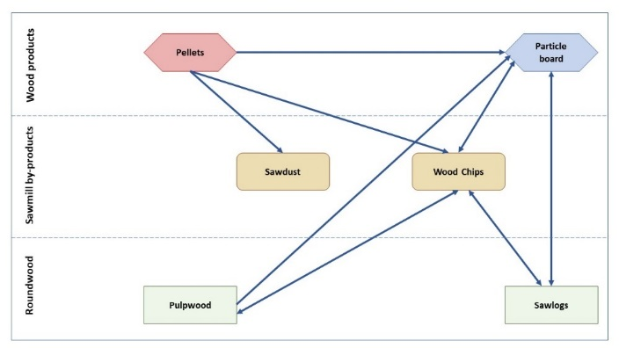
Figure 1: Price cointegration in Austrian roundwood, sawmill by-product and wood product/bioenergy markets. Arrows represent the direction of Granger causality between cointegrated time series. (own illustration)

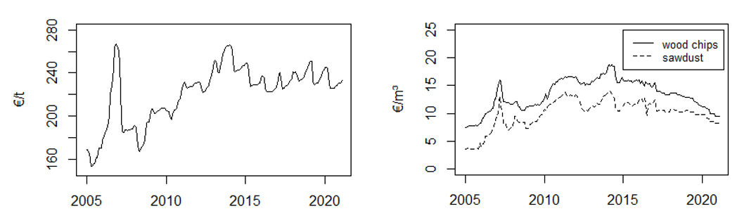
Figure 2: Price development of A1 wood pellets in €/t (left side) and sawmill by-products in €/m³ (right side) in Austria (data sources: proPellets Austria 2020, Holzkurier 2020; own illustration)
Results have shown that pellet prices Granger cause prices of sawdust and wood chips and hence are price leading. The wood pellet market has benefited from the EU Renewable Energy Directive (RED). A first boost in pellet boiler installations has led to shortages in pellet supply. Hence, prices increased significantly in 2006/07. After expansion of capacities and a decrease in demand, prices dropped and stabilized again (Figure 2, left side). Figure 2 shows the influence of pellet prices on sawmill by-product prices, as there are similar movements, but less intense for wood chips and sawdust. Through further price cointegration of wood chips with particle board and roundwood, pellet prices are indirectly influencing these markets as well. These empirical findings suggest that the EAG will have significant market effects in the whole forest-based sector in Austria. As new technologies will also enter the market, increasing use of industrial by-products and residues can mitigate shortages in raw material supply.
However, data of recent years suggest that there are other influences on raw material prices as well, as sawmill by-product prices decreased while pellet prices were stable. There was obviously imperfect price transmission, thus sawmill by-product prices were more affected by Covid-19 consequences. Since wood chip prices are versatilely cointegrated, there are influences exerted from the product (pellets, particle board) as well as from the roundwood side, which are reflected in a stronger decline in prices. This price shock is better mitigated by the sawdust market, as prices are mainly influenced by pellets, which are less affected by the crisis. According to the VECM, the Error Correction Term for sawdust is 0.2352, which means that after short-term deviations, sawdust prices return to the long-term balance by 23.5% per month. After 3 months, more than half of the balance is regained. In comparison, deviations of wood chip prices are only reduced by 7.9% each month. Hence, it takes 8.5 months to regain the long-term balance.

Conclusions
Knowing about price cointegration and price transmissions between raw material and product/bioenergy markets supports the design of political measures such of EAG and RED. Recent developments have shown that supply shortages influenced sawmill by-product and product markets, even in material utilization. Hence, an increased use of industrial by-products and wood residues is incentivized. Analyses have also shown that raw material markets can benefit from the promotion of products, as the pellet market is less affected by the Covid-19 crisis and thus can have a stabilizing effect on other markets to some extent.

