The Value Of Energy Efficiency In Residential Buildings – A Matter Of Heterogeneity?!
Joachim Geske, Imperial College London, +44 (0)20 75942744, j.geske@imperial.ac.uk

Overview
Buildings, most of them already existing, will need to be decarbonised if the world is to hit climate targets. One measure to promote this is the use of energy efficiency certificates and the prospect that buildings with low energy costs will receive a (sale or rental) price premium.
As early as 2002, the EU introduced binding energy efficiency ratings for buildings with the Energy Performance of Buildings Directive. The ratings aimed to reduce uncertainties about the energy consumption of buildings on the market, promoting investments in energy efficiency in order to reduce dependence on fossil fuels and also to meet the greenhouse gas reduction targets, which were lower at that time. The tightening of the climate targets has now encouraged new interest in increasing energy efficiency in the building sector and in the policy instruments that stimulate it. However, the effectiveness of the ratings is still considered insufficiently proven.
Since it is difficult to provide direct evidence of the effectiveness of the investments, international evaluation studies aimed to measure whether energy efficiency ratings were reflected in the building price. This is a prerequisite for the profitability of investments: one would expect that rational homeowners offset the reduction in the building's operating costs through energy efficiency investments for the same housing quality against the building price. For homes that are otherwise comparable, the premium for an above-average energy-efficient building should then be just as high as the price discount for a building that is equally below-average.
In fact, evaluation studies show positive rewards for energy-efficient buildings. However, the discounts on comparable inefficient buildings are two to twenty times lower than the expected energy cost penalty (figure 1 for UK). This result can be found in several studies of different countries. The unexpected asymmetry of the premium makes it difficult to interpret the effectiveness of the ratings and raises fundamental questions about incentives for energy efficiency investments.
In this study we explicitly present the asymmetry of the premiums and discuss possible explanations, such as econometric errors and demand heterogeneity with regard to income, discount rate and environmentally friendly attitudes of the owners. We examine the suitability of these approaches to explain the premium asymmetry measured and examine their implications.
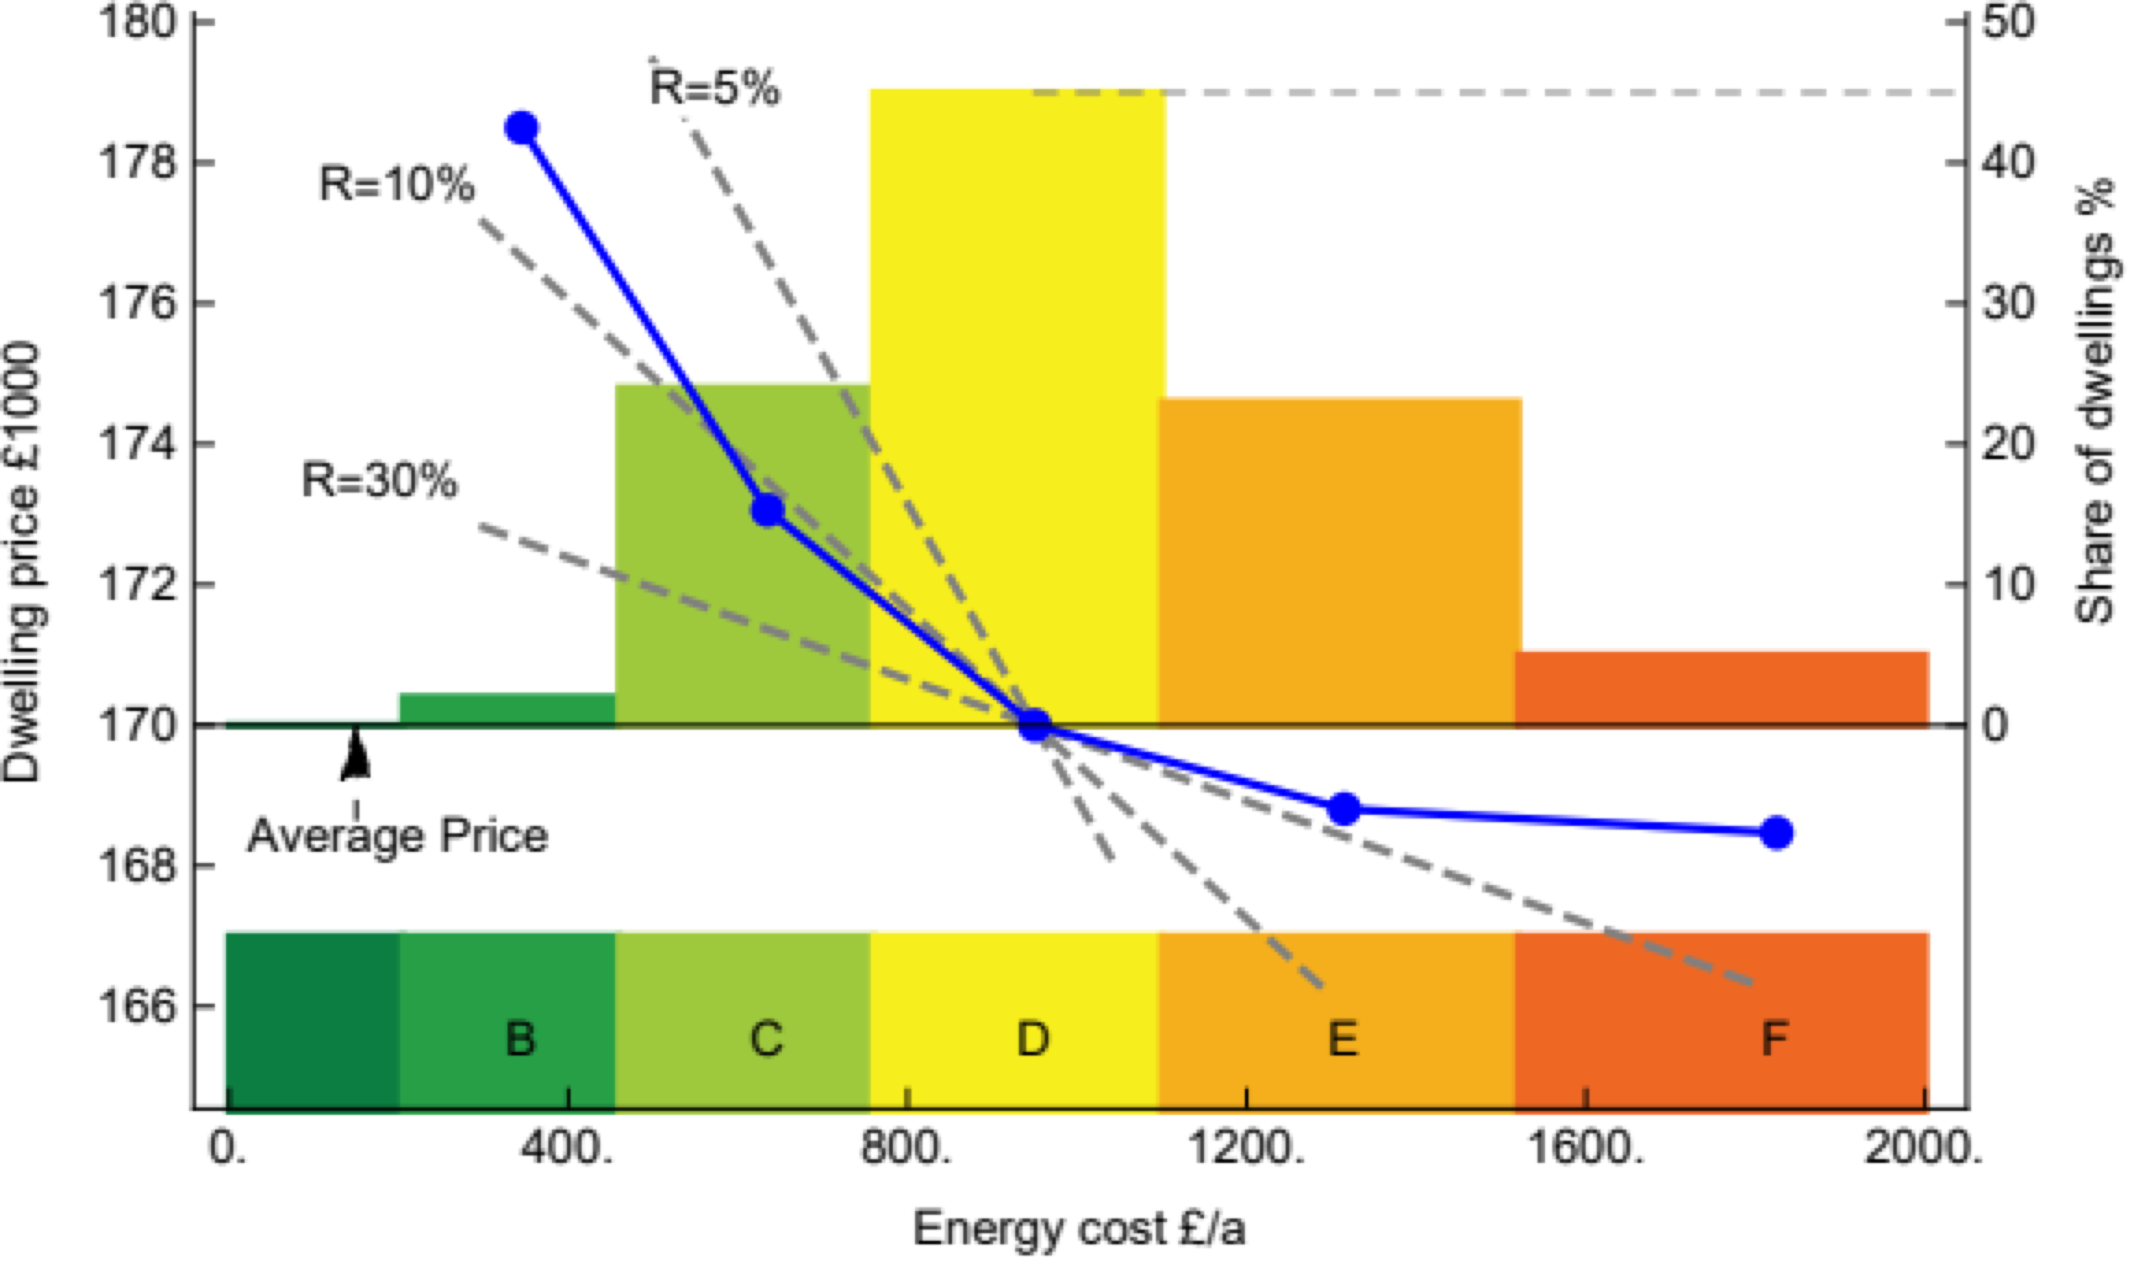
Figure 1: Housing price and energy costs; Blue dots mark the price premium of energy efficiency bands measured by hedonic regression of Fuerst et al. (2015). Dashed black lines: arbitrage solution with 5%, 10% and 30% interest rate.

Methods
We use economic theory to test possible explanations of the empirical pattern of asymmetry. In detail a hedonic model of product differentiation under perfect competition (e.g., Tinbergen (1956), Ekeland et al. (2004)) is applied to the building sector. The model includes demand, supply and a hypothesis of market functioning. Buildings are described by a large number of parameters (characteristics) such as the living space, building age and location. Personal traits of the buyer, among others the willingness to pay for energy efficiency, are also considered. Under these circumstances, rational buyers are assumed to choose a building under the influence of individual random valuations and market prices direct demand and supply until they are balanced. We provide a closed form solution to the hedonic equilibrium model of building heterogeneity and show this can cause the observed non-linearity of the premiums.
As we discuss reasons for differences in the willingness to pay like income, we find discounting heterogeneity is a well-documented and convincing explanation. Finally, we show that the reduced form solution unfortunately does not allow the identification of a common passthrough of efficiency investments. Only the specification of a lower limit is possible. With discounting heterogeneity this lower bound is estimated as 73%.

Results
If the idea that buyers would be willing to switch between buildings for the smallest price difference was given up, competitive markets would behave differently: Assume that the number of buildings in each efficiency class is initially the same. Now assume the supply of medium-efficient buildings was increased. Then the premium curve can modulate demand by diversifying the purchase decisions through heterogeneity of the buildings and the willingness to pay: namely buyers with the highest willingness to pay for efficiency would ask for the most efficient buildings and vice versa. Object heterogeneity increases the willingness to pay for certain buildings, so that the energy costs of the building are no longer the only factors that determine the purchase. This also fans out demand.
Fanned demand offers the premiums “points of attack” to shift demand to the respective neighboring classes - until supply and demand in all classes are balanced. In other words, the price-premium curve deforms non-linearly and “pulls” demand into high-supply regions. In our example, the price premium for buildings with medium efficiency falls because their supply is high, and it increases for buildings with high and low efficiency because their supply is low.
This effect of concentrated supply is overlaid by the linear efficiency premium. As a result, in the case of efficient buildings, the premium from cost savings and scarcity adds to the net premium; in the case of inefficient buildings, the cost surcharge and scarcity premium balance out and are therefore reduced. This results in an asymmetric non-linearity of the net premiums for efficiency. Heterogeneity in demand or buildings and concentrated supply together cause a non-linear premium curve - exactly as empirically observed.

Conclusions
Investing in energy efficiency brings energy cost benefits for building owners. As long as the owner lives in the building himself, this connection is obvious. If the building is rented out, the investment enables the tenant to reduce operating costs. Rationally acting landlords anticipate this, and they price the savings into the rent. Even if the building is sold, a price premium enables the seller to participate in future savings. In both cases, prices have to 'pass-through' the anticipated monetary savings of the investment to the investor without loss in order not to distort investment incentives.
Empirical analyzes of efficiency premiums show that this lossless pass-through is not easily detectable. Rather, different perceptions of future savings and the scarcity of efficient buildings can cloud the transmission: the premium for energy-efficient buildings exceeds the discount for inefficient buildings by many times. This paper models the effect of buyer and building heterogeneity on the premium pass-through, showing that at least 73% of the expected savings are passed through to building prices. This is an encouraging result though the prospect that the premium falls as the share of really efficient buildings rises may prove a hurdle on the way to increasing energy efficiency in the building sector and thus to climate neutrality in 2050.
Rising fossil fuel prices might increase the savings potential and could therefore push the pass-through. Should this not be the case, there would still be building regulations and efficiency standards that would deprive building owners of the freedom of choice and force them to invest - with considerable efficiency losses in implementation and political-economic implications. It is therefore reassuring that the efficiency premium puzzle can in fact be explained by supply, demand and heterogeneity.

References
- Fuerst, F., McAllister, P., Nanda, A., Wyatt, P., 2015: „Does energy efficiency matter to home- buyers? An investigation of EPC ratings and transaction prices in England”, Energy Economics, Volume 48, Pages 145-156.
- Ekeland, I., Heckman, J. and Nesheim, L., 2004: “Identification and Estimation of Hedonic Models”, Journal of Political Economy, Vol. 112, No. S1, Papers in Honor of Sherwin Rosen: A Supplement to Volume 112, pp. S60-S109.
- Tinbergen, J., 1956: “On the Theory of Income Distribution”, Weltwirtschaftliches Archiv 77 (2): 155–73.

