Conceptual Agent-based model of NEIGHBOURHOOD-Level Building retrofits based on Energiesprong approach

Ardak Akhatova, Technische Universität Wien (TUW), ardak.akhatova@tuwien.ac.at
Lukas Kranzl, Technische Universität Wien (TUW), lukas.kranzl@tuwien.ac.at
Javanshir Fouladvand, Delft University of Technology (TU Delft), j.fouladvand@tudelft.nl

Overview
Reducing energy demand in the building sector is one of the fundamental approaches for addressing the climate problems, as buildings and their construction are responsible for over one-third of global energy demand and almost 40% of the carbon emissions [1]. Energy-efficient building retrofits, such as building envelope insulation and improvement of HVAC systems, are necessary measures to reduce energy demand and the related emissions attributed to buildings [2]. However, the current rate and levels of building retrofits in the EU countries are insufficient to meet the pledged climate goals [2,3]. A potential way to accelerate building retrofits in European districts is offered by the innovative building retrofitting approach called “Energiesprong”. It is an innovative business model that relies on net-zero energy performance contracts, cost reduction due to the bundling of the retrofitting demand, off-site manufactured retrofitting components (i.e. insulated facades and PV-integrated roofs), accelerated installation process, and single customer interface [4–6]. This approach transforms the traditional “contractor-supplier” stakeholder structure in the current retrofitting market into a more integrated and interconnected system of stakeholders. In addition to traditional stakeholders (e.g. policy-makers, households, and housing associations), new players such as market development team and refurbishment solution provider need to be involved for a functional market [4]. Nevertheless, the characteristics, behaviours and their possible interactions are more complicated and not well understood yet.

Hence, we want to apply the agent-based modelling (ABM) approach that is deemed suitable for modelling the complex interactions between heterogeneous agents with different goals and characteristics [7]. With the future ABM we want to explore the effect of policies or measures necessary to satisfy the stakeholders and result in the retrofitted neighbourhoods. The current article is the initial step towards this model – conceptualisation. According to the methodology by Nikolic and Ghorbani (2011), a problem to be tackled, actors, their behaviours and relationships, the environment they live in are to be identified and structured at this stage. Supported by the literature review on the ABM of urban and district energy systems and on the Energiesprong approach, a conceptual ABM that explores the standardised retrofitting approach (i.e. Energiesprong) is elaborated within this article. In this way, we intend to contribute to energy demand reduction in the building sector and the energy transition.

Methods
Conceptualisation of the ABM is not an easy process, as ABM is a modelling paradigm that can be implemented in very different ways [7]. Nevertheless, certain frameworks provide generalised methodological support regardless of the discipline or purpose of models. The five-phase framework for developing ABMs of socio-technical systems by Nikolic & Ghorbani (2011) consists of steps common to many software engineering methodologies: system analysis, model design, detailed model design, software implementation and model evaluation [8]. Each phase is subdivided into several ABM-specific iterative steps. In this article, we follow this framework and focus only on the first phase (“system analysis”), which results in the conceptual ABM. This phase consists of the following sub-steps:
- Problem and problem owner identification: formulation of the problem and research questions, defining whose problem is going to be addressed and how the model is going to be used.
- System identification: listing of actors, their behaviour, relationship between the actors; specification of the actions performed by the actors, a description of the environment in which the actors are performing in;
- System conceptualisation: decomposition into a structure that is manageable and understandable via e.g. IAD framework, Williamson’s four-layer model, UML analysis diagrams, or MAIA.
The implementation of this framework is supported by the literature review on Energiesprong and similar “one-stop-shop” business models.

Results
The outcomes of this article can be divided into the following sections:
- Literature review on the Energiesprong retrofitting approach
- Clear statement of the problem to be tackled and the problem owner
- Identification of main stakeholders, their possible behaviours and relationships in the standardised building retrofitting domain
- Conceptualisation of the system to be modelled using a diagram in Unified Modelling Language (UML).
The standardised retrofitting initiative, known as Energiesprong, originated as a government-funded program to achieve net-zero energy homes in the Netherlands and has expanded to the UK, France, the USA and Canada [5]. The main stakeholders include the market development team, the residents, housing provider, the construction industry (i.e. retrofitting solution providers) and policymakers [5]. The market development team is an intermediary actor who brings all stakeholders together and performs key intermediation forms – facilitating, configuring and brokering [5]. It also acts as a single point of contact for customers (i.e. “one-stop shop” model). The customer in this case is a social housing provider, because, so far, the target market for Energiesprong has been the social housing sector (due to large and uniform housing stock belonging to social housing providers). A retrofitting solution provider offers the customer a holistic residential retrofit and guarantees the subsequent net-zero performance amortised over a calendar year. The net-zero consumption is achieved with the set conditions, such as internal temperature of 21°C in living spaces and a set allowance of hot water and electricity consumption [9]. That is where the cooperation and engagement of tenants are necessary. In a net-zero building, tenants’ energy bills are decreased, given they follow the set conditions. However, they pay the saved energy bills to housing providers (i.e. as per “energy plan”), so that the latter can use it as instalments on the loan for retrofitting. For this financial scheme to operate, certain regulatory changes might be necessary. For example, rent caps might be a barrier for the proposed “energy plan” or rules in relation to exchange of PV electricity with the grid should be reconsidered. This is where the role of government or policymakers is crucial.

The characteristics and behaviours of these stakeholders are summarised in Figure 1, the diagram that depicts our initial ideas on how Agent-based model can be designed. Although an ABM can be very versatile, we plan to take the perspective of policymakers in order to test how different measures and policies impact the behaviour and interaction of the represented agents.
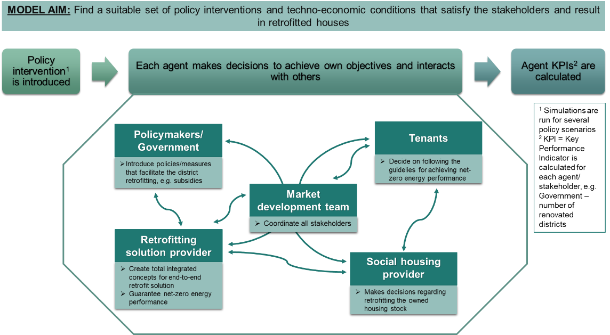
Figure 1. The schematic representation of the actors and interactions in the conceptual ABM of the standardised building retrofitting process

Conclusions
Energiesprong, as the new standard for the building retrofitting processes, has the potential to change the building retrofitting domain. Agent-based modelling framework will be used to explore how this novel approach can be supported to achieve the net-zero building retrofits in district/neighbourhood scale. As an initial step towards the model, we use five-phase methodology and identify the main stakeholders, their behaviours and relationships. This results in the conceptual ABM of standardised neighbourhood-level retrofitting approach, which will help finding suitable policies and measures to enable the energy transition through such housing stock renovations. Future research should explore potential policies and initiatives that could incentivise ‘standardised’ district retrofitting.

References
1. IEA. Buildings – Topics - IEA. Iea (2020).
2. Filippidou, F. & Jimenez Navarro, J. . Achieving the cost-effective energy transformation of Europe’s buildings. (2019). doi:10.2760/278207.
3. Enerdata. Zebra 2020 - DATA TOOL. (2016).
4. Energiesprong. Energiesprong explained – Energiesprong. (2020).
5. Brown, D., Kivimaa, P. & Sorrell, S. An energy leap? Business model innovation and intermediation in the ‘Energiesprong’ retrofit initiative. Energy Res. Soc. Sci. 58, 101253 (2019).
6. Fawcett, T. & Topouzi, M. The time dimension in deep renovation: Evidence and analysis from across the EU. Eceee Summer Study Proc. 2019-June, 1253–1258 (2019).
7. Akhatova, A., Kranzl, L., Schipfer, F. & Heendeniya, C. B. Agent-based modelling of urban and district energy systems – A systematic literature review. (2021).
8. Nikolic, I. & Ghorbani, A. A method for developing agent-based models of socio-technical systems. 2011 Int. Conf. Networking, Sens. Control. ICNSC 2011 44–49 (2011) doi:10.1109/ICNSC.2011.5874914.
9. Brown, D. Business models for residential retrofit in the UK: a critical assessment of five key archetypes. Energy Effic. 11, 1497–1517 (2018).

