Reducing carbon emissions of households through monetary incentives and behavioral interventions:

Tarun Khanna, MCC-Berlin, 4917627014179, khanna@mcc-berlin.net
Jan Minx, MCC-Berlin, minx@mcc-berlin.net
and others (available in the main paper)

Overview

Despite the importance of evaluating all mitigation options to inform policy decisions addressing climate change, a systematic analysis of household-scale interventions to reduce carbon emissions is missing. Here, we address this gap for one important category of demand side measures: interventions aimed at changing the usage of existing equipment by households. We perform a machine learning-assisted meta-analysis to comparatively assess the effectiveness of these interventions and combinations of them in reducing energy demand of residential buildings. We identify 122 studies and extract 360 effect sizes representing trials on 1.2 million households in 25 countries. We find that all the studied interventions reduce energy consumption. Our meta-regression shows that monetary incentives are on an average more effective than behavioral interventions but deploying the right combinations of interventions together can increase overall effectiveness. We estimate a global carbon emissions reduction potential of 0.35 Gt CO2 yr-1, though deploying the most effective packages and interventions could result in greater reduction. While very modest, this potential should be viewed in conjunction with the need for de-risking mitigation with energy demand reductions and realizing substantial co-benefits.

Methods
We provide what we believe is the most comprehensive, machine-learning assisted, comparative meta-analysis of behavioral interventions targeting household energy consumption in residential buildings. We identify and code 122 relevant studies across disciplines and geographies. Our final sample represents research on a total of 1.2 million households across 25 countries. About half of the sample comes from studies in economics or business, about a quarter from psychology and around a fifth from engineering or technology literature. Based on this comprehensive evidence base our analysis highlights which interventions work best, in what combinations and provides a simple emission reduction wedge. We extend previous analyses in important ways. First, following international standards for systematic reviews, we do not restrict our literature search based on research design, source or timelines. The resulting sample of relevant studies is at least twice as large as previous analyses, which allows us to run rigorous multilevel meta-analysis models to increase reliability of results. Second, with the exponential growth of the literature in recent years, there are several new studies from countries like Japan, China, India, Israel, and Australia that provide regionally varied insights. Third, none of the previous reviews estimate mitigation potentials, the commonly applied metric in climate change assessments. We translate the evidence on interventions in energy consumption into meaningful estimates of CO2 reduction potentials. Last, all the information collected, and code developed in this project is publicly available in line with the systematic reviews reporting protocol (ROSES), providing the transparency and reproducibility required to conform with Open Synthesis principles.

Results

We find a medium-sized, average impact of interventions targeted towards fostering behavioral change in energy consumption in residential buildings. The effect is robust across the meta-analytical models and sub-sets of interventions. The average effect differs by intervention type, with monetary incentives being more effective in reducing energy consumption than other behavioral interventions. Our findings support the idea that such interventions should not be looked at only individually but rather as packages to increase effectiveness. Smart packaging can ensure that the overall effect of a portfolio of well-integrated interventions is larger than the sum of the separate effects when interventions are applied in isolation. Our moderator variable analysis points towards possibly lower effects for interventions implemented at scale due to self-selection bias, a concern which has also been noted in primary studies. Our analysis also highlights the need for more long-term trials, using rigorous methodology and controls for contiguous factors.

Figure 2 Panel (a) shows the average effect size across interventions along with the 95% confidence intervals. Panel (b) shows average effect size for combination of interventions. Z > 0 implies reduction in energy consumption and Z <= 0 implies increase in energy consumption as a result of the interventions
Panel (a)
Z
Panel (b)
Average = 0.15
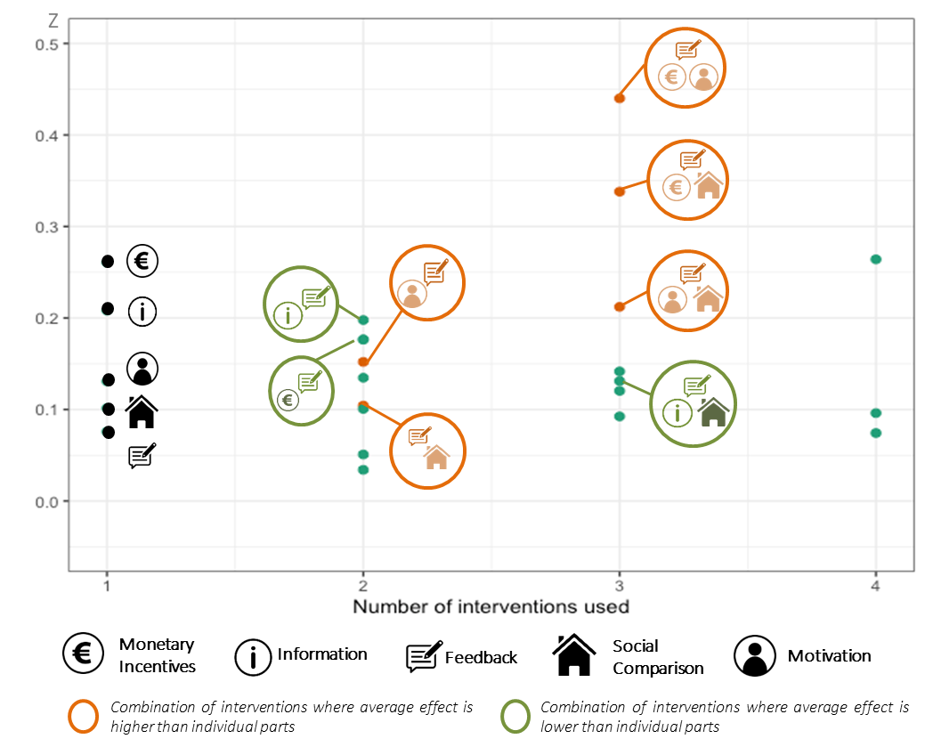

Conclusions
To address the lack of synthetic evidence on demand-side solutions, we extend our meta-analysis to provide an initial estimate of the carbon emissions mitigation potential of the studied interventions for climate changes assessments. We do this by using percentage reduction in electricity consumption as the dependent variable in our meta-analytical models along with the aggregate emissions of residential buildings. Interventions aimed at changing the usage of existing equipment by households can on an average deliver reduction of 0.35 Gt CO₂ yr⁻¹ in global carbon emissions of residential buildings. While the estimated emissions reductions are relevant in size, they are very modest compared to the approximately 5.5 Gt CO₂ of emissions from residential buildings in 2018. Cumulatively, the emissions reductions will add up to 1.05 -1.75 Gt CO₂ if these effects persist over three to five years. Our estimates are however conservative. The reductions derived could also be enhanced by using our evidence on interactions between the various interventions, considering growth in energy demand in developing countries, and including other interventions around the maintenance, replacement or upgrade of heating and non-heating equipment in residential buildings that have been shown to have higher plasticity and potential.

