LONG-TERM PLANNING AND CHARACTERIZATION OF LATIN AMERICAN ELECTRICAL SYSTEMS BASED ON THEIR RESOURCES

Lorena Di Chiara, +59899294106, lorenadichiara@gmail.com
Gonzalo Casaravilla, Member, +59899725662, gcp@fing.edu.uy
Ruben Chaer, Member, +59899671944, rchaer@fing.edu.uy

Overview
Power system planning is a fundamental activity for the energy sector. Allows anticipating potential challenges, such as, supplying a growing energy demand, achieving energy policy goals, meeting environmental commitments, among others. Long-term planning studies typically have time horizons of 15 to 30 years. The result of these studies are a set of investments that meet certain requirements, including the type of technology to be installed and when they should be installed.
Traditionally, one of the most common questions in long-term energy planning in systems with mediuma and high share of hydroelectric capacity is the risk of non service energy that a country is willing to take in the face of a very low probability extreme drought. In addittion, nowadays due to improvements in efficiency and costs drop of wind and solar photovoltaic generation, these technologies are very competitives, so, the variability in the short term (hours, days) should be taking into account in the energy planning process. In the medium and long term (months to years ) the variation of the energy produced by these technologies is very low.
In systems with hydroelectric plants with storage capacity, the short-term fluctuations of non-conventional renewable energy (NCRE) can be mitigated by increasing hydroelectric generation when their production drops or by storing water when they are generating in abundance. In this study, the generation expansions will be carry out considering NCRE (wind and solar photovoltaic) and tradictional thermal generation (open turbines and combined clycles).
In 2019, hydroelectric generation in Latin American region represented approximately 50% of the total electricity demand [1]. It is observed that most Latin American countries rainflow regime are influenced by El Niño / La Niña climatologic phenomenon. In extreme situations, this climatologic phenomenon might cause severe droughts and / or floods.
The main objective of this study is to determine the optimal generation investments in systems with different shares of hydroelectric and storage capacity, considering the characteristics of wind and solar resources, hydrological flows, electricity demand and fossil fuel prices of several Latin American countries.

Methods
A survey of hydroelectric capacity installed, historical hydrological flow, electricity demand, installation costs of different technologies, wind and solar resources, availability and price of fossil fuels in Latin American countries was carried out. Due to the differet characteristics of natural resources, mainly wind and solar resources, Latin America is divided into the following 3 regions: Southern Cone, Andean and Central America.
Wind and solar resources are modeled from data from the Global Wind Atlas, Global Solar Atlas and public information and historical data available from each Latin American region. The Southern Cone region is the one with the highest wind generation potential, while the Andean region in the areas close to Atacama desert has the best conditions for the development of solar energy.
Three fuel cost scenarios were considered: Low Prices, Medium Prices and High Prices, which are associated with the availability of sufficient indigenous natural gas, use of liquefied natural gas and use of oil for the operation of the thermal plants respectively.
For each region, 12 scenarios of hydroelectric capacity / storage were considered. The installed hydroelectric capacity assumed were 60%, 40% and 20% of the electricity peak demand and the storage capacity: few hours, 1 week, 12 weeks (3 months) or 52 weeks (1 year).
The optimizations of the generation expansions were carried out using SimSEE [2] platform with its Generation Investment Planning module (PIG-OddFace) [3]. SimSEE model allows the stochastic resources to be adequately represented with a corresponding time simulation step.
The investment costs of wind and solar photovoltaic capacity were modeled based on cost projections published by the International Renewable Energy Agency (IRENA). The investment cost of open-cycle and closed-cycle thermal power plants were modelled based on real projects in Latin American countries.
All costs / prices considered in this study are expressed in 2020 constant dollars. A discount rate of 10% were assumed and taxes were not considered.

Results
The results of the optimal expansions shows that as fossil fuel prices increases, the share of wind and solar generation are higher. In countries with indigenous natural gas (low fuel prices), the optimal integration of NCRE is very low or even non-existent. On the other hand, in countries where thermal plants operate with oil, the integration is very high.
In systems with little storage capacity, the daily evolution of wind and solar photovoltaic generation in relation to the demand, has a more important role than in systems with greater storage capacity.
For the same assumptions of fuel prices, technology costs and hydroelectric capacity, the optimum varies according to the region considered. In Southern Cone, due to the excellent wind resource wind generation expansion is predominates, while in areas surrounding the Atacama desert, solar photovoltaic generation is the predominant one.
Fig. 1 summarizes the aspects outlined.
The reduction of CO₂ emissions in systems with medium and high fossil fuel prices is significant. In this study, no economic benefits associated with this reduction were added, which may make a difference in the expansion of systems that have indigenous natural gas.

Conclusions
Nowadays, except in scenarios with very low fossil fuel prices, wind and solar photovoltaic technologies are very competitive generation expansion alternatives. The share of solar photovoltaic and wind energy generation varies along LatinAmerican countries, and depends mainly on fossil fuel prices, hydroelectric capacity, storage capacity, solar and wind resources.
In general, the share of NCRE increase in system with higher fossil fuel prices. On the other hand decrease in systems with more hydroelectric installed capacity. In systems with the same hydroelectric capacity, by increasing the storage, the share of NCRE is higher since it is possible to displace more energy over time, taking better advantage of NCRE generation.

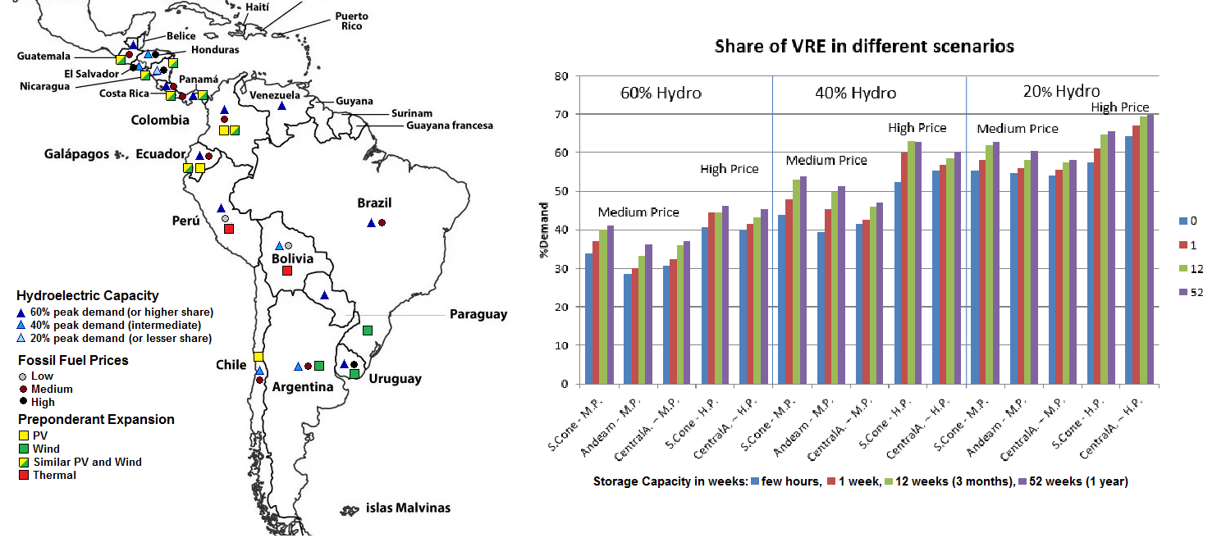
Fig. 1 Left.: Preponderant technologies – optimal expansions; Right: Share of VRE in different scenarios

References
[1] Datos del Panorama Energético de América Latina y el Caribe 2018, OLADE, 2019
[2] Simulación de Sistemas de Energía Eléctrica, Montevideo – Uruguay, Agosto 2008 Autores: RubenChaer https://www.colibri.udelar.edu.uy/jspui/bitstream/20.500.12008/2877/1/Cha08.pdf
[3] Manuales de SimSEE Volumen 6 – OddFace Optimizador Distribuido de Funciones de Alto Costo de Evaluación https://simsee.org/db-docs/Docs_secciones/comunes/ManualSimSEE_Vol6_oddface.pdf

