Regulatory incentives for TRANSMISSION SYSTEM Operators under Flow-based market coupling
Michiel Kenis, KU Leuven/ VITO/ EnergyVille, michiel.kenis@kuleuven.be
Kenneth Bruninx, KU Leuven/ EnergyVille, kenneth.bruninx@kuleuven.be
Fernando Dominguez, VITO/ EnergyVille, fernando.dominguez@vito.be
Erik Delarue, KU Leuven/ EnergyVille, erik.delarue@kuleuven.be

Overview
Power systems around the globe are undergoing an unprecedented transition. The increase of intermittent renewable energy sources (RES) in electricity generation puts stresses on the ability of the system operators to ensure a high level of security of supply. Power grids have a potential to serve as a source of flexibility in order to cope with an increasing share of RES-based generation. Supra-national markets, i.e., market coupling, prove to be economically beneficial. Herein, the role of system operators is crucial in providing transmission constraints to the market. Specifically, flow-based market coupling is in place in Central Western Europe (and currently expanding towards Core Europe) to calculate and allocate cross-border transmission capacities [1, 2]. However, in current regulatory frameworks, TSOs receive regulatory incentives that lead to overly conservative behaviour by TSO’s [3]. In this work, we investigate what the main drivers are behind possibly misaligned regulatory incentives for TSO’s. We provide a model that allows to holistically analyse the impact of regulatory incentives for TSOs by capturing three relevant stages: determination of transmission constraints (D-2), day-ahead market clearing (D-1) and re-dispatch (D). We show that there might exist misaligned regulatory incentives for TSOs, leading to underused potential of the flow-based methodology.

Methods
This work analyses the impact of regulatory incentives for TSOs in the context of providing transmission capacity to day-ahead energy markets. To undertake this analysis, this paper develops a coherent model that allows to holistically by capturing three relevant stages: determination of constraining transmission network elements (D-2), day-ahead market clearing (D-1) and re-dispatch (D). A mixed complementarity optimization problem is set up, in wich the following three agents are, among others, modelled. Firstly, the TSO’s that determine discretionary parameters (at D-2) to define the flow-based domains are considered. Secondly, the market operator that performs the clearing of the coupled zonal day-ahead markets (at D-1) is modeled. Thirdly, the re-dispatch problem (at D) is included. The three problems are interlinked with eachother as shown by the arrows in Figure 1, which presents an overview of the modelling framework. The problem is solved with a linear commercial solver after derivation of the Karush-Kuhn-Tucker conditions of each of the problems.
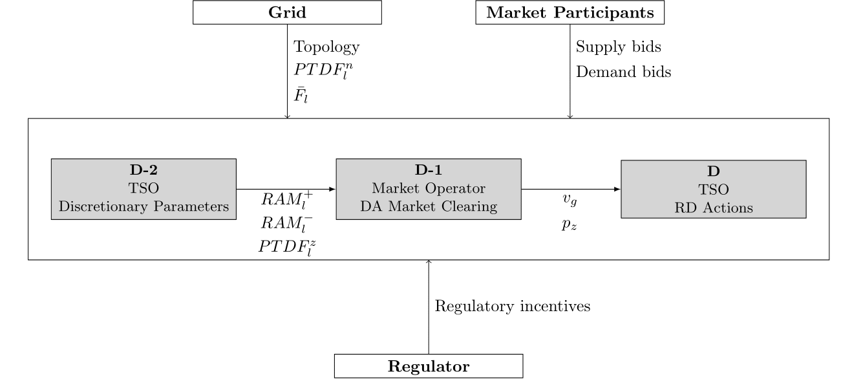
Figure 1: Overview of the three stages. The TSO's and market operator are limited in their actions by eachother, the regulator, the grid and the day-ahead market participants.

Results
The model is applied on both a stylized power network and a more extended fictive power network. Two extreme cost allocations can be observed. In case the Remaining Available Margins, i.e. the transmission capacity made available for trade, of the critical line elements is set rather low, day-ahead energy costs are high compared to re-dispatch costs. Contrary, in case the Remaining Available Margins are rather high, day-ahead energy costs are low compared to re-dispatch costs. Since current regulatory frameworks highly incentivize reliability, misaligned incentives for TSOs might exist. This could lead to underused potential when applying a flow-based methodology in coupled markets. However, the order of magnitude of this underlying cost-efficiency gap is dependent on the assumed objective of TSO’s (e.g., minimization of re-dispatch costs or maximization of social welfare) and should be threated carefully. 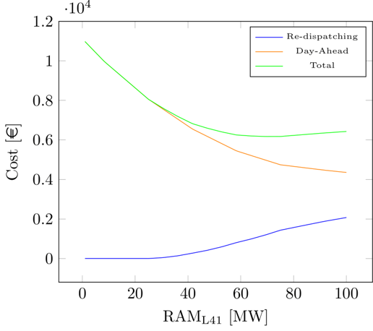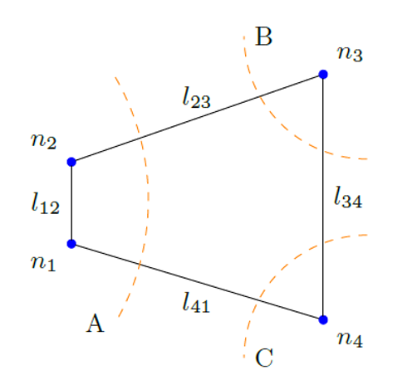
Figure 2: Preliminary results after application of the model on a stylized example. Figure with network from [4].

Figure 2 presents a preliminary result in which the Remaining Available Margin (RAM) on a critical line l₄₁ in a 3-zone/4-node stylized network example is varied from 0 MW up until its thermal capacity of 100 MW. There is uncertainty considered on generation and demand at each node of which numerical values are left out here. RAM is an output of the determination of TSO’s on the discretionary parameters at D-2. It can be seen that, on the one hand, if the TSO’s minimize their own expected re-dispatch costs, a RAM of maximum 25 MW is set on line l₄₁. On the other hand, if the TSO’s minimize the expected total (day-ahead energy + re-dispatch) costs, a much higher RAM of 70 MW is set. We envision to extend this analysis by deepening the insights on the optimal parameter setting by TSO’s, and by applying our model on a scaled-up power grid.

Conclusions
Flow-based market coupling is prone to cost-efficiency losses compared to its potential as TSOs determine discretionary parameters that represent the transmission constraints for the market. This work provides a model that allows to holistically analyse the impact of regulatory incentives for TSOs by capturing three relevant stages: determination of transmission constraints (D-2), day-ahead market clearing (D-1) and re-dispatch (D). We show that there might exist misaligned regulatory incentives for TSOs, leading to underused potential of the flow-based methodology.

References
  - [1] Van den Bergh, K., Boury, J., Delarue, E., 2016. The flow-based market coupling in central western Europe: concepts and definitions. The Electricity Journal, vol. 29, pp. 24–29.
  - [2] Schönheit, D., Kenis, M., Lorenz, L., Möst, D., Delarue, E., Bruninx, K., 2020. Toward understanding flow-based market coupling: An open-acces model. TME Working Paper. https://www.mech.kuleuven.be/en/tme/research/energy-systems-integration-modeling/pdf-publications/wp-esim2020-23
  - [3] CREG, 2017. Functioning and design of the Central West European day-ahead flow based market coupling for electricity: Impact of TSOs Discretionary Actions. Commission de Régulation de l’Electricité et du Gaz.
[4] Aravena, I., Papavasiliou, A., 2016. Renewable energy integration in zonal markets. IEEE Transactions on Power Systems, vol. 32, pp. 1334–1349.

