POTENTIAL OF ELECTRIC VEHICLES TO OVERCOME TRANSMISSION LINE CONGESTIONS AND BALANCE REDISPATCH NEEDS: A CASE STUDY FOR THE AUSTRIAN CONTROL AREA

[Christoph Loschan, TU Wien – Energy Economics Group, +43 (1) 58801 370334, loschan@eeg.tuwien.ac.at]
[Carlo Corinaldesi, TU Wien – Energy Economics Group, +43 (1) 58801 370370, corinaldesi@eeg.tuwien.ac.at]
[Georg Lettner, TU Wien – Energy Economics Group, +43 (1) 58801 370376, lettner@eeg.tuwien.ac.at]

Overview

Redispatch measurements form the basis of the central European energy market design, to prevent congestion of serval transmission lines after the market is cleared. This process within a bidding zone increases the power generation of several thermal power plants while other ones are curtailed. The growing share of renewable energy source of electricity (RES-E) increases the hours during which the dispatch process is intervened and thus raises redispatch costs. For example, in Austria, till 2030, 100% of the net electrical energy should be generated by RES-E. The resulting redispatch measures increase the electricity prices for all costumers and CO2 is emitted by the usage of regulating thermal power plants, which makes it more difficult to achieve the previously set goals. In addition to the increased frequency of network congestion due to the volatile RES-E, the ever-increasing demand for electrical energy caused by the charging of electric vehicles (EV) also contributes to this. The charging processes, which are carried out with very high power due to the technological progress of the charging infrastructure and the EVs, are generally not evenly distributed over the day or even correlate with periods of high electricity prices/generation-demand ratio. They rather take place in parallel to a large extent since the charging of the EVs commonly starts immediately after plug-in. In this work, the influence of EVs on the congestion of transmission lines in a high share RES-E energy system is analysed. Furthermore, the potential of coordinated EV charging to overcome congestions or grid expansion, reduce system costs and CO2 emissions is analysed.

Methods
A two-step optimisation model, based on the EDisOn model [1, 2] was developed in MATLAB. In the first step, the dispatch of all power plants generation schedules within each balancing group is done separately based on their short-run marginal costs (SRMC), renewable generation, and the merit order function. In the second step of the optimisation, a 17-node model of Austrians balancing group is implemented and the power flow of this electricity network is calculated. The power plant usage remains unchanged from the one determined in the first optimisation step as the optimum of the market-clearing perspective. If a high RES-E generation or energy demand from parallel EVs charging leads to congestion, redispatch measures have to be evaluated. This can be done, by displacement of thermal power plants generation, curtailment of RES-E (that increases CO2 emissions in a high share RES-E energy market), and demand shifting measurements of EVs. Figure 1 shows these two main steps of the optimisation process.

First optimisation step: Dispatch
- Objective: min. overall generation costs
- Power plants Dispatch based on the merit order of each’s country balancing groups
- Power plants are constrained by their capacity and ramp limits
- Electrical energy demand including EVs demand
- No demand shift possibility for EVs
- Power flow between the energy markets is possible but constrained by their NTC capacity

Second optimisation step: Redispatch
- Objective: min Redispatch costs (increase/decrease of thermal power plants generation, curtailment of RES-E)
- Power plants Redispatch in Austria based on the calculated power flow and potential transmission line congestion
- Power plants are constrained by their capacity and ramp limits
- Electrical energy demand including EVs demand
- EVs energy demand could be shifted (EV – Demand-side-management)
- DSM potential is limited by the plugged-in time of an EV and min./max. power of the charging infrastructure

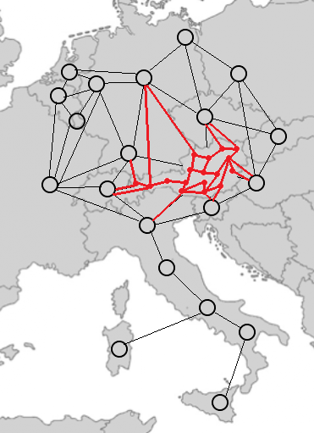
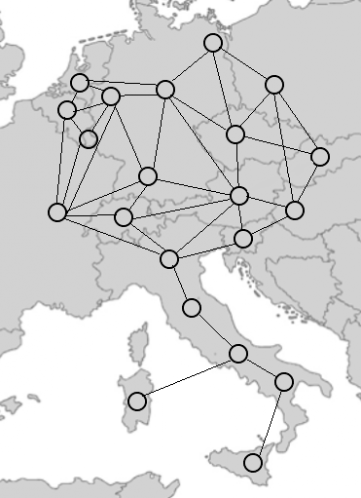
Figure 1 Electricity market-based dispatch (left) and power flow based redispatch (right) optimisation step
The demand shifting potential of EVs is investigated considering multiple types of car users and their individual charging behavior (e.g. commuter, business, leisure, etc.). The profiles are characterised by the amount of energy that should be charged, the plugged-in time, and power restrictions. Figure 2 shows the percentage of cars that are plugged in/charging over an entire day, based on the data in [3].

Figure 2 Characteristic of the EVs charging profiles with their demand shift potential

Results
The DSM potential resulting from the increasing number of EVs is used in the redispatch process to overcome transmission line congestions. The share of RES-E, the number of EVs, and the charging power of the charging infrastructure are analysed as sensitivities. Further, the influence on the redispatch process regarding its costs and CO2 emissions are assessed.

Conclusions
Preliminary work has shown that there is a huge potential in the future which can avoid congestions or expensive transmission line expansions. With the currently registered 40 000 EVs in Austria, redispatch costs can be reduced by 0.4 %, with 200 000 EVs 3 %, with 600k by 7 % and with 2 million by 20 %, by using them as DSM appliances. The impact on the reduction of redispatch caused CO2 emssions is even higher with -7 % / - 20 % / - 46 % in the three future scenarios.

References

[1] B. Dallinger, 2018, Model-based analysis and design of an improved European electricity market with high shares of renewable generation technologies, Dissertation, http://hdl.handle.net/20.500.12708/1928
[2] L. Lang, B. Dallinger, G. Lettner, 2020, The meaning of flow-based market coupling on redispatch measures in Austria, Energy Policy Volume 136, https://doi.org/10.1016/j.enpol.2019.111061
[3] C. Nelder, G. Fitzgerald, 2016, Electric Vehicles as Distributed Energy Resources, Technical Report, https://www.researchgate.net/publication/324417842_Electric_Vehicles_as_Distributed_Energy_Resources

