Sector Coupling of a Local Energy System - Influence of Location Dependent Parameters

Frida Huglen Revheim, TU Wien, Energy Economics Group, +43 (1) 58801 370343, revheim@eeg.tuwien.ac.at
Daniel Schwabeneder, TU Wien, Energy Economics Group, +43 (1) 58801 370375, schwabeneder@eeg.tuwien.ac.at
Georg Lettner, TU Wien, Energy Economics Group, +43 (1) 58801 370376, lettner@eeg.tuwien.ac.at

Overview
The share of local energy sources is rapidly increasing together with the growing implementation of renewable volatile energy sources. Nevertheless, low electricity prices and expiring subsidies result in challenging economic operation of renewable energy sources (RES). Hence, further implementation of RES could face an uncertain future in the current energy economic environment. Innovative operating concepts are therefore needed in order to ensure operation and expansion of generation, conversion and storage capacities based on RES also in future.
Energy sector coupling could be an economically viable solution in order to ensure the continuation of RES implementation and operation. The concept opens up market segments for new energy services and products by coupling electricity, heating/cooling and gas sectors. Both technical and economical experience and knowledge regarding coupled operation of different grid infrastructures are lacking. By utilizing the concepts of sector coupling to produce green hydrogen and green heat, significant emission reductions can be achieved, both in the mobility sector as well as in other emission-prone sectors such as the heating sector. Furthermore, curtailment of renewable electricity generation can be reduced. Depending on system location and location-specific variables (e.g. electricity generation, heat demand and fuel options available), the investigated sector coupling concept may prove more profitable and more adept at mitigating greenhouse gas emissions in certain areas.
This work builds on a use case developed in the SektoKop Net project [1] and conducts a comparative analysis on how external location-dependent parameters affect the ability of a sector coupling system to operate in an optimal manner and mitigate greenhouse gas emissions.

Methods
A mathematical optimization model, based on a use case defined in the SektoKop Net project, is developed in Julia. An overview of the modelled system is presented in Figure 1. The investigated system includes both Power-2-Heat and Power-2-Gas concepts, through the implementation of both a heat pump and an electrolyzer. The model aims to optimize the operation of the defined system and maximize the revenue, while still fulfilling local energy demand requirements related to heat and gas at all times.
In order to thoroughly assess the system operation at various geographic locations and the influence of external location-dependent parameters, this work will define three separate use cases, representing Austria, Norway and a Southern European country. Thus, relevant parameters and input data from each respective country will be gathered and used as input for the model. The results will then serve as a base for comparison in regards to system profitability and emission mitigation potential.
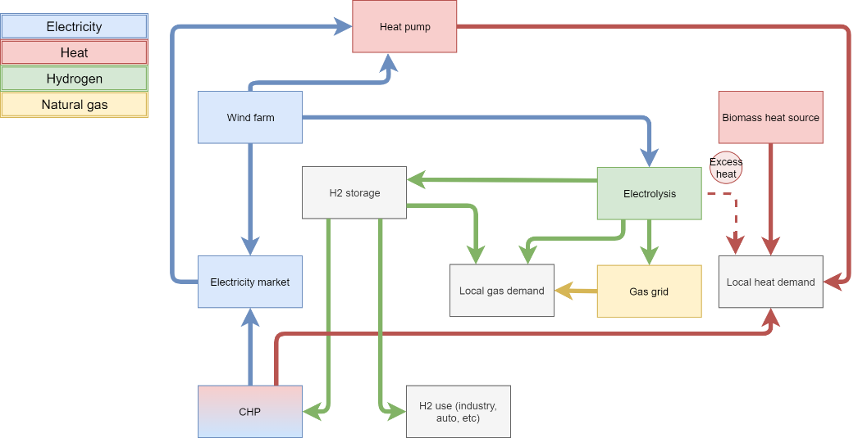
Figure 1: Sector coupling model with P2H and P2G technologies

Results
Results related to both system profitability and ability to mitigate greenhouse gas emissions will be calculated and used as base for a thorough comparison between the investigated countries. The preliminary results for the Austrian use case are calculated and show that, due to high operational costs combined with the costs of covering the local energy demands, a negative profitability of the analysed system is achieved. Figure 2 shows a Sankey diagram representing a quantitative analysis performed for the Austrian use case. The diagram provides a graphical overview of the energy flows occurring in the examined system. The majority of the electricity generated is sold directly to the electricity spot market. In addition, significant amounts of the generated electricity are fed into the electrolyzer, which produces hydrogen that is sold directly to the market. The remaining available electricity is either fed into the heat pump or curtailed. Final results for all three countries are expected to be concluded within the first half of 2021.
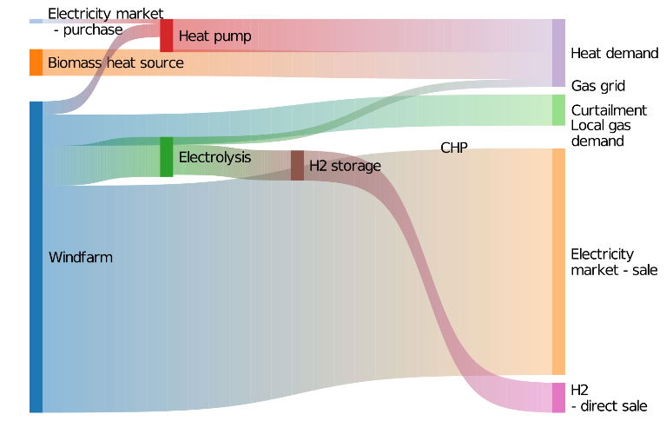
Figure 2: System operation - AT use case

Conclusions
Conclusions regarding the influence of external location-specific parameters on sector coupling based systems, particularly related to profitability and ability to reduce greenhouse gas emissions, will depend on comprehensive analyses that will be performed in the course of this work. However, preliminary results suggest that each country’s specific energy demands, energy prices and alternative fuel options, as well as plans for deployment of low-emission vehicles, will affect how well the sector coupling system operates.

References

[1] | Energieforschung, “SektoKop Net Sektorübergreifender und gekoppelter Betrieb von Strom-, Wärme- und Gasnetzen,” Energieforschung, [Online]. Available: https://www.energieforschung.at/projekte/1046/sektoruebergreifender-und-gekoppelter-betrieb-von-strom-waerme-und-gasnetzen.

https://julialang.org/

